

Project Name: Inter-city Car Pooling System

Branch PG-DAC Mar-2023

Documentation On

**“**Inter-city Car Pooling System**”**

PG-DAC MARCH 2023

**Guided By: Bakul Joshi**

Submitted By :

**Group No: 05**

* **Nikhil Madhekar 230343020052**
* **S M Mohsin Naqvi 230343020079**
* **Tarun Rathore 230343020099**
* **Mahesh Bhabad 230343020055**

**Table of Contents**

**1. Introduction 4**

1.1 Document Purpose **4**

1.2 Project Background **4**

1.3 Aim & Objectives **4**

**2. Business Requirements Overview**…………………………………………………………**5**

**3.Functional Requirements** **6**

3.1 Car owner Module **6**

3.2 User Module **6**

3.3 Admin Module **6**

**4.** **Non-Functional Requirement………………………………………………………………7**

**5. Use Case Diagram 8**

5.1 Car owner **9**

5.2 User **10**

5.3 Admin **11**

**6. Database Design 12**

1 Role **12**

2 Login **12**

3 Users…………………………………………………………………………………… **13**

4 Co-passengers **13**

5 Car-company **13**

6 Car-models **13**

7 Vehicles **13**

8 Rides **13**

9 States **14**

10 Cities **14**

11 Payment **14**

12 Booking…………………………………………………………………………………**15**

13 Passenger-review…..……………………………………………………………………**15**

**7. E-R Diagram………………………………………………………………………………………14**

**8. Snapshots 15**

**9. Conclusion 20**

**List of Figures**

**Use Case Diagrams 17**

Fig 1 Car-owner 8

Fig 2 Users 9

Fig 3 Admin 10

Fig 4 ER Diagram 14

1. **Introduction:**
   1. **Document Purpose:**

This document communicates the business requirements and scope for developing

Inter-city Car Pooling System. The scope of this document is to define the functional and non functional requirements, business rules and other constraints requirements.

## Project Background:

There is a growing awareness of the challenges associated with individual commuting, such as increasing traffic congestion, rising fuel costs, and environmental concerns. Inefficient use of private vehicles and the lack of convenient alternatives contribute to these challenges.

## Aim & Objectives:

The online carpooling system is a platform designed to connect individuals who are traveling in the same direction so they can share a ride together. It aims to provide a more sustainable and cost-effective transportation option by reducing the number of vehicles on the road and optimizing the use of existing resources.

1. **Business Requirements Overview:**

* Online car pooling system is the public Web Application.
* Online car pooling system will be opened to the global, but in the phase 1, the main target is in the Maharashtra .
* There are mainly two types of user. One is the **User** and other is **Car owner**.
* User can find out the minimum price ride and then user can send the request to particular Car owner.
* There are mainly two types of users.One is the Car-owner and the other one is Users who get a ride with car owner .
* Online car pooling system provides the functions which connect the users and the Car owner efficiently and directly.
* Online car pooling system could be maintained by **Administrator**.

Inter-city Car Pooling system provides such functionalities through which Users can book ride and make ride share with Car-owner who is travelling in that direction.

# Functional Requirements Overview:

Inter-city Car Pooling System consists of three modules described as below.

1. Car owner Module
2. Users Module
3. Admin Module

# **3.1** Car owner **Module**

* Car owner can register and create his own account.
* Car owner should be able to registered by providing their personal information, vehicle details, driving-license information and contact details.
* Car owner will have login first before the send the request.
* Inter-city Car Pooling System provides the function which allows Car owner to publish his travelling details like date, time, price and location.
* He/she is able to select existing user with their choice.
* Car owner should have the ability to set their availability by specifying their preferred routes,range of fixation of amount, timings, and the number of available seats in their vehicles.

# **User Module**

* User can register and create his own account.
* Online car pooling system provides functionality which allows user to find out the rides where he/she wanted to go.
* User can find out the minimum price ride and then user can send the request to particular Car owner.

# **3.3 Admin Module**

* Online car pooling system should provide all function to admin how to handle the System.
* Admin can had a authority to accepts whole Car owner verified and Users to allow to use the system.
* What all are the Car owner and Users using this system and are they authorized,valid actual or not all those things are checking the responsibility of admin.
* Admin had the authority to see the worst review of the users according to that they select the Car owner disabled or blocked.

1. **Non-Functional Requirement:**

* The website should use professional design, look and feel and color scheme.
* Users will have no limitations for accessing the application through Internet.
* The portal being an internet application, it is difficult specify exact number of visitor or users. Hence we will target the system to support between 1 and 5 million users on launch of phase 1.
* Being a public website, the site must follow general usability guidelines for menus, navigation, colors, links and other actions provided on the screens.
* The system should be designed in such a manner that user will be able to complete tasks in minimum number of steps.

.

## 5. Use-Case Diagram

**5.1 Car Owner:**

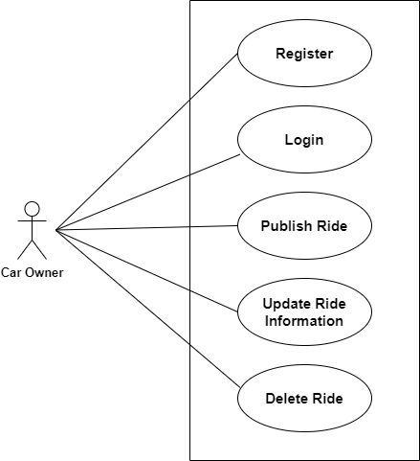

Fig. Use-Case Diagram for Car owner

## 5.2 User:

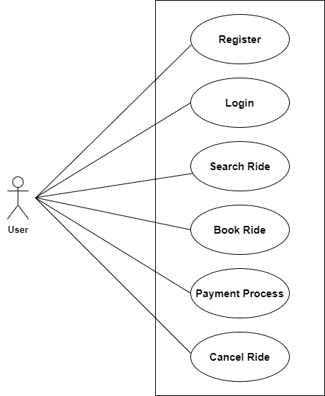

Fig. Use-Case Diagram for User

**5.3 Admin:**  
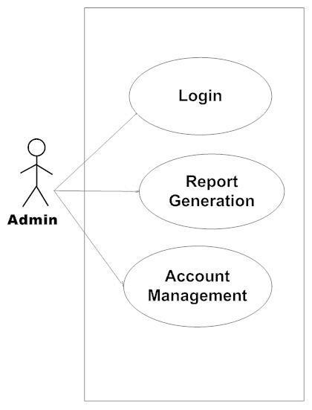

Fig. Use-Case Diagram for Admin

**6. Database Design:**

1. **Role**

|  |  |  |  |  |  |
| --- | --- | --- | --- | --- | --- |
| **Field** | **Type** | **Null** | **Key** | **Default** | **Description** |
| id | Integer | No | Primary key | Null | Role ID |
| role | Varchar(45) | No |  | Null | Which type of user is enrolled. |

1. **Login**

|  |  |  |  |  |  |
| --- | --- | --- | --- | --- | --- |
| **Field** | **Type** | **Null** | **Key** | **Default** | **Description** |
| id | Integer | No | Primary key | Null | Which type of user logged in |
| roll_id | Integer | No | Foreign key | Null | Reference to roll_id(Tbl Role) |
| login_id | Varchar(100) | No | Unique | Null | Login_id |
| password | Varchar(100) | No |  | Null | Password |
| status | Tinyint | No |  | Null | Login Status |

1. **Users**

|  |  |  |  |  |  |
| --- | --- | --- | --- | --- | --- |
| **Field** | **Type** | **Null** | **Key** | **Default** | **Description** |
| id | Integer | No | Primary key | Null | Car_owner/User |
| user_id | Integer | No | Foreign key | Null | reference to Login_id(Tbl_login) |
| password | Varchar(100) | No |  | Null | Password of user |
| aadhar_no | Varchar(45) | No |  | Null | Aadhar number of user |
| fname | Varchar(100) | No |  | Null | First name of User |
| lname | Varchar(100) | No |  | Null | Last name of User |
| gender | Varchar(45) | No |  | Null | Gender of User |
| dob | Date | No |  | Null | Date of Birth of User |
| licence | Varchar(45) | Yes |  | Null |  |
| phone-no | Varchar(45) | No |  | Null | Phone no of User |
| primary email | Varchar(100) | No |  | Null | email id of User for login |
| secondary_email | Varchar(100) | Yes |  | Null | Secondary email id of User |

1. **Co_passenger**

|  |  |  |  |  |  |
| --- | --- | --- | --- | --- | --- |
| **Field** | **Type** | **Null** | **Key** | **Default** | **Description** |
| id | Integer | No | Primary key | Null | Co-passenger ID |
| passenger_id | Integer | No | Foreign key | Null | Reference to User_id (Tbl_User) |
| aadhar_no | Varchar(45) | No |  | Null | Aadhar no of co_passenger |
| phone_no | Varchar(45) | Yes |  | Null | Phone no of co_passenger |
| email | Varchar(45) | Yes |  | Null | Email of co_passenger |
| fname | Varchar(45) | No |  | Null | First name of co_passenger |
| lname | Varchar(45) | No |  | Null | Last name of co_passenger |
| Gender | Varchar(45) | No |  | Null | Gender of co_passenger |

1. **Car_company**

|  |  |  |  |  |  |
| --- | --- | --- | --- | --- | --- |
| **Field** | **Type** | **Null** | **Key** | **Default** | **Description** |
| id | Integer | No | Primary key | Null | Admin ID |
| company_name | Varchar(100) | No |  | Null | Company name of car |

1. **Car_Models**

|  |  |  |  |  |  |
| --- | --- | --- | --- | --- | --- |
| **Field** | **Type** | **Null** | **Key** | **Default** | **Description** |
| id | Integer | No | Primary key | Null | Admin ID |
| Company_id | Integer | Yes | Foreign_key | Null | Reference to Car_company_id(Tbl_**Car_company**) |
| model_name | Varchar(100) | No |  | Null | Model name of car |
| fuel_type | Varchar(100) | No |  | Null | Fuel type of car |
| model_type | Varchar(100) | No |  | Null | Model type of car |

1. **Vehicles**

|  |  |  |  |  |  |
| --- | --- | --- | --- | --- | --- |
| **Field** | **Type** | **Null** | **Key** | **Default** | **Description** |
| id | Integer | No | Primary key | Null | Vehicle id |
| carowner_id | Integer | No | Foreign key | Null | Reference to Users_id(Tbl_**users**) |
| model_id | Integer | No | Foreign key | Null | Reference to Car_Model_id(Tbl_c**ar_model_**) |
| year | Integer | No |  | Null | Year of buying car |
| color | Varchar(45) | No |  | Null | Color of car |
| rc-book | Varchar(200) | No |  | Null | Registration card of car owner |

**8] Rides**

|  |  |  |  |  |  |
| --- | --- | --- | --- | --- | --- |
| **Field** | **Type** | **Null** | **Key** | **Default** | **Description** |
| id | Integer | No | Primary key | Null | Ride Id |
| carowner_id | Integer | No | Foreign key | Null | Reference to Carowner_id(Users_Tbl) |
| start_Location | Integer | No | Foreign key | Null | Reference to Cid (Tbl_City) |
| end_Location | Integer | No | Foreign key | Null | Reference to Cid (Tbl_City) |
| vehicle_id | Integer | No | Foreign key | Null | Reference to Vid (Tbl_Vehicle) |
| time_of_departure | Time | Yes |  | Null | Time of departure |
| time_of_arival | Time | Yes |  | Null | Arrival time |
| price_per_seat | Integer | No |  | Null | Price per seat amount |
| Available_seats | Integer | No |  | Null | Total available seats in car |
| status | Varchar(100) | Yes |  | Null | Ride is confirmed or not |
| date_of_journey | Date | Yes |  | Null | Date of Journey |

**9] Booking**

|  |  |  |  |  |  |
| --- | --- | --- | --- | --- | --- |
| **Field** | **Type** | **Null** | **Key** | **Default** | **Description** |
| id | Integer | No | Primary key | Null | Booking ID |
| passenger_id | Integer | No | Foreign key | Null | Reference to passenger_id(Tbl_User) |
| ride_id | Integer | No | Foreign key | Null | Reference to Ride_id(Tbl_Ride) |
| time | DateTime | No |  | Null | Booking time |
| no_of_seats | Integer | No |  | Null | How many seats are booked |
| total_price | Integer | No |  | Null | Total price acc to passenger |
| status | Varchar(100) | Yes |  | Null | Status of booking confirmation or not |

**10] Payment**

|  |  |  |  |  |  |
| --- | --- | --- | --- | --- | --- |
| **Field** | **Type** | **Null** | **Key** | **Default** | **Description** |
| id | Integer | No | Primary key | Null | Payment ID |
| booking_id | Integer | No | Foreign key | Null | Reference to Booking_id(Tbl_Booking) |
| passenger_id | Integer | No | Foreign key | Null | Reference to passenger_id(Tbl_Co_passenger) |
| amount | Integer | No |  | Null | Total amount |
| Date_Time | Datetime | No |  | Null | Date and time of payment |
| payment_method | Varchar(45) | No |  | Null | Permanent method |
| status | Varchar(100) | No |  | Null | Paymnt is succesfull or not |

**11] State**

|  |  |  |  |  |  |
| --- | --- | --- | --- | --- | --- |
| **Field** | **Type** | **Null** | **Key** | **Default** | **Description** |
| id | Integer | No | Primary key | Null | State id |
| state | Varchar(45) | No |  | Null | State name |

**12] City**

|  |  |  |  |  |  |
| --- | --- | --- | --- | --- | --- |
| **Field** | **Type** | **Null** | **Key** | **Default** | **Description** |
| id | Integer | No | Primary key | Null | City id |
| city | Varchar(45) | No |  | Null | City name |
| state_id | Integer | No |  | Null | Reference to State_id(Tbl_State) |

**13] Passenger_review**

|  |  |  |  |  |  |
| --- | --- | --- | --- | --- | --- |
| **Field** | **Type** | **Null** | **Key** | **Default** | **Description** |
| id | Integer | No | Primary key | Null | City id |
| passenger_id | Integer | No | Foreign key | Null | Reference to User_id(Tbl_User) |
| ride_id | Integer | No | Foreign key | Null | Reference to Ride_id(Tbl_Ride) |
| rating | Decimal(3,2) | No |  | Null | Rating given by user to car_owner. |
| comments | Varchar(100) | Yes |  | Null | Any comments. |

## ER-Diagram:

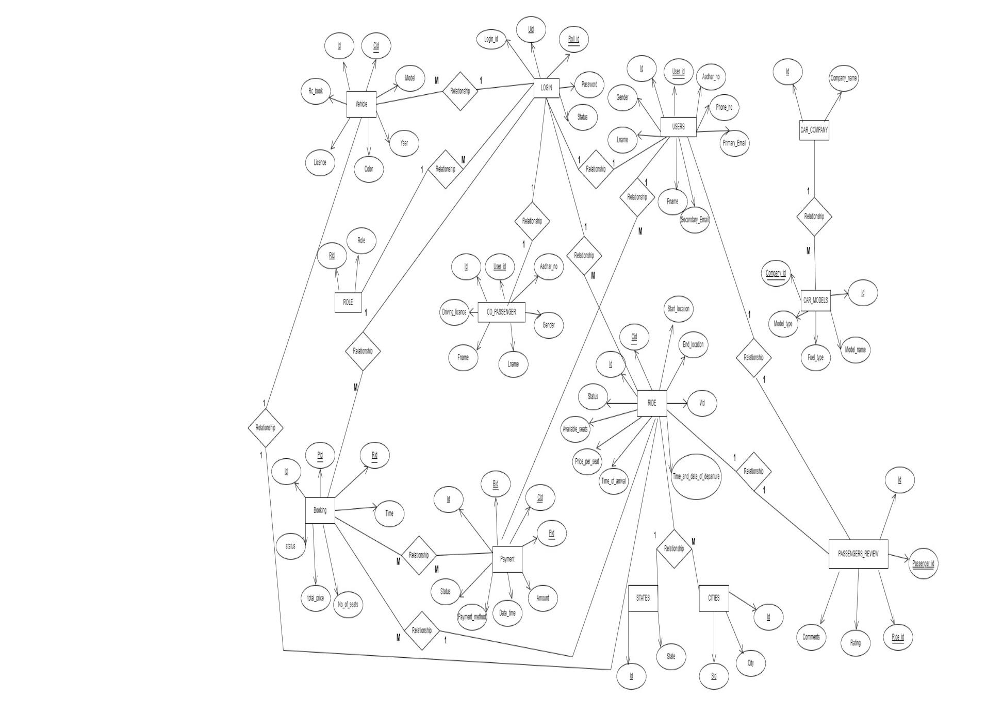

%3CmxGraphModel%3E%3Croot%3E%3CmxCell%20id%3D%220%22%2F%3E%3CmxCell%20id%3D%221%22%20parent%3D%220%22%2F%3E%3CmxCell%20id%3D%222%22%20value%3D%22ROLE%22%20style%3D%22whiteSpace%3Dwrap%3Bhtml%3D1%3Balign%3Dcenter%3B%22%20vertex%3D%221%22%20parent%3D%221%22%3E%3CmxGeometry%20x%3D%22-565%22%20y%3D%22450%22%20width%3D%2290%22%20height%3D%2230%22%20as%3D%22geometry%22%2F%3E%3C%2FmxCell%3E%3CmxCell%20id%3D%223%22%20value%3D%22%26lt%3Bu%26gt%3BRid%26lt%3B%2Fu%26gt%3B%22%20style%3D%22ellipse%3BwhiteSpace%3Dwrap%3Bhtml%3D1%3Balign%3Dcenter%3B%22%20vertex%3D%221%22%20parent%3D%221%22%3E%3CmxGeometry%20x%3D%22-625%22%20y%3D%22373%22%20width%3D%22100%22%20height%3D%2240%22%20as%3D%22geometry%22%2F%3E%3C%2FmxCell%3E%3CmxCell%20id%3D%224%22%20value%3D%22Role%22%20style%3D%22ellipse%3BwhiteSpace%3Dwrap%3Bhtml%3D1%3Balign%3Dcenter%3B%22%20vertex%3D%221%22%20parent%3D%221%22%3E%3CmxGeometry%20x%3D%22-525%22%20y%3D%22350%22%20width%3D%22100%22%20height%3D%2240%22%20as%3D%22geometry%22%2F%3E%3C%2FmxCell%3E%3CmxCell%20id%3D%225%22%20value%3D%22%22%20style%3D%22endArrow%3Dopen%3BendFill%3D1%3BendSize%3D12%3Bhtml%3D1%3Brounded%3D0%3BentryX%3D0.628%3BentryY%3D0.955%3BentryDx%3D0%3BentryDy%3D0%3BentryPerimeter%3D0%3BexitX%3D0.148%3BexitY%3D-0.144%3BexitDx%3D0%3BexitDy%3D0%3BexitPerimeter%3D0%3B%22%20edge%3D%221%22%20source%3D%222%22%20target%3D%223%22%20parent%3D%221%22%3E%3CmxGeometry%20width%3D%22160%22%20relative%3D%221%22%20as%3D%22geometry%22%3E%3CmxPoint%20x%3D%2230%22%20y%3D%22260%22%20as%3D%22sourcePoint%22%2F%3E%3CmxPoint%20x%3D%22190%22%20y%3D%22260%22%20as%3D%22targetPoint%22%2F%3E%3C%2FmxGeometry%3E%3C%2FmxCell%3E%3CmxCell%20id%3D%226%22%20value%3D%22%22%20style%3D%22endArrow%3Dopen%3BendFill%3D1%3BendSize%3D12%3Bhtml%3D1%3Brounded%3D0%3BentryX%3D0.392%3BentryY%3D1.015%3BentryDx%3D0%3BentryDy%3D0%3BentryPerimeter%3D0%3BexitX%3D0.75%3BexitY%3D0%3BexitDx%3D0%3BexitDy%3D0%3B%22%20edge%3D%221%22%20source%3D%222%22%20target%3D%224%22%20parent%3D%221%22%3E%3CmxGeometry%20width%3D%22160%22%20relative%3D%221%22%20as%3D%22geometry%22%3E%3CmxPoint%20x%3D%2250%22%20y%3D%22260%22%20as%3D%22sourcePoint%22%2F%3E%3CmxPoint%20x%3D%22210%22%20y%3D%22260%22%20as%3D%22targetPoint%22%2F%3E%3C%2FmxGeometry%3E%3C%2FmxCell%3E%3CmxCell%20id%3D%227%22%20value%3D%22LOGIN%22%20style%3D%22whiteSpace%3Dwrap%3Bhtml%3D1%3Balign%3Dcenter%3B%22%20vertex%3D%221%22%20parent%3D%221%22%3E%3CmxGeometry%20x%3D%22110%22%20y%3D%22120%22%20width%3D%2285%22%20height%3D%2230%22%20as%3D%22geometry%22%2F%3E%3C%2FmxCell%3E%3CmxCell%20id%3D%228%22%20value%3D%22%26lt%3Bu%26gt%3BRoll_id%26lt%3B%2Fu%26gt%3B%22%20style%3D%22ellipse%3BwhiteSpace%3Dwrap%3Bhtml%3D1%3Balign%3Dcenter%3B%22%20vertex%3D%221%22%20parent%3D%221%22%3E%3CmxGeometry%20x%3D%22195%22%20y%3D%2240%22%20width%3D%22100%22%20height%3D%2240%22%20as%3D%22geometry%22%2F%3E%3C%2FmxCell%3E%3CmxCell%20id%3D%229%22%20value%3D%22Password%22%20style%3D%22ellipse%3BwhiteSpace%3Dwrap%3Bhtml%3D1%3Balign%3Dcenter%3B%22%20vertex%3D%221%22%20parent%3D%221%22%3E%3CmxGeometry%20x%3D%22247.5%22%20y%3D%22110%22%20width%3D%22100%22%20height%3D%2240%22%20as%3D%22geometry%22%2F%3E%3C%2FmxCell%3E%3CmxCell%20id%3D%2210%22%20value%3D%22Login_id%22%20style%3D%22ellipse%3BwhiteSpace%3Dwrap%3Bhtml%3D1%3Balign%3Dcenter%3B%22%20vertex%3D%221%22%20parent%3D%221%22%3E%3CmxGeometry%20x%3D%22-85%22%20y%3D%2245%22%20width%3D%22100%22%20height%3D%2230%22%20as%3D%22geometry%22%2F%3E%3C%2FmxCell%3E%3CmxCell%20id%3D%2211%22%20value%3D%22%22%20style%3D%22endArrow%3Dopen%3BendFill%3D1%3BendSize%3D12%3Bhtml%3D1%3Brounded%3D0%3BexitX%3D0.5%3BexitY%3D0%3BexitDx%3D0%3BexitDy%3D0%3BentryX%3D0.368%3BentryY%3D1.075%3BentryDx%3D0%3BentryDy%3D0%3BentryPerimeter%3D0%3B%22%20edge%3D%221%22%20source%3D%227%22%20target%3D%228%22%20parent%3D%221%22%3E%3CmxGeometry%20width%3D%22160%22%20relative%3D%221%22%20as%3D%22geometry%22%3E%3CmxPoint%20x%3D%22340%22%20y%3D%22240%22%20as%3D%22sourcePoint%22%2F%3E%3CmxPoint%20x%3D%22500%22%20y%3D%22240%22%20as%3D%22targetPoint%22%2F%3E%3C%2FmxGeometry%3E%3C%2FmxCell%3E%3CmxCell%20id%3D%2212%22%20value%3D%22%22%20style%3D%22endArrow%3Dopen%3BendFill%3D1%3BendSize%3D12%3Bhtml%3D1%3Brounded%3D0%3BexitX%3D0.25%3BexitY%3D0%3BexitDx%3D0%3BexitDy%3D0%3BentryX%3D0.5%3BentryY%3D1%3BentryDx%3D0%3BentryDy%3D0%3B%22%20edge%3D%221%22%20source%3D%227%22%20parent%3D%221%22%3E%3CmxGeometry%20width%3D%22160%22%20relative%3D%221%22%20as%3D%22geometry%22%3E%3CmxPoint%20x%3D%22340%22%20y%3D%22240%22%20as%3D%22sourcePoint%22%2F%3E%3CmxPoint%20x%3D%22100%22%20y%3D%2265%22%20as%3D%22targetPoint%22%2F%3E%3C%2FmxGeometry%3E%3C%2FmxCell%3E%3CmxCell%20id%3D%2213%22%20value%3D%22%22%20style%3D%22endArrow%3Dopen%3BendFill%3D1%3BendSize%3D12%3Bhtml%3D1%3Brounded%3D0%3BexitX%3D1%3BexitY%3D0.5%3BexitDx%3D0%3BexitDy%3D0%3B%22%20edge%3D%221%22%20source%3D%227%22%20target%3D%229%22%20parent%3D%221%22%3E%3CmxGeometry%20width%3D%22160%22%20relative%3D%221%22%20as%3D%22geometry%22%3E%3CmxPoint%20x%3D%22200%22%20y%3D%22140%22%20as%3D%22sourcePoint%22%2F%3E%3CmxPoint%20x%3D%22500%22%20y%3D%22240%22%20as%3D%22targetPoint%22%2F%3E%3C%2FmxGeometry%3E%3C%2FmxCell%3E%3CmxCell%20id%3D%2214%22%20value%3D%22%22%20style%3D%22endArrow%3Dopen%3BendFill%3D1%3BendSize%3D12%3Bhtml%3D1%3Brounded%3D0%3BexitX%3D0%3BexitY%3D0%3BexitDx%3D0%3BexitDy%3D0%3BentryX%3D1%3BentryY%3D0.5%3BentryDx%3D0%3BentryDy%3D0%3B%22%20edge%3D%221%22%20source%3D%227%22%20target%3D%2210%22%20parent%3D%221%22%3E%3CmxGeometry%20width%3D%22160%22%20relative%3D%221%22%20as%3D%22geometry%22%3E%3CmxPoint%20x%3D%22340%22%20y%3D%22240%22%20as%3D%22sourcePoint%22%2F%3E%3CmxPoint%20x%3D%22500%22%20y%3D%22240%22%20as%3D%22targetPoint%22%2F%3E%3C%2FmxGeometry%3E%3C%2FmxCell%3E%3CmxCell%20id%3D%2215%22%20value%3D%22%22%20style%3D%22line%3BstrokeWidth%3D1%3BfillColor%3Dnone%3Balign%3Dleft%3BverticalAlign%3Dmiddle%3BspacingTop%3D-1%3BspacingLeft%3D3%3BspacingRight%3D3%3Brotatable%3D0%3BlabelPosition%3Dright%3Bpoints%3D%5B%5D%3BportConstraint%3Deastwest%3BstrokeColor%3Dinherit%3B%22%20vertex%3D%221%22%20parent%3D%221%22%3E%3CmxGeometry%20x%3D%22225%22%20y%3D%2266%22%20width%3D%2240%22%20height%3D%228%22%20as%3D%22geometry%22%2F%3E%3C%2FmxCell%3E%3CmxCell%20id%3D%2216%22%20value%3D%22CO_PASSENGER%22%20style%3D%22whiteSpace%3Dwrap%3Bhtml%3D1%3Balign%3Dcenter%3B%22%20vertex%3D%221%22%20parent%3D%221%22%3E%3CmxGeometry%20x%3D%22-80%22%20y%3D%22465%22%20width%3D%22160%22%20height%3D%2230%22%20as%3D%22geometry%22%2F%3E%3C%2FmxCell%3E%3CmxCell%20id%3D%2217%22%20value%3D%22%26lt%3Bu%26gt%3BId%26lt%3B%2Fu%26gt%3B%22%20style%3D%22ellipse%3BwhiteSpace%3Dwrap%3Bhtml%3D1%3Balign%3Dcenter%3B%22%20vertex%3D%221%22%20parent%3D%221%22%3E%3CmxGeometry%20x%3D%22-170%22%20y%3D%22390%22%20width%3D%22100%22%20height%3D%2240%22%20as%3D%22geometry%22%2F%3E%3C%2FmxCell%3E%3CmxCell%20id%3D%2218%22%20value%3D%22Aadhar_no%22%20style%3D%22ellipse%3BwhiteSpace%3Dwrap%3Bhtml%3D1%3Balign%3Dcenter%3B%22%20vertex%3D%221%22%20parent%3D%221%22%3E%3CmxGeometry%20x%3D%22110%22%20y%3D%22390%22%20width%3D%22100%22%20height%3D%2240%22%20as%3D%22geometry%22%2F%3E%3C%2FmxCell%3E%3CmxCell%20id%3D%2219%22%20value%3D%22%26lt%3Bu%26gt%3BUser_id%26lt%3B%2Fu%26gt%3B%22%20style%3D%22ellipse%3BwhiteSpace%3Dwrap%3Bhtml%3D1%3Balign%3Dcenter%3B%22%20vertex%3D%221%22%20parent%3D%221%22%3E%3CmxGeometry%20x%3D%22-56%22%20y%3D%22390%22%20width%3D%22100%22%20height%3D%2240%22%20as%3D%22geometry%22%2F%3E%3C%2FmxCell%3E%3CmxCell%20id%3D%2220%22%20value%3D%22Lname%22%20style%3D%22ellipse%3BwhiteSpace%3Dwrap%3Bhtml%3D1%3Balign%3Dcenter%3B%22%20vertex%3D%221%22%20parent%3D%221%22%3E%3CmxGeometry%20x%3D%22-10%22%20y%3D%22540%22%20width%3D%22100%22%20height%3D%2240%22%20as%3D%22geometry%22%2F%3E%3C%2FmxCell%3E%3CmxCell%20id%3D%2221%22%20value%3D%22Gender%22%20style%3D%22ellipse%3BwhiteSpace%3Dwrap%3Bhtml%3D1%3Balign%3Dcenter%3B%22%20vertex%3D%221%22%20parent%3D%221%22%3E%3CmxGeometry%20x%3D%22110%22%20y%3D%22480%22%20width%3D%22100%22%20height%3D%2240%22%20as%3D%22geometry%22%2F%3E%3C%2FmxCell%3E%3CmxCell%20id%3D%2222%22%20value%3D%22Driving_licence%22%20style%3D%22ellipse%3BwhiteSpace%3Dwrap%3Bhtml%3D1%3Balign%3Dcenter%3B%22%20vertex%3D%221%22%20parent%3D%221%22%3E%3CmxGeometry%20x%3D%22-210%22%20y%3D%22460%22%20width%3D%22100%22%20height%3D%2240%22%20as%3D%22geometry%22%2F%3E%3C%2FmxCell%3E%3CmxCell%20id%3D%2223%22%20value%3D%22Fname%22%20style%3D%22ellipse%3BwhiteSpace%3Dwrap%3Bhtml%3D1%3Balign%3Dcenter%3B%22%20vertex%3D%221%22%20parent%3D%221%22%3E%3CmxGeometry%20x%3D%22-180%22%20y%3D%22530%22%20width%3D%22100%22%20height%3D%2240%22%20as%3D%22geometry%22%2F%3E%3C%2FmxCell%3E%3CmxCell%20id%3D%2224%22%20value%3D%22%22%20style%3D%22endArrow%3Dopen%3BendFill%3D1%3BendSize%3D12%3Bhtml%3D1%3Brounded%3D0%3BentryX%3D0.246%3BentryY%3D0.102%3BentryDx%3D0%3BentryDy%3D0%3BentryPerimeter%3D0%3BexitX%3D1%3BexitY%3D0.5%3BexitDx%3D0%3BexitDy%3D0%3B%22%20edge%3D%221%22%20source%3D%2216%22%20target%3D%2221%22%20parent%3D%221%22%3E%3CmxGeometry%20width%3D%22160%22%20relative%3D%221%22%20as%3D%22geometry%22%3E%3CmxPoint%20x%3D%22100%22%20y%3D%22480%22%20as%3D%22sourcePoint%22%2F%3E%3CmxPoint%20x%3D%22240%22%20y%3D%22410%22%20as%3D%22targetPoint%22%2F%3E%3C%2FmxGeometry%3E%3C%2FmxCell%3E%3CmxCell%20id%3D%2225%22%20value%3D%22%22%20style%3D%22endArrow%3Dopen%3BendFill%3D1%3BendSize%3D12%3Bhtml%3D1%3Brounded%3D0%3BexitX%3D0.706%3BexitY%3D-0.018%3BexitDx%3D0%3BexitDy%3D0%3BexitPerimeter%3D0%3BentryX%3D0%3BentryY%3D1%3BentryDx%3D0%3BentryDy%3D0%3B%22%20edge%3D%221%22%20source%3D%2216%22%20target%3D%2218%22%20parent%3D%221%22%3E%3CmxGeometry%20width%3D%22160%22%20relative%3D%221%22%20as%3D%22geometry%22%3E%3CmxPoint%20x%3D%2280%22%20y%3D%22410%22%20as%3D%22sourcePoint%22%2F%3E%3CmxPoint%20x%3D%22240%22%20y%3D%22410%22%20as%3D%22targetPoint%22%2F%3E%3C%2FmxGeometry%3E%3C%2FmxCell%3E%3CmxCell%20id%3D%2226%22%20value%3D%22%22%20style%3D%22endArrow%3Dopen%3BendFill%3D1%3BendSize%3D12%3Bhtml%3D1%3Brounded%3D0%3BentryX%3D0.5%3BentryY%3D1%3BentryDx%3D0%3BentryDy%3D0%3B%22%20edge%3D%221%22%20target%3D%2219%22%20parent%3D%221%22%3E%3CmxGeometry%20width%3D%22160%22%20relative%3D%221%22%20as%3D%22geometry%22%3E%3CmxPoint%20x%3D%2210%22%20y%3D%22459.23%22%20as%3D%22sourcePoint%22%2F%3E%3CmxPoint%20x%3D%22170%22%20y%3D%22459.23%22%20as%3D%22targetPoint%22%2F%3E%3C%2FmxGeometry%3E%3C%2FmxCell%3E%3CmxCell%20id%3D%2227%22%20value%3D%22%22%20style%3D%22endArrow%3Dopen%3BendFill%3D1%3BendSize%3D12%3Bhtml%3D1%3Brounded%3D0%3BexitX%3D0.185%3BexitY%3D-0.067%3BexitDx%3D0%3BexitDy%3D0%3BexitPerimeter%3D0%3BentryX%3D1%3BentryY%3D1%3BentryDx%3D0%3BentryDy%3D0%3B%22%20edge%3D%221%22%20source%3D%2216%22%20target%3D%2217%22%20parent%3D%221%22%3E%3CmxGeometry%20width%3D%22160%22%20relative%3D%221%22%20as%3D%22geometry%22%3E%3CmxPoint%20x%3D%2290%22%20y%3D%22400%22%20as%3D%22sourcePoint%22%2F%3E%3CmxPoint%20x%3D%22250%22%20y%3D%22400%22%20as%3D%22targetPoint%22%2F%3E%3C%2FmxGeometry%3E%3C%2FmxCell%3E%3CmxCell%20id%3D%2228%22%20value%3D%22%22%20style%3D%22endArrow%3Dopen%3BendFill%3D1%3BendSize%3D12%3Bhtml%3D1%3Brounded%3D0%3BexitX%3D0.694%3BexitY%3D1.067%3BexitDx%3D0%3BexitDy%3D0%3BexitPerimeter%3D0%3BentryX%3D0.5%3BentryY%3D0%3BentryDx%3D0%3BentryDy%3D0%3B%22%20edge%3D%221%22%20source%3D%2216%22%20target%3D%2220%22%20parent%3D%221%22%3E%3CmxGeometry%20width%3D%22160%22%20relative%3D%221%22%20as%3D%22geometry%22%3E%3CmxPoint%20x%3D%2290%22%20y%3D%22400%22%20as%3D%22sourcePoint%22%2F%3E%3CmxPoint%20x%3D%22250%22%20y%3D%22400%22%20as%3D%22targetPoint%22%2F%3E%3C%2FmxGeometry%3E%3C%2FmxCell%3E%3CmxCell%20id%3D%2229%22%20value%3D%22%22%20style%3D%22endArrow%3Dopen%3BendFill%3D1%3BendSize%3D12%3Bhtml%3D1%3Brounded%3D0%3BexitX%3D0.25%3BexitY%3D1%3BexitDx%3D0%3BexitDy%3D0%3BentryX%3D0.95%3BentryY%3D0.217%3BentryDx%3D0%3BentryDy%3D0%3BentryPerimeter%3D0%3B%22%20edge%3D%221%22%20source%3D%2216%22%20target%3D%2223%22%20parent%3D%221%22%3E%3CmxGeometry%20width%3D%22160%22%20relative%3D%221%22%20as%3D%22geometry%22%3E%3CmxPoint%20x%3D%2290%22%20y%3D%22400%22%20as%3D%22sourcePoint%22%2F%3E%3CmxPoint%20x%3D%22250%22%20y%3D%22400%22%20as%3D%22targetPoint%22%2F%3E%3C%2FmxGeometry%3E%3C%2FmxCell%3E%3CmxCell%20id%3D%2230%22%20value%3D%22%22%20style%3D%22endArrow%3Dopen%3BendFill%3D1%3BendSize%3D12%3Bhtml%3D1%3Brounded%3D0%3BexitX%3D0%3BexitY%3D0.5%3BexitDx%3D0%3BexitDy%3D0%3BentryX%3D1%3BentryY%3D0.5%3BentryDx%3D0%3BentryDy%3D0%3B%22%20edge%3D%221%22%20source%3D%2216%22%20target%3D%2222%22%20parent%3D%221%22%3E%3CmxGeometry%20width%3D%22160%22%20relative%3D%221%22%20as%3D%22geometry%22%3E%3CmxPoint%20x%3D%2290%22%20y%3D%22400%22%20as%3D%22sourcePoint%22%2F%3E%3CmxPoint%20x%3D%22250%22%20y%3D%22400%22%20as%3D%22targetPoint%22%2F%3E%3C%2FmxGeometry%3E%3C%2FmxCell%3E%3CmxCell%20id%3D%2231%22%20value%3D%22RIDE%22%20style%3D%22whiteSpace%3Dwrap%3Bhtml%3D1%3Balign%3Dcenter%3B%22%20vertex%3D%221%22%20parent%3D%221%22%3E%3CmxGeometry%20x%3D%22460%22%20y%3D%22600%22%20width%3D%22100%22%20height%3D%2240%22%20as%3D%22geometry%22%2F%3E%3C%2FmxCell%3E%3CmxCell%20id%3D%2232%22%20value%3D%22%26lt%3Bu%26gt%3BId%26lt%3B%2Fu%26gt%3B%22%20style%3D%22ellipse%3BwhiteSpace%3Dwrap%3Bhtml%3D1%3Balign%3Dcenter%3B%22%20vertex%3D%221%22%20parent%3D%221%22%3E%3CmxGeometry%20x%3D%22320%22%20y%3D%22540%22%20width%3D%22100%22%20height%3D%2240%22%20as%3D%22geometry%22%2F%3E%3C%2FmxCell%3E%3CmxCell%20id%3D%2233%22%20value%3D%22Price_per_seat%22%20style%3D%22ellipse%3BwhiteSpace%3Dwrap%3Bhtml%3D1%3Balign%3Dcenter%3B%22%20vertex%3D%221%22%20parent%3D%221%22%3E%3CmxGeometry%20x%3D%22240%22%20y%3D%22690%22%20width%3D%22100%22%20height%3D%2240%22%20as%3D%22geometry%22%2F%3E%3C%2FmxCell%3E%3CmxCell%20id%3D%2234%22%20value%3D%22Start_location%22%20style%3D%22ellipse%3BwhiteSpace%3Dwrap%3Bhtml%3D1%3Balign%3Dcenter%3B%22%20vertex%3D%221%22%20parent%3D%221%22%3E%3CmxGeometry%20x%3D%22550%22%20y%3D%22455%22%20width%3D%22100%22%20height%3D%2240%22%20as%3D%22geometry%22%2F%3E%3C%2FmxCell%3E%3CmxCell%20id%3D%2235%22%20value%3D%22Time_and_date_of_departure%22%20style%3D%22ellipse%3BwhiteSpace%3Dwrap%3Bhtml%3D1%3Balign%3Dcenter%3B%22%20vertex%3D%221%22%20parent%3D%221%22%3E%3CmxGeometry%20x%3D%22575%22%20y%3D%22698%22%20width%3D%22170%22%20height%3D%2270%22%20as%3D%22geometry%22%2F%3E%3C%2FmxCell%3E%3CmxCell%20id%3D%2236%22%20value%3D%22Time_of_arrival%22%20style%3D%22ellipse%3BwhiteSpace%3Dwrap%3Bhtml%3D1%3Balign%3Dcenter%3B%22%20vertex%3D%221%22%20parent%3D%221%22%3E%3CmxGeometry%20x%3D%22330%22%20y%3D%22720%22%20width%3D%22100%22%20height%3D%2240%22%20as%3D%22geometry%22%2F%3E%3C%2FmxCell%3E%3CmxCell%20id%3D%2237%22%20value%3D%22Available_seats%22%20style%3D%22ellipse%3BwhiteSpace%3Dwrap%3Bhtml%3D1%3Balign%3Dcenter%3B%22%20vertex%3D%221%22%20parent%3D%221%22%3E%3CmxGeometry%20x%3D%22200%22%20y%3D%22640%22%20width%3D%22100%22%20height%3D%2240%22%20as%3D%22geometry%22%2F%3E%3C%2FmxCell%3E%3CmxCell%20id%3D%2238%22%20value%3D%22Vid%22%20style%3D%22ellipse%3BwhiteSpace%3Dwrap%3Bhtml%3D1%3Balign%3Dcenter%3B%22%20vertex%3D%221%22%20parent%3D%221%22%3E%3CmxGeometry%20x%3D%22630%22%20y%3D%22600%22%20width%3D%22100%22%20height%3D%2240%22%20as%3D%22geometry%22%2F%3E%3C%2FmxCell%3E%3CmxCell%20id%3D%2239%22%20value%3D%22End_location%22%20style%3D%22ellipse%3BwhiteSpace%3Dwrap%3Bhtml%3D1%3Balign%3Dcenter%3B%22%20vertex%3D%221%22%20parent%3D%221%22%3E%3CmxGeometry%20x%3D%22600%22%20y%3D%22510%22%20width%3D%22100%22%20height%3D%2240%22%20as%3D%22geometry%22%2F%3E%3C%2FmxCell%3E%3CmxCell%20id%3D%2240%22%20value%3D%22Status%22%20style%3D%22ellipse%3BwhiteSpace%3Dwrap%3Bhtml%3D1%3Balign%3Dcenter%3B%22%20vertex%3D%221%22%20parent%3D%221%22%3E%3CmxGeometry%20x%3D%22260%22%20y%3D%22590%22%20width%3D%22100%22%20height%3D%2240%22%20as%3D%22geometry%22%2F%3E%3C%2FmxCell%3E%3CmxCell%20id%3D%2241%22%20value%3D%22%26lt%3Bu%26gt%3BCid%26lt%3B%2Fu%26gt%3B%22%20style%3D%22ellipse%3BwhiteSpace%3Dwrap%3Bhtml%3D1%3Balign%3Dcenter%3B%22%20vertex%3D%221%22%20parent%3D%221%22%3E%3CmxGeometry%20x%3D%22400%22%20y%3D%22498%22%20width%3D%22100%22%20height%3D%2240%22%20as%3D%22geometry%22%2F%3E%3C%2FmxCell%3E%3CmxCell%20id%3D%2242%22%20value%3D%22%22%20style%3D%22endArrow%3Dnone%3Bhtml%3D1%3Brounded%3D0%3B%22%20edge%3D%221%22%20parent%3D%221%22%3E%3CmxGeometry%20relative%3D%221%22%20as%3D%22geometry%22%3E%3CmxPoint%20x%3D%22438%22%20y%3D%22529%22%20as%3D%22sourcePoint%22%2F%3E%3CmxPoint%20x%3D%22458%22%20y%3D%22529%22%20as%3D%22targetPoint%22%2F%3E%3C%2FmxGeometry%3E%3C%2FmxCell%3E%3CmxCell%20id%3D%2243%22%20value%3D%22%22%20style%3D%22endArrow%3Dopen%3BendFill%3D1%3BendSize%3D12%3Bhtml%3D1%3Brounded%3D0%3BexitX%3D0.5%3BexitY%3D1%3BexitDx%3D0%3BexitDy%3D0%3BentryX%3D0.43%3BentryY%3D-0.067%3BentryDx%3D0%3BentryDy%3D0%3BentryPerimeter%3D0%3B%22%20edge%3D%221%22%20source%3D%2231%22%20target%3D%2236%22%20parent%3D%221%22%3E%3CmxGeometry%20width%3D%22160%22%20relative%3D%221%22%20as%3D%22geometry%22%3E%3CmxPoint%20x%3D%22310%22%20y%3D%22620%22%20as%3D%22sourcePoint%22%2F%3E%3CmxPoint%20x%3D%22470%22%20y%3D%22620%22%20as%3D%22targetPoint%22%2F%3E%3C%2FmxGeometry%3E%3C%2FmxCell%3E%3CmxCell%20id%3D%2244%22%20value%3D%22%22%20style%3D%22endArrow%3Dopen%3BendFill%3D1%3BendSize%3D12%3Bhtml%3D1%3Brounded%3D0%3BexitX%3D0.5%3BexitY%3D0%3BexitDx%3D0%3BexitDy%3D0%3BentryX%3D0.5%3BentryY%3D1%3BentryDx%3D0%3BentryDy%3D0%3B%22%20edge%3D%221%22%20source%3D%2231%22%20target%3D%2241%22%20parent%3D%221%22%3E%3CmxGeometry%20width%3D%22160%22%20relative%3D%221%22%20as%3D%22geometry%22%3E%3CmxPoint%20x%3D%22310%22%20y%3D%22620%22%20as%3D%22sourcePoint%22%2F%3E%3CmxPoint%20x%3D%22470%22%20y%3D%22620%22%20as%3D%22targetPoint%22%2F%3E%3C%2FmxGeometry%3E%3C%2FmxCell%3E%3CmxCell%20id%3D%2245%22%20value%3D%22%22%20style%3D%22endArrow%3Dopen%3BendFill%3D1%3BendSize%3D12%3Bhtml%3D1%3Brounded%3D0%3BexitX%3D0.75%3BexitY%3D0%3BexitDx%3D0%3BexitDy%3D0%3BentryX%3D0.31%3BentryY%3D1.083%3BentryDx%3D0%3BentryDy%3D0%3BentryPerimeter%3D0%3B%22%20edge%3D%221%22%20source%3D%2231%22%20target%3D%2234%22%20parent%3D%221%22%3E%3CmxGeometry%20width%3D%22160%22%20relative%3D%221%22%20as%3D%22geometry%22%3E%3CmxPoint%20x%3D%22310%22%20y%3D%22620%22%20as%3D%22sourcePoint%22%2F%3E%3CmxPoint%20x%3D%22470%22%20y%3D%22620%22%20as%3D%22targetPoint%22%2F%3E%3C%2FmxGeometry%3E%3C%2FmxCell%3E%3CmxCell%20id%3D%2246%22%20value%3D%22%22%20style%3D%22endArrow%3Dopen%3BendFill%3D1%3BendSize%3D12%3Bhtml%3D1%3Brounded%3D0%3BexitX%3D0%3BexitY%3D0.25%3BexitDx%3D0%3BexitDy%3D0%3BentryX%3D1%3BentryY%3D1%3BentryDx%3D0%3BentryDy%3D0%3B%22%20edge%3D%221%22%20source%3D%2231%22%20target%3D%2232%22%20parent%3D%221%22%3E%3CmxGeometry%20width%3D%22160%22%20relative%3D%221%22%20as%3D%22geometry%22%3E%3CmxPoint%20x%3D%22310%22%20y%3D%22620%22%20as%3D%22sourcePoint%22%2F%3E%3CmxPoint%20x%3D%22470%22%20y%3D%22620%22%20as%3D%22targetPoint%22%2F%3E%3C%2FmxGeometry%3E%3C%2FmxCell%3E%3CmxCell%20id%3D%2247%22%20value%3D%22%22%20style%3D%22endArrow%3Dopen%3BendFill%3D1%3BendSize%3D12%3Bhtml%3D1%3Brounded%3D0%3BexitX%3D0%3BexitY%3D0.5%3BexitDx%3D0%3BexitDy%3D0%3BentryX%3D0.948%3BentryY%3D0.75%3BentryDx%3D0%3BentryDy%3D0%3BentryPerimeter%3D0%3B%22%20edge%3D%221%22%20source%3D%2231%22%20target%3D%2240%22%20parent%3D%221%22%3E%3CmxGeometry%20width%3D%22160%22%20relative%3D%221%22%20as%3D%22geometry%22%3E%3CmxPoint%20x%3D%22310%22%20y%3D%22620%22%20as%3D%22sourcePoint%22%2F%3E%3CmxPoint%20x%3D%22470%22%20y%3D%22620%22%20as%3D%22targetPoint%22%2F%3E%3C%2FmxGeometry%3E%3C%2FmxCell%3E%3CmxCell%20id%3D%2248%22%20value%3D%22%22%20style%3D%22endArrow%3Dopen%3BendFill%3D1%3BendSize%3D12%3Bhtml%3D1%3Brounded%3D0%3BexitX%3D0%3BexitY%3D0.75%3BexitDx%3D0%3BexitDy%3D0%3BentryX%3D0.968%3BentryY%3D0.267%3BentryDx%3D0%3BentryDy%3D0%3BentryPerimeter%3D0%3B%22%20edge%3D%221%22%20source%3D%2231%22%20target%3D%2237%22%20parent%3D%221%22%3E%3CmxGeometry%20width%3D%22160%22%20relative%3D%221%22%20as%3D%22geometry%22%3E%3CmxPoint%20x%3D%22310%22%20y%3D%22620%22%20as%3D%22sourcePoint%22%2F%3E%3CmxPoint%20x%3D%22470%22%20y%3D%22620%22%20as%3D%22targetPoint%22%2F%3E%3C%2FmxGeometry%3E%3C%2FmxCell%3E%3CmxCell%20id%3D%2249%22%20value%3D%22%22%20style%3D%22endArrow%3Dopen%3BendFill%3D1%3BendSize%3D12%3Bhtml%3D1%3Brounded%3D0%3BexitX%3D0.137%3BexitY%3D1.033%3BexitDx%3D0%3BexitDy%3D0%3BexitPerimeter%3D0%3BentryX%3D0.803%3BentryY%3D-0.017%3BentryDx%3D0%3BentryDy%3D0%3BentryPerimeter%3D0%3B%22%20edge%3D%221%22%20source%3D%2231%22%20target%3D%2233%22%20parent%3D%221%22%3E%3CmxGeometry%20width%3D%22160%22%20relative%3D%221%22%20as%3D%22geometry%22%3E%3CmxPoint%20x%3D%22310%22%20y%3D%22620%22%20as%3D%22sourcePoint%22%2F%3E%3CmxPoint%20x%3D%22470%22%20y%3D%22620%22%20as%3D%22targetPoint%22%2F%3E%3C%2FmxGeometry%3E%3C%2FmxCell%3E%3CmxCell%20id%3D%2250%22%20value%3D%22%22%20style%3D%22endArrow%3Dopen%3BendFill%3D1%3BendSize%3D12%3Bhtml%3D1%3Brounded%3D0%3BexitX%3D1%3BexitY%3D0%3BexitDx%3D0%3BexitDy%3D0%3BentryX%3D0.223%3BentryY%3D0.933%3BentryDx%3D0%3BentryDy%3D0%3BentryPerimeter%3D0%3B%22%20edge%3D%221%22%20source%3D%2231%22%20target%3D%2239%22%20parent%3D%221%22%3E%3CmxGeometry%20width%3D%22160%22%20relative%3D%221%22%20as%3D%22geometry%22%3E%3CmxPoint%20x%3D%22310%22%20y%3D%22620%22%20as%3D%22sourcePoint%22%2F%3E%3CmxPoint%20x%3D%22470%22%20y%3D%22620%22%20as%3D%22targetPoint%22%2F%3E%3C%2FmxGeometry%3E%3C%2FmxCell%3E%3CmxCell%20id%3D%2251%22%20value%3D%22%22%20style%3D%22endArrow%3Dopen%3BendFill%3D1%3BendSize%3D12%3Bhtml%3D1%3Brounded%3D0%3BexitX%3D1%3BexitY%3D0.5%3BexitDx%3D0%3BexitDy%3D0%3BentryX%3D0%3BentryY%3D0.5%3BentryDx%3D0%3BentryDy%3D0%3B%22%20edge%3D%221%22%20source%3D%2231%22%20target%3D%2238%22%20parent%3D%221%22%3E%3CmxGeometry%20width%3D%22160%22%20relative%3D%221%22%20as%3D%22geometry%22%3E%3CmxPoint%20x%3D%22310%22%20y%3D%22620%22%20as%3D%22sourcePoint%22%2F%3E%3CmxPoint%20x%3D%22470%22%20y%3D%22620%22%20as%3D%22targetPoint%22%2F%3E%3C%2FmxGeometry%3E%3C%2FmxCell%3E%3CmxCell%20id%3D%2252%22%20value%3D%22%22%20style%3D%22endArrow%3Dopen%3BendFill%3D1%3BendSize%3D12%3Bhtml%3D1%3Brounded%3D0%3BexitX%3D1%3BexitY%3D1%3BexitDx%3D0%3BexitDy%3D0%3BentryX%3D0%3BentryY%3D0.429%3BentryDx%3D0%3BentryDy%3D0%3BentryPerimeter%3D0%3B%22%20edge%3D%221%22%20source%3D%2231%22%20target%3D%2235%22%20parent%3D%221%22%3E%3CmxGeometry%20width%3D%22160%22%20relative%3D%221%22%20as%3D%22geometry%22%3E%3CmxPoint%20x%3D%22310%22%20y%3D%22620%22%20as%3D%22sourcePoint%22%2F%3E%3CmxPoint%20x%3D%22470%22%20y%3D%22620%22%20as%3D%22targetPoint%22%2F%3E%3C%2FmxGeometry%3E%3C%2FmxCell%3E%3CmxCell%20id%3D%2253%22%20value%3D%22USERS%22%20style%3D%22whiteSpace%3Dwrap%3Bhtml%3D1%3Balign%3Dcenter%3B%22%20vertex%3D%221%22%20parent%3D%221%22%3E%3CmxGeometry%20x%3D%22540%22%20y%3D%22180%22%20width%3D%22120%22%20height%3D%2230%22%20as%3D%22geometry%22%2F%3E%3C%2FmxCell%3E%3CmxCell%20id%3D%2254%22%20value%3D%22Lname%22%20style%3D%22ellipse%3BwhiteSpace%3Dwrap%3Bhtml%3D1%3Balign%3Dcenter%3B%22%20vertex%3D%221%22%20parent%3D%221%22%3E%3CmxGeometry%20x%3D%22360%22%20y%3D%22195%22%20width%3D%22100%22%20height%3D%2240%22%20as%3D%22geometry%22%2F%3E%3C%2FmxCell%3E%3CmxCell%20id%3D%2255%22%20value%3D%22Phone_no%22%20style%3D%22ellipse%3BwhiteSpace%3Dwrap%3Bhtml%3D1%3Balign%3Dcenter%3B%22%20vertex%3D%221%22%20parent%3D%221%22%3E%3CmxGeometry%20x%3D%22705%22%20y%3D%22145%22%20width%3D%22100%22%20height%3D%2240%22%20as%3D%22geometry%22%2F%3E%3C%2FmxCell%3E%3CmxCell%20id%3D%2256%22%20value%3D%22Primary_Email%22%20style%3D%22ellipse%3BwhiteSpace%3Dwrap%3Bhtml%3D1%3Balign%3Dcenter%3B%22%20vertex%3D%221%22%20parent%3D%221%22%3E%3CmxGeometry%20x%3D%22740%22%20y%3D%22200%22%20width%3D%22100%22%20height%3D%2240%22%20as%3D%22geometry%22%2F%3E%3C%2FmxCell%3E%3CmxCell%20id%3D%2257%22%20value%3D%22Gender%22%20style%3D%22ellipse%3BwhiteSpace%3Dwrap%3Bhtml%3D1%3Balign%3Dcenter%3B%22%20vertex%3D%221%22%20parent%3D%221%22%3E%3CmxGeometry%20x%3D%22360%22%20y%3D%22130%22%20width%3D%22100%22%20height%3D%2240%22%20as%3D%22geometry%22%2F%3E%3C%2FmxCell%3E%3CmxCell%20id%3D%2258%22%20value%3D%22Fname%22%20style%3D%22ellipse%3BwhiteSpace%3Dwrap%3Bhtml%3D1%3Balign%3Dcenter%3B%22%20vertex%3D%221%22%20parent%3D%221%22%3E%3CmxGeometry%20x%3D%22530%22%20y%3D%22290%22%20width%3D%22100%22%20height%3D%2240%22%20as%3D%22geometry%22%2F%3E%3C%2FmxCell%3E%3CmxCell%20id%3D%2259%22%20value%3D%22Aadhar_no%22%20style%3D%22ellipse%3BwhiteSpace%3Dwrap%3Bhtml%3D1%3Balign%3Dcenter%3B%22%20vertex%3D%221%22%20parent%3D%221%22%3E%3CmxGeometry%20x%3D%22660%22%20y%3D%2298%22%20width%3D%22100%22%20height%3D%2240%22%20as%3D%22geometry%22%2F%3E%3C%2FmxCell%3E%3CmxCell%20id%3D%2260%22%20value%3D%22%26lt%3Bu%26gt%3BUser_id%26lt%3B%2Fu%26gt%3B%22%20style%3D%22ellipse%3BwhiteSpace%3Dwrap%3Bhtml%3D1%3Balign%3Dcenter%3B%22%20vertex%3D%221%22%20parent%3D%221%22%3E%3CmxGeometry%20x%3D%22550%22%20y%3D%2290%22%20width%3D%22100%22%20height%3D%2240%22%20as%3D%22geometry%22%2F%3E%3C%2FmxCell%3E%3CmxCell%20id%3D%2261%22%20value%3D%22%26lt%3Bu%26gt%3BId%26lt%3B%2Fu%26gt%3B%22%20style%3D%22ellipse%3BwhiteSpace%3Dwrap%3Bhtml%3D1%3Balign%3Dcenter%3B%22%20vertex%3D%221%22%20parent%3D%221%22%3E%3CmxGeometry%20x%3D%22425%22%20y%3D%2285%22%20width%3D%22100%22%20height%3D%2240%22%20as%3D%22geometry%22%2F%3E%3C%2FmxCell%3E%3CmxCell%20id%3D%2262%22%20value%3D%22%22%20style%3D%22line%3BstrokeWidth%3D1%3Brotatable%3D0%3Bdashed%3D0%3BlabelPosition%3Dright%3Balign%3Dleft%3BverticalAlign%3Dmiddle%3BspacingTop%3D0%3BspacingLeft%3D6%3Bpoints%3D%5B%5D%3BportConstraint%3Deastwest%3B%22%20vertex%3D%221%22%20parent%3D%221%22%3E%3CmxGeometry%20x%3D%22580%22%20y%3D%22115%22%20width%3D%2240%22%20height%3D%2210%22%20as%3D%22geometry%22%2F%3E%3C%2FmxCell%3E%3CmxCell%20id%3D%2263%22%20value%3D%22%22%20style%3D%22endArrow%3Dopen%3BendFill%3D1%3BendSize%3D12%3Bhtml%3D1%3Brounded%3D0%3BexitX%3D0.392%3BexitY%3D-0.074%3BexitDx%3D0%3BexitDy%3D0%3BexitPerimeter%3D0%3BentryX%3D0.355%3BentryY%3D1.033%3BentryDx%3D0%3BentryDy%3D0%3BentryPerimeter%3D0%3B%22%20edge%3D%221%22%20source%3D%2253%22%20target%3D%2260%22%20parent%3D%221%22%3E%3CmxGeometry%20width%3D%22160%22%20relative%3D%221%22%20as%3D%22geometry%22%3E%3CmxPoint%20x%3D%22420%22%20y%3D%22210%22%20as%3D%22sourcePoint%22%2F%3E%3CmxPoint%20x%3D%22580%22%20y%3D%22210%22%20as%3D%22targetPoint%22%2F%3E%3C%2FmxGeometry%3E%3C%2FmxCell%3E%3CmxCell%20id%3D%2264%22%20value%3D%22%22%20style%3D%22endArrow%3Dopen%3BendFill%3D1%3BendSize%3D12%3Bhtml%3D1%3Brounded%3D0%3BexitX%3D0.083%3BexitY%3D0%3BexitDx%3D0%3BexitDy%3D0%3BexitPerimeter%3D0%3BentryX%3D1%3BentryY%3D1%3BentryDx%3D0%3BentryDy%3D0%3B%22%20edge%3D%221%22%20source%3D%2253%22%20target%3D%2261%22%20parent%3D%221%22%3E%3CmxGeometry%20width%3D%22160%22%20relative%3D%221%22%20as%3D%22geometry%22%3E%3CmxPoint%20x%3D%22420%22%20y%3D%22210%22%20as%3D%22sourcePoint%22%2F%3E%3CmxPoint%20x%3D%22580%22%20y%3D%22210%22%20as%3D%22targetPoint%22%2F%3E%3C%2FmxGeometry%3E%3C%2FmxCell%3E%3CmxCell%20id%3D%2265%22%20value%3D%22%22%20style%3D%22endArrow%3Dopen%3BendFill%3D1%3BendSize%3D12%3Bhtml%3D1%3Brounded%3D0%3BexitX%3D0%3BexitY%3D0.75%3BexitDx%3D0%3BexitDy%3D0%3BentryX%3D1%3BentryY%3D0.5%3BentryDx%3D0%3BentryDy%3D0%3B%22%20edge%3D%221%22%20source%3D%2253%22%20target%3D%2257%22%20parent%3D%221%22%3E%3CmxGeometry%20width%3D%22160%22%20relative%3D%221%22%20as%3D%22geometry%22%3E%3CmxPoint%20x%3D%22420%22%20y%3D%22210%22%20as%3D%22sourcePoint%22%2F%3E%3CmxPoint%20x%3D%22580%22%20y%3D%22210%22%20as%3D%22targetPoint%22%2F%3E%3C%2FmxGeometry%3E%3C%2FmxCell%3E%3CmxCell%20id%3D%2266%22%20value%3D%22%22%20style%3D%22endArrow%3Dopen%3BendFill%3D1%3BendSize%3D12%3Bhtml%3D1%3Brounded%3D0%3BentryX%3D0.998%3BentryY%3D0.302%3BentryDx%3D0%3BentryDy%3D0%3BentryPerimeter%3D0%3B%22%20edge%3D%221%22%20target%3D%2254%22%20parent%3D%221%22%3E%3CmxGeometry%20width%3D%22160%22%20relative%3D%221%22%20as%3D%22geometry%22%3E%3CmxPoint%20x%3D%22550%22%20y%3D%22210%22%20as%3D%22sourcePoint%22%2F%3E%3CmxPoint%20x%3D%22580%22%20y%3D%22210%22%20as%3D%22targetPoint%22%2F%3E%3C%2FmxGeometry%3E%3C%2FmxCell%3E%3CmxCell%20id%3D%2267%22%20value%3D%22%22%20style%3D%22endArrow%3Dopen%3BendFill%3D1%3BendSize%3D12%3Bhtml%3D1%3Brounded%3D0%3BexitX%3D0.448%3BexitY%3D1.078%3BexitDx%3D0%3BexitDy%3D0%3BexitPerimeter%3D0%3BentryX%3D0.628%3BentryY%3D0.069%3BentryDx%3D0%3BentryDy%3D0%3BentryPerimeter%3D0%3B%22%20edge%3D%221%22%20source%3D%2253%22%20target%3D%2258%22%20parent%3D%221%22%3E%3CmxGeometry%20width%3D%22160%22%20relative%3D%221%22%20as%3D%22geometry%22%3E%3CmxPoint%20x%3D%22420%22%20y%3D%22210%22%20as%3D%22sourcePoint%22%2F%3E%3CmxPoint%20x%3D%22580%22%20y%3D%22210%22%20as%3D%22targetPoint%22%2F%3E%3C%2FmxGeometry%3E%3C%2FmxCell%3E%3CmxCell%20id%3D%2268%22%20value%3D%22%22%20style%3D%22endArrow%3Dopen%3BendFill%3D1%3BendSize%3D12%3Bhtml%3D1%3Brounded%3D0%3BexitX%3D1%3BexitY%3D0.75%3BexitDx%3D0%3BexitDy%3D0%3BentryX%3D0.329%3BentryY%3D0.009%3BentryDx%3D0%3BentryDy%3D0%3BentryPerimeter%3D0%3B%22%20edge%3D%221%22%20source%3D%2253%22%20target%3D%2256%22%20parent%3D%221%22%3E%3CmxGeometry%20width%3D%22160%22%20relative%3D%221%22%20as%3D%22geometry%22%3E%3CmxPoint%20x%3D%22420%22%20y%3D%22210%22%20as%3D%22sourcePoint%22%2F%3E%3CmxPoint%20x%3D%22580%22%20y%3D%22210%22%20as%3D%22targetPoint%22%2F%3E%3C%2FmxGeometry%3E%3C%2FmxCell%3E%3CmxCell%20id%3D%2269%22%20value%3D%22%22%20style%3D%22endArrow%3Dopen%3BendFill%3D1%3BendSize%3D12%3Bhtml%3D1%3Brounded%3D0%3BexitX%3D1%3BexitY%3D0%3BexitDx%3D0%3BexitDy%3D0%3BentryX%3D0%3BentryY%3D1%3BentryDx%3D0%3BentryDy%3D0%3B%22%20edge%3D%221%22%20source%3D%2253%22%20target%3D%2259%22%20parent%3D%221%22%3E%3CmxGeometry%20width%3D%22160%22%20relative%3D%221%22%20as%3D%22geometry%22%3E%3CmxPoint%20x%3D%22420%22%20y%3D%22210%22%20as%3D%22sourcePoint%22%2F%3E%3CmxPoint%20x%3D%22580%22%20y%3D%22210%22%20as%3D%22targetPoint%22%2F%3E%3C%2FmxGeometry%3E%3C%2FmxCell%3E%3CmxCell%20id%3D%2270%22%20value%3D%22%22%20style%3D%22endArrow%3Dopen%3BendFill%3D1%3BendSize%3D12%3Bhtml%3D1%3Brounded%3D0%3BexitX%3D1%3BexitY%3D0.75%3BexitDx%3D0%3BexitDy%3D0%3BentryX%3D-0.015%3BentryY%3D0.386%3BentryDx%3D0%3BentryDy%3D0%3BentryPerimeter%3D0%3B%22%20edge%3D%221%22%20source%3D%2253%22%20target%3D%2255%22%20parent%3D%221%22%3E%3CmxGeometry%20width%3D%22160%22%20relative%3D%221%22%20as%3D%22geometry%22%3E%3CmxPoint%20x%3D%22420%22%20y%3D%22210%22%20as%3D%22sourcePoint%22%2F%3E%3CmxPoint%20x%3D%22580%22%20y%3D%22210%22%20as%3D%22targetPoint%22%2F%3E%3C%2FmxGeometry%3E%3C%2FmxCell%3E%3CmxCell%20id%3D%2271%22%20value%3D%22Vehicle%22%20style%3D%22whiteSpace%3Dwrap%3Bhtml%3D1%3Balign%3Dcenter%3B%22%20vertex%3D%221%22%20parent%3D%221%22%3E%3CmxGeometry%20x%3D%22-525%22%20y%3D%22140%22%20width%3D%22100%22%20height%3D%2240%22%20as%3D%22geometry%22%2F%3E%3C%2FmxCell%3E%3CmxCell%20id%3D%2272%22%20value%3D%22Model%22%20style%3D%22ellipse%3BwhiteSpace%3Dwrap%3Bhtml%3D1%3Balign%3Dcenter%3B%22%20vertex%3D%221%22%20parent%3D%221%22%3E%3CmxGeometry%20x%3D%22-360%22%20y%3D%22100%22%20width%3D%22100%22%20height%3D%2240%22%20as%3D%22geometry%22%2F%3E%3C%2FmxCell%3E%3CmxCell%20id%3D%2273%22%20value%3D%22Rc_book%22%20style%3D%22ellipse%3BwhiteSpace%3Dwrap%3Bhtml%3D1%3Balign%3Dcenter%3B%22%20vertex%3D%221%22%20parent%3D%221%22%3E%3CmxGeometry%20x%3D%22-680%22%20y%3D%22120%22%20width%3D%22100%22%20height%3D%2240%22%20as%3D%22geometry%22%2F%3E%3C%2FmxCell%3E%3CmxCell%20id%3D%2274%22%20value%3D%22Licence%22%20style%3D%22ellipse%3BwhiteSpace%3Dwrap%3Bhtml%3D1%3Balign%3Dcenter%3B%22%20vertex%3D%221%22%20parent%3D%221%22%3E%3CmxGeometry%20x%3D%22-665%22%20y%3D%22230%22%20width%3D%22100%22%20height%3D%2240%22%20as%3D%22geometry%22%2F%3E%3C%2FmxCell%3E%3CmxCell%20id%3D%2275%22%20value%3D%22Color%22%20style%3D%22ellipse%3BwhiteSpace%3Dwrap%3Bhtml%3D1%3Balign%3Dcenter%3B%22%20vertex%3D%221%22%20parent%3D%221%22%3E%3CmxGeometry%20x%3D%22-500%22%20y%3D%22240%22%20width%3D%22100%22%20height%3D%2240%22%20as%3D%22geometry%22%2F%3E%3C%2FmxCell%3E%3CmxCell%20id%3D%2276%22%20value%3D%22Year%22%20style%3D%22ellipse%3BwhiteSpace%3Dwrap%3Bhtml%3D1%3Balign%3Dcenter%3B%22%20vertex%3D%221%22%20parent%3D%221%22%3E%3CmxGeometry%20x%3D%22-380%22%20y%3D%22200%22%20width%3D%22100%22%20height%3D%2240%22%20as%3D%22geometry%22%2F%3E%3C%2FmxCell%3E%3CmxCell%20id%3D%2277%22%20value%3D%22%26lt%3Bu%26gt%3BCid%26lt%3B%2Fu%26gt%3B%22%20style%3D%22ellipse%3BwhiteSpace%3Dwrap%3Bhtml%3D1%3Balign%3Dcenter%3B%22%20vertex%3D%221%22%20parent%3D%221%22%3E%3CmxGeometry%20x%3D%22-475%22%20y%3D%2250%22%20width%3D%22100%22%20height%3D%2240%22%20as%3D%22geometry%22%2F%3E%3C%2FmxCell%3E%3CmxCell%20id%3D%2278%22%20value%3D%22%26lt%3Bu%26gt%3BId%26lt%3B%2Fu%26gt%3B%22%20style%3D%22ellipse%3BwhiteSpace%3Dwrap%3Bhtml%3D1%3Balign%3Dcenter%3B%22%20vertex%3D%221%22%20parent%3D%221%22%3E%3CmxGeometry%20x%3D%22-600%22%20y%3D%2250%22%20width%3D%22100%22%20height%3D%2240%22%20as%3D%22geometry%22%2F%3E%3C%2FmxCell%3E%3CmxCell%20id%3D%2279%22%20value%3D%22%22%20style%3D%22endArrow%3Dnone%3Bhtml%3D1%3Brounded%3D0%3B%22%20edge%3D%221%22%20parent%3D%221%22%3E%3CmxGeometry%20relative%3D%221%22%20as%3D%22geometry%22%3E%3CmxPoint%20x%3D%22-435%22%20y%3D%2280%22%20as%3D%22sourcePoint%22%2F%3E%3CmxPoint%20x%3D%22-416%22%20y%3D%2280%22%20as%3D%22targetPoint%22%2F%3E%3C%2FmxGeometry%3E%3C%2FmxCell%3E%3CmxCell%20id%3D%2280%22%20value%3D%22%22%20style%3D%22endArrow%3Dopen%3BendFill%3D1%3BendSize%3D12%3Bhtml%3D1%3Brounded%3D0%3BexitX%3D1%3BexitY%3D0.25%3BexitDx%3D0%3BexitDy%3D0%3B%22%20edge%3D%221%22%20source%3D%2271%22%20target%3D%2272%22%20parent%3D%221%22%3E%3CmxGeometry%20width%3D%22160%22%20relative%3D%221%22%20as%3D%22geometry%22%3E%3CmxPoint%20x%3D%22-240%22%20y%3D%22120%22%20as%3D%22sourcePoint%22%2F%3E%3CmxPoint%20x%3D%22-80%22%20y%3D%22120%22%20as%3D%22targetPoint%22%2F%3E%3C%2FmxGeometry%3E%3C%2FmxCell%3E%3CmxCell%20id%3D%2281%22%20value%3D%22%22%20style%3D%22endArrow%3Dopen%3BendFill%3D1%3BendSize%3D12%3Bhtml%3D1%3Brounded%3D0%3BexitX%3D1%3BexitY%3D0.75%3BexitDx%3D0%3BexitDy%3D0%3BentryX%3D0%3BentryY%3D0.5%3BentryDx%3D0%3BentryDy%3D0%3B%22%20edge%3D%221%22%20source%3D%2271%22%20target%3D%2276%22%20parent%3D%221%22%3E%3CmxGeometry%20width%3D%22160%22%20relative%3D%221%22%20as%3D%22geometry%22%3E%3CmxPoint%20x%3D%22-240%22%20y%3D%22120%22%20as%3D%22sourcePoint%22%2F%3E%3CmxPoint%20x%3D%22-80%22%20y%3D%22120%22%20as%3D%22targetPoint%22%2F%3E%3C%2FmxGeometry%3E%3C%2FmxCell%3E%3CmxCell%20id%3D%2282%22%20value%3D%22%22%20style%3D%22endArrow%3Dopen%3BendFill%3D1%3BendSize%3D12%3Bhtml%3D1%3Brounded%3D0%3BexitX%3D0.75%3BexitY%3D1%3BexitDx%3D0%3BexitDy%3D0%3BentryX%3D0.5%3BentryY%3D0%3BentryDx%3D0%3BentryDy%3D0%3B%22%20edge%3D%221%22%20source%3D%2271%22%20target%3D%2275%22%20parent%3D%221%22%3E%3CmxGeometry%20width%3D%22160%22%20relative%3D%221%22%20as%3D%22geometry%22%3E%3CmxPoint%20x%3D%22-240%22%20y%3D%22120%22%20as%3D%22sourcePoint%22%2F%3E%3CmxPoint%20x%3D%22-80%22%20y%3D%22120%22%20as%3D%22targetPoint%22%2F%3E%3C%2FmxGeometry%3E%3C%2FmxCell%3E%3CmxCell%20id%3D%2283%22%20value%3D%22%22%20style%3D%22endArrow%3Dopen%3BendFill%3D1%3BendSize%3D12%3Bhtml%3D1%3Brounded%3D0%3BexitX%3D0.105%3BexitY%3D1.025%3BexitDx%3D0%3BexitDy%3D0%3BexitPerimeter%3D0%3BentryX%3D0.851%3BentryY%3D-0.013%3BentryDx%3D0%3BentryDy%3D0%3BentryPerimeter%3D0%3B%22%20edge%3D%221%22%20source%3D%2271%22%20target%3D%2274%22%20parent%3D%221%22%3E%3CmxGeometry%20width%3D%22160%22%20relative%3D%221%22%20as%3D%22geometry%22%3E%3CmxPoint%20x%3D%22-240%22%20y%3D%22120%22%20as%3D%22sourcePoint%22%2F%3E%3CmxPoint%20x%3D%22-80%22%20y%3D%22120%22%20as%3D%22targetPoint%22%2F%3E%3C%2FmxGeometry%3E%3C%2FmxCell%3E%3CmxCell%20id%3D%2284%22%20value%3D%22%22%20style%3D%22endArrow%3Dopen%3BendFill%3D1%3BendSize%3D12%3Bhtml%3D1%3Brounded%3D0%3BexitX%3D0%3BexitY%3D0.5%3BexitDx%3D0%3BexitDy%3D0%3BentryX%3D0.948%3BentryY%3D0.737%3BentryDx%3D0%3BentryDy%3D0%3BentryPerimeter%3D0%3B%22%20edge%3D%221%22%20source%3D%2271%22%20target%3D%2273%22%20parent%3D%221%22%3E%3CmxGeometry%20width%3D%22160%22%20relative%3D%221%22%20as%3D%22geometry%22%3E%3CmxPoint%20x%3D%22-240%22%20y%3D%22120%22%20as%3D%22sourcePoint%22%2F%3E%3CmxPoint%20x%3D%22-80%22%20y%3D%22120%22%20as%3D%22targetPoint%22%2F%3E%3C%2FmxGeometry%3E%3C%2FmxCell%3E%3CmxCell%20id%3D%2285%22%20value%3D%22%22%20style%3D%22endArrow%3Dopen%3BendFill%3D1%3BendSize%3D12%3Bhtml%3D1%3Brounded%3D0%3BexitX%3D0.655%3BexitY%3D-0.011%3BexitDx%3D0%3BexitDy%3D0%3BexitPerimeter%3D0%3BentryX%3D0.5%3BentryY%3D1%3BentryDx%3D0%3BentryDy%3D0%3B%22%20edge%3D%221%22%20source%3D%2271%22%20target%3D%2277%22%20parent%3D%221%22%3E%3CmxGeometry%20width%3D%22160%22%20relative%3D%221%22%20as%3D%22geometry%22%3E%3CmxPoint%20x%3D%22-240%22%20y%3D%22120%22%20as%3D%22sourcePoint%22%2F%3E%3CmxPoint%20x%3D%22-80%22%20y%3D%22120%22%20as%3D%22targetPoint%22%2F%3E%3C%2FmxGeometry%3E%3C%2FmxCell%3E%3CmxCell%20id%3D%2286%22%20value%3D%22%22%20style%3D%22endArrow%3Dopen%3BendFill%3D1%3BendSize%3D12%3Bhtml%3D1%3Brounded%3D0%3BexitX%3D0.099%3BexitY%3D-0.049%3BexitDx%3D0%3BexitDy%3D0%3BexitPerimeter%3D0%3BentryX%3D0.635%3BentryY%3D1.096%3BentryDx%3D0%3BentryDy%3D0%3BentryPerimeter%3D0%3B%22%20edge%3D%221%22%20source%3D%2271%22%20target%3D%2278%22%20parent%3D%221%22%3E%3CmxGeometry%20width%3D%22160%22%20relative%3D%221%22%20as%3D%22geometry%22%3E%3CmxPoint%20x%3D%22-240%22%20y%3D%22120%22%20as%3D%22sourcePoint%22%2F%3E%3CmxPoint%20x%3D%22-80%22%20y%3D%22120%22%20as%3D%22targetPoint%22%2F%3E%3C%2FmxGeometry%3E%3C%2FmxCell%3E%3CmxCell%20id%3D%2287%22%20value%3D%22Booking%22%20style%3D%22whiteSpace%3Dwrap%3Bhtml%3D1%3Balign%3Dcenter%3B%22%20vertex%3D%221%22%20parent%3D%221%22%3E%3CmxGeometry%20x%3D%22-665%22%20y%3D%22765%22%20width%3D%22100%22%20height%3D%2240%22%20as%3D%22geometry%22%2F%3E%3C%2FmxCell%3E%3CmxCell%20id%3D%2288%22%20value%3D%22Time%22%20style%3D%22ellipse%3BwhiteSpace%3Dwrap%3Bhtml%3D1%3Balign%3Dcenter%3B%22%20vertex%3D%221%22%20parent%3D%221%22%3E%3CmxGeometry%20x%3D%22-430%22%20y%3D%22770%22%20width%3D%22100%22%20height%3D%2240%22%20as%3D%22geometry%22%2F%3E%3C%2FmxCell%3E%3CmxCell%20id%3D%2289%22%20value%3D%22No_of_seats%22%20style%3D%22ellipse%3BwhiteSpace%3Dwrap%3Bhtml%3D1%3Balign%3Dcenter%3B%22%20vertex%3D%221%22%20parent%3D%221%22%3E%3CmxGeometry%20x%3D%22-570%22%20y%3D%22910%22%20width%3D%22100%22%20height%3D%2240%22%20as%3D%22geometry%22%2F%3E%3C%2FmxCell%3E%3CmxCell%20id%3D%2290%22%20value%3D%22total_price%22%20style%3D%22ellipse%3BwhiteSpace%3Dwrap%3Bhtml%3D1%3Balign%3Dcenter%3B%22%20vertex%3D%221%22%20parent%3D%221%22%3E%3CmxGeometry%20x%3D%22-680%22%20y%3D%22900%22%20width%3D%22100%22%20height%3D%2240%22%20as%3D%22geometry%22%2F%3E%3C%2FmxCell%3E%3CmxCell%20id%3D%2291%22%20value%3D%22%26lt%3Bu%26gt%3BRid%26lt%3B%2Fu%26gt%3B%22%20style%3D%22ellipse%3BwhiteSpace%3Dwrap%3Bhtml%3D1%3Balign%3Dcenter%3B%22%20vertex%3D%221%22%20parent%3D%221%22%3E%3CmxGeometry%20x%3D%22-480%22%20y%3D%22680%22%20width%3D%22100%22%20height%3D%2240%22%20as%3D%22geometry%22%2F%3E%3C%2FmxCell%3E%3CmxCell%20id%3D%2292%22%20value%3D%22%26lt%3Bu%26gt%3BPid%26lt%3B%2Fu%26gt%3B%22%20style%3D%22ellipse%3BwhiteSpace%3Dwrap%3Bhtml%3D1%3Balign%3Dcenter%3B%22%20vertex%3D%221%22%20parent%3D%221%22%3E%3CmxGeometry%20x%3D%22-665%22%20y%3D%22680%22%20width%3D%22100%22%20height%3D%2240%22%20as%3D%22geometry%22%2F%3E%3C%2FmxCell%3E%3CmxCell%20id%3D%2293%22%20value%3D%22status%22%20style%3D%22ellipse%3BwhiteSpace%3Dwrap%3Bhtml%3D1%3Balign%3Dcenter%3B%22%20vertex%3D%221%22%20parent%3D%221%22%3E%3CmxGeometry%20x%3D%22-765%22%20y%3D%22820%22%20width%3D%22100%22%20height%3D%2240%22%20as%3D%22geometry%22%2F%3E%3C%2FmxCell%3E%3CmxCell%20id%3D%2294%22%20value%3D%22%26lt%3Bu%26gt%3BId%26lt%3B%2Fu%26gt%3B%22%20style%3D%22ellipse%3BwhiteSpace%3Dwrap%3Bhtml%3D1%3Balign%3Dcenter%3B%22%20vertex%3D%221%22%20parent%3D%221%22%3E%3CmxGeometry%20x%3D%22-780%22%20y%3D%22705%22%20width%3D%22100%22%20height%3D%2240%22%20as%3D%22geometry%22%2F%3E%3C%2FmxCell%3E%3CmxCell%20id%3D%2295%22%20value%3D%22%22%20style%3D%22line%3BstrokeWidth%3D1%3Brotatable%3D0%3Bdashed%3D0%3BlabelPosition%3Dright%3Balign%3Dleft%3BverticalAlign%3Dmiddle%3BspacingTop%3D0%3BspacingLeft%3D6%3Bpoints%3D%5B%5D%3BportConstraint%3Deastwest%3B%22%20vertex%3D%221%22%20parent%3D%221%22%3E%3CmxGeometry%20x%3D%22-625%22%20y%3D%22705%22%20width%3D%2220%22%20height%3D%2210%22%20as%3D%22geometry%22%2F%3E%3C%2FmxCell%3E%3CmxCell%20id%3D%2296%22%20value%3D%22%22%20style%3D%22endArrow%3Dnone%3Bhtml%3D1%3Brounded%3D0%3B%22%20edge%3D%221%22%20parent%3D%221%22%3E%3CmxGeometry%20relative%3D%221%22%20as%3D%22geometry%22%3E%3CmxPoint%20x%3D%22-441%22%20y%3D%22711%22%20as%3D%22sourcePoint%22%2F%3E%3CmxPoint%20x%3D%22-421%22%20y%3D%22711%22%20as%3D%22targetPoint%22%2F%3E%3C%2FmxGeometry%3E%3C%2FmxCell%3E%3CmxCell%20id%3D%2297%22%20value%3D%22%22%20style%3D%22endArrow%3Dopen%3BendFill%3D1%3BendSize%3D12%3Bhtml%3D1%3Brounded%3D0%3BexitX%3D0.5%3BexitY%3D0%3BexitDx%3D0%3BexitDy%3D0%3BentryX%3D0.5%3BentryY%3D1%3BentryDx%3D0%3BentryDy%3D0%3B%22%20edge%3D%221%22%20source%3D%2287%22%20target%3D%2292%22%20parent%3D%221%22%3E%3CmxGeometry%20width%3D%22160%22%20relative%3D%221%22%20as%3D%22geometry%22%3E%3CmxPoint%20x%3D%22-440%22%20y%3D%22830%22%20as%3D%22sourcePoint%22%2F%3E%3CmxPoint%20x%3D%22-280%22%20y%3D%22830%22%20as%3D%22targetPoint%22%2F%3E%3C%2FmxGeometry%3E%3C%2FmxCell%3E%3CmxCell%20id%3D%2298%22%20value%3D%22%22%20style%3D%22endArrow%3Dopen%3BendFill%3D1%3BendSize%3D12%3Bhtml%3D1%3Brounded%3D0%3BexitX%3D1%3BexitY%3D0%3BexitDx%3D0%3BexitDy%3D0%3BentryX%3D0.288%3BentryY%3D0.93%3BentryDx%3D0%3BentryDy%3D0%3BentryPerimeter%3D0%3B%22%20edge%3D%221%22%20source%3D%2287%22%20target%3D%2291%22%20parent%3D%221%22%3E%3CmxGeometry%20width%3D%22160%22%20relative%3D%221%22%20as%3D%22geometry%22%3E%3CmxPoint%20x%3D%22-440%22%20y%3D%22830%22%20as%3D%22sourcePoint%22%2F%3E%3CmxPoint%20x%3D%22-280%22%20y%3D%22830%22%20as%3D%22targetPoint%22%2F%3E%3C%2FmxGeometry%3E%3C%2FmxCell%3E%3CmxCell%20id%3D%2299%22%20value%3D%22%22%20style%3D%22endArrow%3Dopen%3BendFill%3D1%3BendSize%3D12%3Bhtml%3D1%3Brounded%3D0%3BexitX%3D1%3BexitY%3D0.5%3BexitDx%3D0%3BexitDy%3D0%3BentryX%3D0.072%3BentryY%3D0.235%3BentryDx%3D0%3BentryDy%3D0%3BentryPerimeter%3D0%3B%22%20edge%3D%221%22%20source%3D%2287%22%20target%3D%2288%22%20parent%3D%221%22%3E%3CmxGeometry%20width%3D%22160%22%20relative%3D%221%22%20as%3D%22geometry%22%3E%3CmxPoint%20x%3D%22-440%22%20y%3D%22830%22%20as%3D%22sourcePoint%22%2F%3E%3CmxPoint%20x%3D%22-430%22%20y%3D%22820%22%20as%3D%22targetPoint%22%2F%3E%3C%2FmxGeometry%3E%3C%2FmxCell%3E%3CmxCell%20id%3D%22100%22%20value%3D%22%22%20style%3D%22endArrow%3Dopen%3BendFill%3D1%3BendSize%3D12%3Bhtml%3D1%3Brounded%3D0%3BentryX%3D0%3BentryY%3D0%3BentryDx%3D0%3BentryDy%3D0%3B%22%20edge%3D%221%22%20source%3D%2287%22%20target%3D%2289%22%20parent%3D%221%22%3E%3CmxGeometry%20width%3D%22160%22%20relative%3D%221%22%20as%3D%22geometry%22%3E%3CmxPoint%20x%3D%22-440%22%20y%3D%22830%22%20as%3D%22sourcePoint%22%2F%3E%3CmxPoint%20x%3D%22-280%22%20y%3D%22830%22%20as%3D%22targetPoint%22%2F%3E%3C%2FmxGeometry%3E%3C%2FmxCell%3E%3CmxCell%20id%3D%22101%22%20value%3D%22%22%20style%3D%22endArrow%3Dopen%3BendFill%3D1%3BendSize%3D12%3Bhtml%3D1%3Brounded%3D0%3BexitX%3D0.25%3BexitY%3D1%3BexitDx%3D0%3BexitDy%3D0%3BentryX%3D0.5%3BentryY%3D0%3BentryDx%3D0%3BentryDy%3D0%3B%22%20edge%3D%221%22%20source%3D%2287%22%20target%3D%2290%22%20parent%3D%221%22%3E%3CmxGeometry%20width%3D%22160%22%20relative%3D%221%22%20as%3D%22geometry%22%3E%3CmxPoint%20x%3D%22-440%22%20y%3D%22830%22%20as%3D%22sourcePoint%22%2F%3E%3CmxPoint%20x%3D%22-280%22%20y%3D%22830%22%20as%3D%22targetPoint%22%2F%3E%3C%2FmxGeometry%3E%3C%2FmxCell%3E%3CmxCell%20id%3D%22102%22%20value%3D%22%22%20style%3D%22endArrow%3Dopen%3BendFill%3D1%3BendSize%3D12%3Bhtml%3D1%3Brounded%3D0%3BexitX%3D0%3BexitY%3D0.5%3BexitDx%3D0%3BexitDy%3D0%3BentryX%3D1%3BentryY%3D0.5%3BentryDx%3D0%3BentryDy%3D0%3B%22%20edge%3D%221%22%20source%3D%2287%22%20target%3D%2293%22%20parent%3D%221%22%3E%3CmxGeometry%20width%3D%22160%22%20relative%3D%221%22%20as%3D%22geometry%22%3E%3CmxPoint%20x%3D%22-440%22%20y%3D%22830%22%20as%3D%22sourcePoint%22%2F%3E%3CmxPoint%20x%3D%22-280%22%20y%3D%22830%22%20as%3D%22targetPoint%22%2F%3E%3C%2FmxGeometry%3E%3C%2FmxCell%3E%3CmxCell%20id%3D%22103%22%20value%3D%22%22%20style%3D%22endArrow%3Dopen%3BendFill%3D1%3BendSize%3D12%3Bhtml%3D1%3Brounded%3D0%3BexitX%3D0%3BexitY%3D0%3BexitDx%3D0%3BexitDy%3D0%3B%22%20edge%3D%221%22%20source%3D%2287%22%20target%3D%2294%22%20parent%3D%221%22%3E%3CmxGeometry%20width%3D%22160%22%20relative%3D%221%22%20as%3D%22geometry%22%3E%3CmxPoint%20x%3D%22-440%22%20y%3D%22830%22%20as%3D%22sourcePoint%22%2F%3E%3CmxPoint%20x%3D%22-280%22%20y%3D%22830%22%20as%3D%22targetPoint%22%2F%3E%3C%2FmxGeometry%3E%3C%2FmxCell%3E%3CmxCell%20id%3D%22104%22%20value%3D%22Payment%22%20style%3D%22whiteSpace%3Dwrap%3Bhtml%3D1%3Balign%3Dcenter%3B%22%20vertex%3D%221%22%20parent%3D%221%22%3E%3CmxGeometry%20x%3D%22-30%22%20y%3D%22840%22%20width%3D%22100%22%20height%3D%2240%22%20as%3D%22geometry%22%2F%3E%3C%2FmxCell%3E%3CmxCell%20id%3D%22105%22%20value%3D%22Status%22%20style%3D%22ellipse%3BwhiteSpace%3Dwrap%3Bhtml%3D1%3Balign%3Dcenter%3B%22%20vertex%3D%221%22%20parent%3D%221%22%3E%3CmxGeometry%20x%3D%22-240%22%20y%3D%22890%22%20width%3D%22100%22%20height%3D%2240%22%20as%3D%22geometry%22%2F%3E%3C%2FmxCell%3E%3CmxCell%20id%3D%22106%22%20value%3D%22Payment_method%22%20style%3D%22ellipse%3BwhiteSpace%3Dwrap%3Bhtml%3D1%3Balign%3Dcenter%3B%22%20vertex%3D%221%22%20parent%3D%221%22%3E%3CmxGeometry%20x%3D%22-150%22%20y%3D%22929%22%20width%3D%22100%22%20height%3D%2240%22%20as%3D%22geometry%22%2F%3E%3C%2FmxCell%3E%3CmxCell%20id%3D%22107%22%20value%3D%22Amount%22%20style%3D%22ellipse%3BwhiteSpace%3Dwrap%3Bhtml%3D1%3Balign%3Dcenter%3B%22%20vertex%3D%221%22%20parent%3D%221%22%3E%3CmxGeometry%20x%3D%2290%22%20y%3D%22900%22%20width%3D%22100%22%20height%3D%2240%22%20as%3D%22geometry%22%2F%3E%3C%2FmxCell%3E%3CmxCell%20id%3D%22108%22%20value%3D%22%26lt%3Bu%26gt%3BPid%26lt%3B%2Fu%26gt%3B%22%20style%3D%22ellipse%3BwhiteSpace%3Dwrap%3Bhtml%3D1%3Balign%3Dcenter%3B%22%20vertex%3D%221%22%20parent%3D%221%22%3E%3CmxGeometry%20x%3D%22120%22%20y%3D%22800%22%20width%3D%22100%22%20height%3D%2240%22%20as%3D%22geometry%22%2F%3E%3C%2FmxCell%3E%3CmxCell%20id%3D%22109%22%20value%3D%22%26lt%3Bu%26gt%3BBid%26lt%3B%2Fu%26gt%3B%22%20style%3D%22ellipse%3BwhiteSpace%3Dwrap%3Bhtml%3D1%3Balign%3Dcenter%3B%22%20vertex%3D%221%22%20parent%3D%221%22%3E%3CmxGeometry%20x%3D%22-70%22%20y%3D%22724%22%20width%3D%22100%22%20height%3D%2240%22%20as%3D%22geometry%22%2F%3E%3C%2FmxCell%3E%3CmxCell%20id%3D%22110%22%20value%3D%22Date_time%22%20style%3D%22ellipse%3BwhiteSpace%3Dwrap%3Bhtml%3D1%3Balign%3Dcenter%3B%22%20vertex%3D%221%22%20parent%3D%221%22%3E%3CmxGeometry%20x%3D%22-30%22%20y%3D%22923%22%20width%3D%22100%22%20height%3D%2240%22%20as%3D%22geometry%22%2F%3E%3C%2FmxCell%3E%3CmxCell%20id%3D%22111%22%20value%3D%22%26lt%3Bu%26gt%3BCid%26lt%3B%2Fu%26gt%3B%22%20style%3D%22ellipse%3BwhiteSpace%3Dwrap%3Bhtml%3D1%3Balign%3Dcenter%3B%22%20vertex%3D%221%22%20parent%3D%221%22%3E%3CmxGeometry%20x%3D%2281.25%22%20y%3D%22745%22%20width%3D%22100%22%20height%3D%2240%22%20as%3D%22geometry%22%2F%3E%3C%2FmxCell%3E%3CmxCell%20id%3D%22112%22%20value%3D%22%26lt%3Bu%26gt%3BId%26lt%3B%2Fu%26gt%3B%22%20style%3D%22ellipse%3BwhiteSpace%3Dwrap%3Bhtml%3D1%3Balign%3Dcenter%3B%22%20vertex%3D%221%22%20parent%3D%221%22%3E%3CmxGeometry%20x%3D%22-230%22%20y%3D%22748%22%20width%3D%22100%22%20height%3D%2240%22%20as%3D%22geometry%22%2F%3E%3C%2FmxCell%3E%3CmxCell%20id%3D%22113%22%20value%3D%22%22%20style%3D%22line%3BstrokeWidth%3D1%3Brotatable%3D0%3Bdashed%3D0%3BlabelPosition%3Dright%3Balign%3Dleft%3BverticalAlign%3Dmiddle%3BspacingTop%3D0%3BspacingLeft%3D6%3Bpoints%3D%5B%5D%3BportConstraint%3Deastwest%3B%22%20vertex%3D%221%22%20parent%3D%221%22%3E%3CmxGeometry%20x%3D%22-30%22%20y%3D%22748%22%20width%3D%2220%22%20height%3D%2210%22%20as%3D%22geometry%22%2F%3E%3C%2FmxCell%3E%3CmxCell%20id%3D%22114%22%20value%3D%22%22%20style%3D%22line%3BstrokeWidth%3D1%3Brotatable%3D0%3Bdashed%3D0%3BlabelPosition%3Dright%3Balign%3Dleft%3BverticalAlign%3Dmiddle%3BspacingTop%3D0%3BspacingLeft%3D6%3Bpoints%3D%5B%5D%3BportConstraint%3Deastwest%3B%22%20vertex%3D%221%22%20parent%3D%221%22%3E%3CmxGeometry%20x%3D%22119%22%20y%3D%22768%22%20width%3D%2220%22%20height%3D%2210%22%20as%3D%22geometry%22%2F%3E%3C%2FmxCell%3E%3CmxCell%20id%3D%22115%22%20value%3D%22%22%20style%3D%22line%3BstrokeWidth%3D1%3Brotatable%3D0%3Bdashed%3D0%3BlabelPosition%3Dright%3Balign%3Dleft%3BverticalAlign%3Dmiddle%3BspacingTop%3D0%3BspacingLeft%3D6%3Bpoints%3D%5B%5D%3BportConstraint%3Deastwest%3B%22%20vertex%3D%221%22%20parent%3D%221%22%3E%3CmxGeometry%20x%3D%22158.75%22%20y%3D%22824%22%20width%3D%2222.5%22%20height%3D%2210%22%20as%3D%22geometry%22%2F%3E%3C%2FmxCell%3E%3CmxCell%20id%3D%22116%22%20value%3D%22%22%20style%3D%22endArrow%3Dopen%3BendFill%3D1%3BendSize%3D12%3Bhtml%3D1%3Brounded%3D0%3BexitX%3D0.155%3BexitY%3D-0.035%3BexitDx%3D0%3BexitDy%3D0%3BexitPerimeter%3D0%3BentryX%3D0.5%3BentryY%3D1%3BentryDx%3D0%3BentryDy%3D0%3B%22%20edge%3D%221%22%20source%3D%22104%22%20target%3D%22109%22%20parent%3D%221%22%3E%3CmxGeometry%20width%3D%22160%22%20relative%3D%221%22%20as%3D%22geometry%22%3E%3CmxPoint%20x%3D%22-20%22%20y%3D%22810%22%20as%3D%22sourcePoint%22%2F%3E%3CmxPoint%20x%3D%22140%22%20y%3D%22810%22%20as%3D%22targetPoint%22%2F%3E%3C%2FmxGeometry%3E%3C%2FmxCell%3E%3CmxCell%20id%3D%22117%22%20value%3D%22%22%20style%3D%22endArrow%3Dopen%3BendFill%3D1%3BendSize%3D12%3Bhtml%3D1%3Brounded%3D0%3BentryX%3D0%3BentryY%3D1%3BentryDx%3D0%3BentryDy%3D0%3B%22%20edge%3D%221%22%20target%3D%22111%22%20parent%3D%221%22%3E%3CmxGeometry%20width%3D%22160%22%20relative%3D%221%22%20as%3D%22geometry%22%3E%3CmxPoint%20x%3D%2228%22%20y%3D%22836%22%20as%3D%22sourcePoint%22%2F%3E%3CmxPoint%20x%3D%22140%22%20y%3D%22810%22%20as%3D%22targetPoint%22%2F%3E%3C%2FmxGeometry%3E%3C%2FmxCell%3E%3CmxCell%20id%3D%22118%22%20value%3D%22%22%20style%3D%22endArrow%3Dopen%3BendFill%3D1%3BendSize%3D12%3Bhtml%3D1%3Brounded%3D0%3BexitX%3D1%3BexitY%3D0%3BexitDx%3D0%3BexitDy%3D0%3BentryX%3D0.008%3BentryY%3D0.685%3BentryDx%3D0%3BentryDy%3D0%3BentryPerimeter%3D0%3B%22%20edge%3D%221%22%20source%3D%22104%22%20target%3D%22108%22%20parent%3D%221%22%3E%3CmxGeometry%20width%3D%22160%22%20relative%3D%221%22%20as%3D%22geometry%22%3E%3CmxPoint%20x%3D%22-20%22%20y%3D%22810%22%20as%3D%22sourcePoint%22%2F%3E%3CmxPoint%20x%3D%22110%22%20y%3D%22820%22%20as%3D%22targetPoint%22%2F%3E%3C%2FmxGeometry%3E%3C%2FmxCell%3E%3CmxCell%20id%3D%22119%22%20value%3D%22%22%20style%3D%22endArrow%3Dopen%3BendFill%3D1%3BendSize%3D12%3Bhtml%3D1%3Brounded%3D0%3BexitX%3D0%3BexitY%3D0.25%3BexitDx%3D0%3BexitDy%3D0%3BentryX%3D1%3BentryY%3D1%3BentryDx%3D0%3BentryDy%3D0%3B%22%20edge%3D%221%22%20source%3D%22104%22%20target%3D%22112%22%20parent%3D%221%22%3E%3CmxGeometry%20width%3D%22160%22%20relative%3D%221%22%20as%3D%22geometry%22%3E%3CmxPoint%20x%3D%22-20%22%20y%3D%22810%22%20as%3D%22sourcePoint%22%2F%3E%3CmxPoint%20x%3D%22140%22%20y%3D%22810%22%20as%3D%22targetPoint%22%2F%3E%3C%2FmxGeometry%3E%3C%2FmxCell%3E%3CmxCell%20id%3D%22120%22%20value%3D%22%22%20style%3D%22endArrow%3Dopen%3BendFill%3D1%3BendSize%3D12%3Bhtml%3D1%3Brounded%3D0%3BexitX%3D1%3BexitY%3D1%3BexitDx%3D0%3BexitDy%3D0%3BentryX%3D0.08%3BentryY%3D0.185%3BentryDx%3D0%3BentryDy%3D0%3BentryPerimeter%3D0%3B%22%20edge%3D%221%22%20source%3D%22104%22%20target%3D%22107%22%20parent%3D%221%22%3E%3CmxGeometry%20width%3D%22160%22%20relative%3D%221%22%20as%3D%22geometry%22%3E%3CmxPoint%20x%3D%22-20%22%20y%3D%22810%22%20as%3D%22sourcePoint%22%2F%3E%3CmxPoint%20x%3D%22140%22%20y%3D%22810%22%20as%3D%22targetPoint%22%2F%3E%3C%2FmxGeometry%3E%3C%2FmxCell%3E%3CmxCell%20id%3D%22121%22%20value%3D%22%22%20style%3D%22endArrow%3Dopen%3BendFill%3D1%3BendSize%3D12%3Bhtml%3D1%3Brounded%3D0%3BexitX%3D0.5%3BexitY%3D1%3BexitDx%3D0%3BexitDy%3D0%3BentryX%3D0.655%3BentryY%3D-0.028%3BentryDx%3D0%3BentryDy%3D0%3BentryPerimeter%3D0%3B%22%20edge%3D%221%22%20source%3D%22104%22%20target%3D%22110%22%20parent%3D%221%22%3E%3CmxGeometry%20width%3D%22160%22%20relative%3D%221%22%20as%3D%22geometry%22%3E%3CmxPoint%20x%3D%22-1.25%22%20y%3D%22899.33%22%20as%3D%22sourcePoint%22%2F%3E%3CmxPoint%20x%3D%22158.75%22%20y%3D%22899.33%22%20as%3D%22targetPoint%22%2F%3E%3C%2FmxGeometry%3E%3C%2FmxCell%3E%3CmxCell%20id%3D%22122%22%20value%3D%22%22%20style%3D%22endArrow%3Dopen%3BendFill%3D1%3BendSize%3D12%3Bhtml%3D1%3Brounded%3D0%3BexitX%3D0%3BexitY%3D1%3BexitDx%3D0%3BexitDy%3D0%3BentryX%3D0.964%3BentryY%3D0.345%3BentryDx%3D0%3BentryDy%3D0%3BentryPerimeter%3D0%3B%22%20edge%3D%221%22%20source%3D%22104%22%20target%3D%22106%22%20parent%3D%221%22%3E%3CmxGeometry%20width%3D%22160%22%20relative%3D%221%22%20as%3D%22geometry%22%3E%3CmxPoint%20x%3D%22-20%22%20y%3D%22810%22%20as%3D%22sourcePoint%22%2F%3E%3CmxPoint%20x%3D%22140%22%20y%3D%22810%22%20as%3D%22targetPoint%22%2F%3E%3C%2FmxGeometry%3E%3C%2FmxCell%3E%3CmxCell%20id%3D%22123%22%20value%3D%22%22%20style%3D%22endArrow%3Dopen%3BendFill%3D1%3BendSize%3D12%3Bhtml%3D1%3Brounded%3D0%3BexitX%3D-0.037%3BexitY%3D0.645%3BexitDx%3D0%3BexitDy%3D0%3BexitPerimeter%3D0%3BentryX%3D0.971%3BentryY%3D0.705%3BentryDx%3D0%3BentryDy%3D0%3BentryPerimeter%3D0%3B%22%20edge%3D%221%22%20source%3D%22104%22%20target%3D%22105%22%20parent%3D%221%22%3E%3CmxGeometry%20width%3D%22160%22%20relative%3D%221%22%20as%3D%22geometry%22%3E%3CmxPoint%20x%3D%22-20%22%20y%3D%22810%22%20as%3D%22sourcePoint%22%2F%3E%3CmxPoint%20x%3D%22140%22%20y%3D%22810%22%20as%3D%22targetPoint%22%2F%3E%3C%2FmxGeometry%3E%3C%2FmxCell%3E%3CmxCell%20id%3D%22124%22%20value%3D%22Relationship%22%20style%3D%22shape%3Drhombus%3Bperimeter%3DrhombusPerimeter%3BwhiteSpace%3Dwrap%3Bhtml%3D1%3Balign%3Dcenter%3B%22%20vertex%3D%221%22%20parent%3D%221%22%3E%3CmxGeometry%20x%3D%22-250%22%20y%3D%22230%22%20width%3D%22120%22%20height%3D%2260%22%20as%3D%22geometry%22%2F%3E%3C%2FmxCell%3E%3CmxCell%20id%3D%22125%22%20value%3D%22%22%20style%3D%22endArrow%3Dnone%3Bhtml%3D1%3Brounded%3D0%3BentryX%3D0%3BentryY%3D0.5%3BentryDx%3D0%3BentryDy%3D0%3BexitX%3D1%3BexitY%3D0%3BexitDx%3D0%3BexitDy%3D0%3B%22%20edge%3D%221%22%20source%3D%222%22%20target%3D%22124%22%20parent%3D%221%22%3E%3CmxGeometry%20relative%3D%221%22%20as%3D%22geometry%22%3E%3CmxPoint%20x%3D%22-470%22%20y%3D%22470%22%20as%3D%22sourcePoint%22%2F%3E%3CmxPoint%20x%3D%22-290%22%20y%3D%22150%22%20as%3D%22targetPoint%22%2F%3E%3C%2FmxGeometry%3E%3C%2FmxCell%3E%3CmxCell%20id%3D%22126%22%20value%3D%22%22%20style%3D%22endArrow%3Dnone%3Bhtml%3D1%3Brounded%3D0%3BexitX%3D1%3BexitY%3D0.5%3BexitDx%3D0%3BexitDy%3D0%3BentryX%3D0%3BentryY%3D0.25%3BentryDx%3D0%3BentryDy%3D0%3B%22%20edge%3D%221%22%20source%3D%22124%22%20target%3D%227%22%20parent%3D%221%22%3E%3CmxGeometry%20relative%3D%221%22%20as%3D%22geometry%22%3E%3CmxPoint%20x%3D%22-450%22%20y%3D%22150%22%20as%3D%22sourcePoint%22%2F%3E%3CmxPoint%20x%3D%22-290%22%20y%3D%22150%22%20as%3D%22targetPoint%22%2F%3E%3C%2FmxGeometry%3E%3C%2FmxCell%3E%3CmxCell%20id%3D%22127%22%20value%3D%22%26lt%3Bfont%20style%3D%26quot%3Bfont-size%3A%2015px%3B%26quot%3B%26gt%3B1%26lt%3B%2Ffont%26gt%3B%22%20style%3D%22text%3Balign%3Dcenter%3BfontStyle%3D1%3BverticalAlign%3Dmiddle%3BspacingLeft%3D3%3BspacingRight%3D3%3BstrokeColor%3Dnone%3Brotatable%3D0%3Bpoints%3D%5B%5B0%2C0.5%5D%2C%5B1%2C0.5%5D%5D%3BportConstraint%3Deastwest%3Bhtml%3D1%3B%22%20vertex%3D%221%22%20parent%3D%221%22%3E%3CmxGeometry%20x%3D%22-310%22%20y%3D%22247%22%20width%3D%2280%22%20height%3D%2226%22%20as%3D%22geometry%22%2F%3E%3C%2FmxCell%3E%3CmxCell%20id%3D%22128%22%20value%3D%22%26lt%3Bfont%20style%3D%26quot%3Bfont-size%3A%2015px%3B%26quot%3B%26gt%3B%26lt%3Bb%26gt%3BM%26lt%3B%2Fb%26gt%3B%26lt%3B%2Ffont%26gt%3B%22%20style%3D%22text%3Bhtml%3D1%3Balign%3Dcenter%3BverticalAlign%3Dmiddle%3Bresizable%3D0%3Bpoints%3D%5B%5D%3Bautosize%3D1%3BstrokeColor%3Dnone%3BfillColor%3Dnone%3B%22%20vertex%3D%221%22%20parent%3D%221%22%3E%3CmxGeometry%20x%3D%22-150%22%20y%3D%22230%22%20width%3D%2240%22%20height%3D%2230%22%20as%3D%22geometry%22%2F%3E%3C%2FmxCell%3E%3CmxCell%20id%3D%22129%22%20value%3D%22Relationship%22%20style%3D%22shape%3Drhombus%3Bperimeter%3DrhombusPerimeter%3BwhiteSpace%3Dwrap%3Bhtml%3D1%3Balign%3Dcenter%3B%22%20vertex%3D%221%22%20parent%3D%221%22%3E%3CmxGeometry%20x%3D%2244%22%20y%3D%22310%22%20width%3D%22120%22%20height%3D%2260%22%20as%3D%22geometry%22%2F%3E%3C%2FmxCell%3E%3CmxCell%20id%3D%22130%22%20value%3D%22%22%20style%3D%22endArrow%3Dnone%3Bhtml%3D1%3Brounded%3D0%3BentryX%3D0.5%3BentryY%3D0%3BentryDx%3D0%3BentryDy%3D0%3B%22%20edge%3D%221%22%20target%3D%22129%22%20parent%3D%221%22%3E%3CmxGeometry%20relative%3D%221%22%20as%3D%22geometry%22%3E%3CmxPoint%20x%3D%22150%22%20y%3D%22150%22%20as%3D%22sourcePoint%22%2F%3E%3CmxPoint%20x%3D%2270%22%20y%3D%22340%22%20as%3D%22targetPoint%22%2F%3E%3CArray%20as%3D%22points%22%3E%3CmxPoint%20x%3D%22130%22%20y%3D%22230%22%2F%3E%3C%2FArray%3E%3C%2FmxGeometry%3E%3C%2FmxCell%3E%3CmxCell%20id%3D%22131%22%20value%3D%22%22%20style%3D%22endArrow%3Dnone%3Bhtml%3D1%3Brounded%3D0%3BexitX%3D0.5%3BexitY%3D1%3BexitDx%3D0%3BexitDy%3D0%3B%22%20edge%3D%221%22%20source%3D%22129%22%20parent%3D%221%22%3E%3CmxGeometry%20relative%3D%221%22%20as%3D%22geometry%22%3E%3CmxPoint%20x%3D%22-90%22%20y%3D%22340%22%20as%3D%22sourcePoint%22%2F%3E%3CmxPoint%20x%3D%2220%22%20y%3D%22470%22%20as%3D%22targetPoint%22%2F%3E%3C%2FmxGeometry%3E%3C%2FmxCell%3E%3CmxCell%20id%3D%22132%22%20value%3D%22%26lt%3Bfont%20style%3D%26quot%3Bfont-size%3A%2015px%3B%26quot%3B%26gt%3B1%26lt%3B%2Ffont%26gt%3B%22%20style%3D%22text%3Bhtml%3D1%3Balign%3Dcenter%3BverticalAlign%3Dmiddle%3Bresizable%3D0%3Bpoints%3D%5B%5D%3Bautosize%3D1%3BstrokeColor%3Dnone%3BfillColor%3Dnone%3B%22%20vertex%3D%221%22%20parent%3D%221%22%3E%3CmxGeometry%20x%3D%2290%22%20y%3D%22273%22%20width%3D%2230%22%20height%3D%2230%22%20as%3D%22geometry%22%2F%3E%3C%2FmxCell%3E%3CmxCell%20id%3D%22133%22%20value%3D%22%26lt%3Bb%26gt%3B%26lt%3Bfont%20style%3D%26quot%3Bfont-size%3A%2015px%3B%26quot%3B%26gt%3B1%26lt%3B%2Ffont%26gt%3B%26lt%3B%2Fb%26gt%3B%22%20style%3D%22text%3Bhtml%3D1%3Balign%3Dcenter%3BverticalAlign%3Dmiddle%3Bresizable%3D0%3Bpoints%3D%5B%5D%3Bautosize%3D1%3BstrokeColor%3Dnone%3BfillColor%3Dnone%3B%22%20vertex%3D%221%22%20parent%3D%221%22%3E%3CmxGeometry%20x%3D%2260%22%20y%3D%22360%22%20width%3D%2230%22%20height%3D%2230%22%20as%3D%22geometry%22%2F%3E%3C%2FmxCell%3E%3CmxCell%20id%3D%22134%22%20value%3D%22Relationship%22%20style%3D%22shape%3Drhombus%3Bperimeter%3DrhombusPerimeter%3BwhiteSpace%3Dwrap%3Bhtml%3D1%3Balign%3Dcenter%3B%22%20vertex%3D%221%22%20parent%3D%221%22%3E%3CmxGeometry%20x%3D%22260%22%20y%3D%22230%22%20width%3D%22120%22%20height%3D%2260%22%20as%3D%22geometry%22%2F%3E%3C%2FmxCell%3E%3CmxCell%20id%3D%22135%22%20value%3D%22%22%20style%3D%22endArrow%3Dnone%3Bhtml%3D1%3Brounded%3D0%3BentryX%3D0%3BentryY%3D0.5%3BentryDx%3D0%3BentryDy%3D0%3B%22%20edge%3D%221%22%20target%3D%22134%22%20parent%3D%221%22%3E%3CmxGeometry%20relative%3D%221%22%20as%3D%22geometry%22%3E%3CmxPoint%20x%3D%22150%22%20y%3D%22150%22%20as%3D%22sourcePoint%22%2F%3E%3CmxPoint%20x%3D%22120%22%20y%3D%22280%22%20as%3D%22targetPoint%22%2F%3E%3C%2FmxGeometry%3E%3C%2FmxCell%3E%3CmxCell%20id%3D%22136%22%20value%3D%22%22%20style%3D%22endArrow%3Dnone%3Bhtml%3D1%3Brounded%3D0%3BexitX%3D1%3BexitY%3D0.5%3BexitDx%3D0%3BexitDy%3D0%3BentryX%3D0.181%3BentryY%3D0.984%3BentryDx%3D0%3BentryDy%3D0%3BentryPerimeter%3D0%3B%22%20edge%3D%221%22%20source%3D%22134%22%20target%3D%2253%22%20parent%3D%221%22%3E%3CmxGeometry%20relative%3D%221%22%20as%3D%22geometry%22%3E%3CmxPoint%20x%3D%22-40%22%20y%3D%22280%22%20as%3D%22sourcePoint%22%2F%3E%3CmxPoint%20x%3D%22120%22%20y%3D%22280%22%20as%3D%22targetPoint%22%2F%3E%3C%2FmxGeometry%3E%3C%2FmxCell%3E%3CmxCell%20id%3D%22137%22%20value%3D%22%26lt%3Bfont%20style%3D%26quot%3Bfont-size%3A%2015px%3B%26quot%3B%26gt%3B%26lt%3Bb%26gt%3B1%26lt%3B%2Fb%26gt%3B%26lt%3B%2Ffont%26gt%3B%22%20style%3D%22text%3Bhtml%3D1%3Balign%3Dcenter%3BverticalAlign%3Dmiddle%3Bresizable%3D0%3Bpoints%3D%5B%5D%3Bautosize%3D1%3BstrokeColor%3Dnone%3BfillColor%3Dnone%3B%22%20vertex%3D%221%22%20parent%3D%221%22%3E%3CmxGeometry%20x%3D%22247.5%22%20y%3D%22230%22%20width%3D%2230%22%20height%3D%2230%22%20as%3D%22geometry%22%2F%3E%3C%2FmxCell%3E%3CmxCell%20id%3D%22138%22%20value%3D%22%26lt%3Bfont%20style%3D%26quot%3Bfont-size%3A%2015px%3B%26quot%3B%26gt%3B%26lt%3Bb%26gt%3B1%26lt%3B%2Fb%26gt%3B%26lt%3B%2Ffont%26gt%3B%22%20style%3D%22text%3Bhtml%3D1%3Balign%3Dcenter%3BverticalAlign%3Dmiddle%3Bresizable%3D0%3Bpoints%3D%5B%5D%3Bautosize%3D1%3BstrokeColor%3Dnone%3BfillColor%3Dnone%3B%22%20vertex%3D%221%22%20parent%3D%221%22%3E%3CmxGeometry%20x%3D%22365%22%20y%3D%22235%22%20width%3D%2230%22%20height%3D%2230%22%20as%3D%22geometry%22%2F%3E%3C%2FmxCell%3E%3CmxCell%20id%3D%22139%22%20value%3D%22Relationship%22%20style%3D%22shape%3Drhombus%3Bperimeter%3DrhombusPerimeter%3BwhiteSpace%3Dwrap%3Bhtml%3D1%3Balign%3Dcenter%3B%22%20vertex%3D%221%22%20parent%3D%221%22%3E%3CmxGeometry%20x%3D%22-200%22%20y%3D%22110%22%20width%3D%22120%22%20height%3D%2260%22%20as%3D%22geometry%22%2F%3E%3C%2FmxCell%3E%3CmxCell%20id%3D%22140%22%20value%3D%22%22%20style%3D%22endArrow%3Dnone%3Bhtml%3D1%3Brounded%3D0%3BentryX%3D0%3BentryY%3D0.25%3BentryDx%3D0%3BentryDy%3D0%3B%22%20edge%3D%221%22%20source%3D%22139%22%20target%3D%227%22%20parent%3D%221%22%3E%3CmxGeometry%20relative%3D%221%22%20as%3D%22geometry%22%3E%3CmxPoint%20x%3D%22-40%22%20y%3D%22210%22%20as%3D%22sourcePoint%22%2F%3E%3CmxPoint%20x%3D%22120%22%20y%3D%22210%22%20as%3D%22targetPoint%22%2F%3E%3C%2FmxGeometry%3E%3C%2FmxCell%3E%3CmxCell%20id%3D%22141%22%20value%3D%22%22%20style%3D%22endArrow%3Dnone%3Bhtml%3D1%3Brounded%3D0%3BexitX%3D0%3BexitY%3D0.5%3BexitDx%3D0%3BexitDy%3D0%3BentryX%3D1%3BentryY%3D0.5%3BentryDx%3D0%3BentryDy%3D0%3B%22%20edge%3D%221%22%20source%3D%22139%22%20target%3D%2271%22%20parent%3D%221%22%3E%3CmxGeometry%20relative%3D%221%22%20as%3D%22geometry%22%3E%3CmxPoint%20x%3D%22-40%22%20y%3D%22210%22%20as%3D%22sourcePoint%22%2F%3E%3CmxPoint%20x%3D%22120%22%20y%3D%22210%22%20as%3D%22targetPoint%22%2F%3E%3C%2FmxGeometry%3E%3C%2FmxCell%3E%3CmxCell%20id%3D%22142%22%20value%3D%22%26lt%3Bfont%20style%3D%26quot%3Bfont-size%3A%2015px%3B%26quot%3B%26gt%3B%26lt%3Bb%26gt%3B1%26lt%3B%2Fb%26gt%3B%26lt%3B%2Ffont%26gt%3B%22%20style%3D%22text%3Bhtml%3D1%3Balign%3Dcenter%3BverticalAlign%3Dmiddle%3Bresizable%3D0%3Bpoints%3D%5B%5D%3Bautosize%3D1%3BstrokeColor%3Dnone%3BfillColor%3Dnone%3B%22%20vertex%3D%221%22%20parent%3D%221%22%3E%3CmxGeometry%20x%3D%22-85%22%20y%3D%22108%22%20width%3D%2230%22%20height%3D%2230%22%20as%3D%22geometry%22%2F%3E%3C%2FmxCell%3E%3CmxCell%20id%3D%22143%22%20value%3D%22%26lt%3Bb%26gt%3B%26lt%3Bfont%20style%3D%26quot%3Bfont-size%3A%2015px%3B%26quot%3B%26gt%3BM%26lt%3B%2Ffont%26gt%3B%26lt%3B%2Fb%26gt%3B%22%20style%3D%22text%3Bhtml%3D1%3Balign%3Dcenter%3BverticalAlign%3Dmiddle%3Bresizable%3D0%3Bpoints%3D%5B%5D%3Bautosize%3D1%3BstrokeColor%3Dnone%3BfillColor%3Dnone%3B%22%20vertex%3D%221%22%20parent%3D%221%22%3E%3CmxGeometry%20x%3D%22-240%22%20y%3D%22108%22%20width%3D%2240%22%20height%3D%2230%22%20as%3D%22geometry%22%2F%3E%3C%2FmxCell%3E%3CmxCell%20id%3D%22144%22%20value%3D%22Relationship%22%20style%3D%22shape%3Drhombus%3Bperimeter%3DrhombusPerimeter%3BwhiteSpace%3Dwrap%3Bhtml%3D1%3Balign%3Dcenter%3B%22%20vertex%3D%221%22%20parent%3D%221%22%3E%3CmxGeometry%20x%3D%22220%22%20y%3D%22363%22%20width%3D%22120%22%20height%3D%2260%22%20as%3D%22geometry%22%2F%3E%3C%2FmxCell%3E%3CmxCell%20id%3D%22145%22%20value%3D%22%22%20style%3D%22endArrow%3Dnone%3Bhtml%3D1%3Brounded%3D0%3BexitX%3D0.5%3BexitY%3D1%3BexitDx%3D0%3BexitDy%3D0%3BentryX%3D0.5%3BentryY%3D0%3BentryDx%3D0%3BentryDy%3D0%3B%22%20edge%3D%221%22%20source%3D%227%22%20target%3D%22144%22%20parent%3D%221%22%3E%3CmxGeometry%20relative%3D%221%22%20as%3D%22geometry%22%3E%3CmxPoint%20x%3D%22160%22%20y%3D%22300%22%20as%3D%22sourcePoint%22%2F%3E%3CmxPoint%20x%3D%22320%22%20y%3D%22300%22%20as%3D%22targetPoint%22%2F%3E%3C%2FmxGeometry%3E%3C%2FmxCell%3E%3CmxCell%20id%3D%22146%22%20value%3D%22%22%20style%3D%22endArrow%3Dnone%3Bhtml%3D1%3Brounded%3D0%3BexitX%3D0.5%3BexitY%3D1%3BexitDx%3D0%3BexitDy%3D0%3BentryX%3D0%3BentryY%3D0%3BentryDx%3D0%3BentryDy%3D0%3B%22%20edge%3D%221%22%20source%3D%22144%22%20target%3D%2231%22%20parent%3D%221%22%3E%3CmxGeometry%20relative%3D%221%22%20as%3D%22geometry%22%3E%3CmxPoint%20x%3D%22170%22%20y%3D%22290%22%20as%3D%22sourcePoint%22%2F%3E%3CmxPoint%20x%3D%22330%22%20y%3D%22290%22%20as%3D%22targetPoint%22%2F%3E%3C%2FmxGeometry%3E%3C%2FmxCell%3E%3CmxCell%20id%3D%22147%22%20value%3D%22%26lt%3Bb%26gt%3B%26lt%3Bfont%20style%3D%26quot%3Bfont-size%3A%2015px%3B%26quot%3B%26gt%3B1%26lt%3B%2Ffont%26gt%3B%26lt%3B%2Fb%26gt%3B%22%20style%3D%22text%3Bhtml%3D1%3Balign%3Dcenter%3BverticalAlign%3Dmiddle%3Bresizable%3D0%3Bpoints%3D%5B%5D%3Bautosize%3D1%3BstrokeColor%3Dnone%3BfillColor%3Dnone%3B%22%20vertex%3D%221%22%20parent%3D%221%22%3E%3CmxGeometry%20x%3D%22270%22%20y%3D%22333%22%20width%3D%2230%22%20height%3D%2230%22%20as%3D%22geometry%22%2F%3E%3C%2FmxCell%3E%3CmxCell%20id%3D%22148%22%20value%3D%22%26lt%3Bb%26gt%3B%26lt%3Bfont%20style%3D%26quot%3Bfont-size%3A%2015px%3B%26quot%3B%26gt%3BM%26lt%3B%2Ffont%26gt%3B%26lt%3B%2Fb%26gt%3B%22%20style%3D%22text%3Bhtml%3D1%3Balign%3Dcenter%3BverticalAlign%3Dmiddle%3Bresizable%3D0%3Bpoints%3D%5B%5D%3Bautosize%3D1%3BstrokeColor%3Dnone%3BfillColor%3Dnone%3B%22%20vertex%3D%221%22%20parent%3D%221%22%3E%3CmxGeometry%20x%3D%22290%22%20y%3D%22408%22%20width%3D%2240%22%20height%3D%2230%22%20as%3D%22geometry%22%2F%3E%3C%2FmxCell%3E%3CmxCell%20id%3D%22149%22%20value%3D%22Relationship%22%20style%3D%22shape%3Drhombus%3Bperimeter%3DrhombusPerimeter%3BwhiteSpace%3Dwrap%3Bhtml%3D1%3Balign%3Dcenter%3B%22%20vertex%3D%221%22%20parent%3D%221%22%3E%3CmxGeometry%20x%3D%22-530%22%20y%3D%22510%22%20width%3D%22120%22%20height%3D%2260%22%20as%3D%22geometry%22%2F%3E%3C%2FmxCell%3E%3CmxCell%20id%3D%22150%22%20value%3D%22%22%20style%3D%22endArrow%3Dnone%3Bhtml%3D1%3Brounded%3D0%3BexitX%3D0.5%3BexitY%3D0%3BexitDx%3D0%3BexitDy%3D0%3BentryX%3D0%3BentryY%3D1%3BentryDx%3D0%3BentryDy%3D0%3B%22%20edge%3D%221%22%20source%3D%22149%22%20target%3D%227%22%20parent%3D%221%22%3E%3CmxGeometry%20relative%3D%221%22%20as%3D%22geometry%22%3E%3CmxPoint%20x%3D%2230%22%20y%3D%22380%22%20as%3D%22sourcePoint%22%2F%3E%3CmxPoint%20x%3D%22190%22%20y%3D%22380%22%20as%3D%22targetPoint%22%2F%3E%3C%2FmxGeometry%3E%3C%2FmxCell%3E%3CmxCell%20id%3D%22151%22%20value%3D%22%22%20style%3D%22endArrow%3Dnone%3Bhtml%3D1%3Brounded%3D0%3BexitX%3D0.5%3BexitY%3D1%3BexitDx%3D0%3BexitDy%3D0%3BentryX%3D0.75%3BentryY%3D0%3BentryDx%3D0%3BentryDy%3D0%3B%22%20edge%3D%221%22%20source%3D%22149%22%20target%3D%2287%22%20parent%3D%221%22%3E%3CmxGeometry%20relative%3D%221%22%20as%3D%22geometry%22%3E%3CmxPoint%20x%3D%2230%22%20y%3D%22380%22%20as%3D%22sourcePoint%22%2F%3E%3CmxPoint%20x%3D%22190%22%20y%3D%22380%22%20as%3D%22targetPoint%22%2F%3E%3C%2FmxGeometry%3E%3C%2FmxCell%3E%3CmxCell%20id%3D%22152%22%20value%3D%22%26lt%3Bb%26gt%3B%26lt%3Bfont%20style%3D%26quot%3Bfont-size%3A%2015px%3B%26quot%3B%26gt%3B1%26lt%3B%2Ffont%26gt%3B%26lt%3B%2Fb%26gt%3B%22%20style%3D%22text%3Bhtml%3D1%3Balign%3Dcenter%3BverticalAlign%3Dmiddle%3Bresizable%3D0%3Bpoints%3D%5B%5D%3Bautosize%3D1%3BstrokeColor%3Dnone%3BfillColor%3Dnone%3B%22%20vertex%3D%221%22%20parent%3D%221%22%3E%3CmxGeometry%20x%3D%22-475%22%20y%3D%22465%22%20width%3D%2230%22%20height%3D%2230%22%20as%3D%22geometry%22%2F%3E%3C%2FmxCell%3E%3CmxCell%20id%3D%22153%22%20value%3D%22%26lt%3Bb%26gt%3B%26lt%3Bfont%20style%3D%26quot%3Bfont-size%3A%2015px%3B%26quot%3B%26gt%3BM%26lt%3B%2Ffont%26gt%3B%26lt%3B%2Fb%26gt%3B%22%20style%3D%22text%3Bhtml%3D1%3Balign%3Dcenter%3BverticalAlign%3Dmiddle%3Bresizable%3D0%3Bpoints%3D%5B%5D%3Bautosize%3D1%3BstrokeColor%3Dnone%3BfillColor%3Dnone%3B%22%20vertex%3D%221%22%20parent%3D%221%22%3E%3CmxGeometry%20x%3D%22-515%22%20y%3D%22580%22%20width%3D%2240%22%20height%3D%2230%22%20as%3D%22geometry%22%2F%3E%3C%2FmxCell%3E%3CmxCell%20id%3D%22154%22%20value%3D%22Relationship%22%20style%3D%22shape%3Drhombus%3Bperimeter%3DrhombusPerimeter%3BwhiteSpace%3Dwrap%3Bhtml%3D1%3Balign%3Dcenter%3B%22%20vertex%3D%221%22%20parent%3D%221%22%3E%3CmxGeometry%20x%3D%22400%22%20y%3D%22273%22%20width%3D%22120%22%20height%3D%2260%22%20as%3D%22geometry%22%2F%3E%3C%2FmxCell%3E%3CmxCell%20id%3D%22155%22%20value%3D%22%22%20style%3D%22endArrow%3Dnone%3Bhtml%3D1%3Brounded%3D0%3BexitX%3D0.25%3BexitY%3D1%3BexitDx%3D0%3BexitDy%3D0%3BentryX%3D0.5%3BentryY%3D0%3BentryDx%3D0%3BentryDy%3D0%3B%22%20edge%3D%221%22%20source%3D%2253%22%20target%3D%22154%22%20parent%3D%221%22%3E%3CmxGeometry%20relative%3D%221%22%20as%3D%22geometry%22%3E%3CmxPoint%20x%3D%22-770%22%20y%3D%22480%22%20as%3D%22sourcePoint%22%2F%3E%3CmxPoint%20x%3D%22-610%22%20y%3D%22480%22%20as%3D%22targetPoint%22%2F%3E%3C%2FmxGeometry%3E%3C%2FmxCell%3E%3CmxCell%20id%3D%22156%22%20value%3D%22%22%20style%3D%22endArrow%3Dnone%3Bhtml%3D1%3Brounded%3D0%3BentryX%3D0.5%3BentryY%3D1%3BentryDx%3D0%3BentryDy%3D0%3B%22%20edge%3D%221%22%20target%3D%22154%22%20parent%3D%221%22%3E%3CmxGeometry%20relative%3D%221%22%20as%3D%22geometry%22%3E%3CmxPoint%20y%3D%22830%22%20as%3D%22sourcePoint%22%2F%3E%3CmxPoint%20x%3D%22-610%22%20y%3D%22480%22%20as%3D%22targetPoint%22%2F%3E%3C%2FmxGeometry%3E%3C%2FmxCell%3E%3CmxCell%20id%3D%22157%22%20value%3D%22%26lt%3Bb%26gt%3B%26lt%3Bfont%20style%3D%26quot%3Bfont-size%3A%2015px%3B%26quot%3B%26gt%3B1%26lt%3B%2Ffont%26gt%3B%26lt%3B%2Fb%26gt%3B%22%20style%3D%22text%3Bhtml%3D1%3Balign%3Dcenter%3BverticalAlign%3Dmiddle%3Bresizable%3D0%3Bpoints%3D%5B%5D%3Bautosize%3D1%3BstrokeColor%3Dnone%3BfillColor%3Dnone%3B%22%20vertex%3D%221%22%20parent%3D%221%22%3E%3CmxGeometry%20x%3D%22475%22%20y%3D%22265%22%20width%3D%2230%22%20height%3D%2230%22%20as%3D%22geometry%22%2F%3E%3C%2FmxCell%3E%3CmxCell%20id%3D%22158%22%20value%3D%22%26lt%3Bspan%20style%3D%26quot%3Bfont-size%3A%2015px%3B%26quot%3B%26gt%3B%26lt%3Bb%26gt%3BM%26lt%3B%2Fb%26gt%3B%26lt%3B%2Fspan%26gt%3B%22%20style%3D%22text%3Bhtml%3D1%3Balign%3Dcenter%3BverticalAlign%3Dmiddle%3Bresizable%3D0%3Bpoints%3D%5B%5D%3Bautosize%3D1%3BstrokeColor%3Dnone%3BfillColor%3Dnone%3B%22%20vertex%3D%221%22%20parent%3D%221%22%3E%3CmxGeometry%20x%3D%22450%22%20y%3D%22340%22%20width%3D%2240%22%20height%3D%2230%22%20as%3D%22geometry%22%2F%3E%3C%2FmxCell%3E%3CmxCell%20id%3D%22159%22%20value%3D%22Relationship%22%20style%3D%22shape%3Drhombus%3Bperimeter%3DrhombusPerimeter%3BwhiteSpace%3Dwrap%3Bhtml%3D1%3Balign%3Dcenter%3B%22%20vertex%3D%221%22%20parent%3D%221%22%3E%3CmxGeometry%20x%3D%22-330%22%20y%3D%22940%22%20width%3D%22120%22%20height%3D%2260%22%20as%3D%22geometry%22%2F%3E%3C%2FmxCell%3E%3CmxCell%20id%3D%22160%22%20value%3D%22%22%20style%3D%22endArrow%3Dnone%3Bhtml%3D1%3Brounded%3D0%3BexitX%3D1%3BexitY%3D0.5%3BexitDx%3D0%3BexitDy%3D0%3B%22%20edge%3D%221%22%20source%3D%22159%22%20parent%3D%221%22%3E%3CmxGeometry%20relative%3D%221%22%20as%3D%22geometry%22%3E%3CmxPoint%20x%3D%22-140%22%20y%3D%22510%22%20as%3D%22sourcePoint%22%2F%3E%3CmxPoint%20x%3D%22240%22%20y%3D%221010%22%20as%3D%22targetPoint%22%2F%3E%3C%2FmxGeometry%3E%3C%2FmxCell%3E%3CmxCell%20id%3D%22161%22%20value%3D%22%22%20style%3D%22endArrow%3Dnone%3Bhtml%3D1%3Brounded%3D0%3BexitX%3D0%3BexitY%3D0.5%3BexitDx%3D0%3BexitDy%3D0%3BentryX%3D1%3BentryY%3D1%3BentryDx%3D0%3BentryDy%3D0%3B%22%20edge%3D%221%22%20source%3D%22159%22%20target%3D%2287%22%20parent%3D%221%22%3E%3CmxGeometry%20relative%3D%221%22%20as%3D%22geometry%22%3E%3CmxPoint%20x%3D%22-140%22%20y%3D%22510%22%20as%3D%22sourcePoint%22%2F%3E%3CmxPoint%20x%3D%2220%22%20y%3D%22510%22%20as%3D%22targetPoint%22%2F%3E%3C%2FmxGeometry%3E%3C%2FmxCell%3E%3CmxCell%20id%3D%22162%22%20value%3D%22%26lt%3Bb%26gt%3B%26lt%3Bfont%20style%3D%26quot%3Bfont-size%3A%2015px%3B%26quot%3B%26gt%3B1%26lt%3B%2Ffont%26gt%3B%26lt%3B%2Fb%26gt%3B%22%20style%3D%22text%3Bhtml%3D1%3Balign%3Dcenter%3BverticalAlign%3Dmiddle%3Bresizable%3D0%3Bpoints%3D%5B%5D%3Bautosize%3D1%3BstrokeColor%3Dnone%3BfillColor%3Dnone%3B%22%20vertex%3D%221%22%20parent%3D%221%22%3E%3CmxGeometry%20x%3D%22-205%22%20y%3D%22969%22%20width%3D%2230%22%20height%3D%2230%22%20as%3D%22geometry%22%2F%3E%3C%2FmxCell%3E%3CmxCell%20id%3D%22163%22%20value%3D%22%26lt%3Bb%26gt%3B%26lt%3Bfont%20style%3D%26quot%3Bfont-size%3A%2015px%3B%26quot%3B%26gt%3BM%26lt%3B%2Ffont%26gt%3B%26lt%3B%2Fb%26gt%3B%22%20style%3D%22text%3Bhtml%3D1%3Balign%3Dcenter%3BverticalAlign%3Dmiddle%3Bresizable%3D0%3Bpoints%3D%5B%5D%3Bautosize%3D1%3BstrokeColor%3Dnone%3BfillColor%3Dnone%3B%22%20vertex%3D%221%22%20parent%3D%221%22%3E%3CmxGeometry%20x%3D%22-370%22%20y%3D%22965%22%20width%3D%2240%22%20height%3D%2230%22%20as%3D%22geometry%22%2F%3E%3C%2FmxCell%3E%3CmxCell%20id%3D%22164%22%20value%3D%22Relationship%22%20style%3D%22shape%3Drhombus%3Bperimeter%3DrhombusPerimeter%3BwhiteSpace%3Dwrap%3Bhtml%3D1%3Balign%3Dcenter%3B%22%20vertex%3D%221%22%20parent%3D%221%22%3E%3CmxGeometry%20x%3D%22-340%22%20y%3D%22824%22%20width%3D%22120%22%20height%3D%2260%22%20as%3D%22geometry%22%2F%3E%3C%2FmxCell%3E%3CmxCell%20id%3D%22165%22%20value%3D%22%22%20style%3D%22endArrow%3Dnone%3Bhtml%3D1%3Brounded%3D0%3BexitX%3D1%3BexitY%3D0.75%3BexitDx%3D0%3BexitDy%3D0%3BentryX%3D0%3BentryY%3D0.5%3BentryDx%3D0%3BentryDy%3D0%3B%22%20edge%3D%221%22%20source%3D%2287%22%20target%3D%22164%22%20parent%3D%221%22%3E%3CmxGeometry%20relative%3D%221%22%20as%3D%22geometry%22%3E%3CmxPoint%20x%3D%22-140%22%20y%3D%22690%22%20as%3D%22sourcePoint%22%2F%3E%3CmxPoint%20x%3D%2220%22%20y%3D%22690%22%20as%3D%22targetPoint%22%2F%3E%3C%2FmxGeometry%3E%3C%2FmxCell%3E%3CmxCell%20id%3D%22166%22%20value%3D%22%22%20style%3D%22endArrow%3Dnone%3Bhtml%3D1%3Brounded%3D0%3BexitX%3D1%3BexitY%3D0.5%3BexitDx%3D0%3BexitDy%3D0%3BentryX%3D0%3BentryY%3D0.25%3BentryDx%3D0%3BentryDy%3D0%3B%22%20edge%3D%221%22%20source%3D%22164%22%20target%3D%22104%22%20parent%3D%221%22%3E%3CmxGeometry%20relative%3D%221%22%20as%3D%22geometry%22%3E%3CmxPoint%20x%3D%22-140%22%20y%3D%22690%22%20as%3D%22sourcePoint%22%2F%3E%3CmxPoint%20x%3D%2220%22%20y%3D%22690%22%20as%3D%22targetPoint%22%2F%3E%3C%2FmxGeometry%3E%3C%2FmxCell%3E%3CmxCell%20id%3D%22167%22%20value%3D%22%26lt%3Bb%26gt%3B%26lt%3Bfont%20style%3D%26quot%3Bfont-size%3A%2015px%3B%26quot%3B%26gt%3BM%26lt%3B%2Ffont%26gt%3B%26lt%3B%2Fb%26gt%3B%22%20style%3D%22text%3Bhtml%3D1%3Balign%3Dcenter%3BverticalAlign%3Dmiddle%3Bresizable%3D0%3Bpoints%3D%5B%5D%3Bautosize%3D1%3BstrokeColor%3Dnone%3BfillColor%3Dnone%3B%22%20vertex%3D%221%22%20parent%3D%221%22%3E%3CmxGeometry%20x%3D%22-370%22%20y%3D%22848%22%20width%3D%2240%22%20height%3D%2230%22%20as%3D%22geometry%22%2F%3E%3C%2FmxCell%3E%3CmxCell%20id%3D%22168%22%20value%3D%22%26lt%3Bb%26gt%3B%26lt%3Bfont%20style%3D%26quot%3Bfont-size%3A%2015px%3B%26quot%3B%26gt%3BM%26lt%3B%2Ffont%26gt%3B%26lt%3B%2Fb%26gt%3B%22%20style%3D%22text%3Bhtml%3D1%3Balign%3Dcenter%3BverticalAlign%3Dmiddle%3Bresizable%3D0%3Bpoints%3D%5B%5D%3Bautosize%3D1%3BstrokeColor%3Dnone%3BfillColor%3Dnone%3B%22%20vertex%3D%221%22%20parent%3D%221%22%3E%3CmxGeometry%20x%3D%22-240%22%20y%3D%22860%22%20width%3D%2240%22%20height%3D%2230%22%20as%3D%22geometry%22%2F%3E%3C%2FmxCell%3E%3CmxCell%20id%3D%22169%22%20value%3D%22%22%20style%3D%22endArrow%3Dnone%3Bhtml%3D1%3Brounded%3D0%3B%22%20edge%3D%221%22%20parent%3D%221%22%3E%3CmxGeometry%20relative%3D%221%22%20as%3D%22geometry%22%3E%3CmxPoint%20x%3D%22-740%22%20y%3D%221000%22%20as%3D%22sourcePoint%22%2F%3E%3CmxPoint%20x%3D%22370%22%20y%3D%221030%22%20as%3D%22targetPoint%22%2F%3E%3C%2FmxGeometry%3E%3C%2FmxCell%3E%3CmxCell%20id%3D%22170%22%20value%3D%22%22%20style%3D%22endArrow%3Dnone%3Bhtml%3D1%3Brounded%3D0%3BexitX%3D0.5%3BexitY%3D1%3BexitDx%3D0%3BexitDy%3D0%3B%22%20edge%3D%221%22%20source%3D%2271%22%20parent%3D%221%22%3E%3CmxGeometry%20relative%3D%221%22%20as%3D%22geometry%22%3E%3CmxPoint%20x%3D%22-422.68%22%20y%3D%22140%22%20as%3D%22sourcePoint%22%2F%3E%3CmxPoint%20x%3D%22-800%22%20y%3D%22630%22%20as%3D%22targetPoint%22%2F%3E%3C%2FmxGeometry%3E%3C%2FmxCell%3E%3CmxCell%20id%3D%22171%22%20value%3D%22STATES%22%20style%3D%22whiteSpace%3Dwrap%3Bhtml%3D1%3Balign%3Dcenter%3B%22%20vertex%3D%221%22%20parent%3D%221%22%3E%3CmxGeometry%20x%3D%22430%22%20y%3D%22900%22%20width%3D%22100%22%20height%3D%2240%22%20as%3D%22geometry%22%2F%3E%3C%2FmxCell%3E%3CmxCell%20id%3D%22172%22%20value%3D%22Status%22%20style%3D%22ellipse%3BwhiteSpace%3Dwrap%3Bhtml%3D1%3Balign%3Dcenter%3B%22%20vertex%3D%221%22%20parent%3D%221%22%3E%3CmxGeometry%20x%3D%22225%22%20y%3D%22160%22%20width%3D%22100%22%20height%3D%2240%22%20as%3D%22geometry%22%2F%3E%3C%2FmxCell%3E%3CmxCell%20id%3D%22173%22%20value%3D%22%22%20style%3D%22endArrow%3Dopen%3BendFill%3D1%3BendSize%3D12%3Bhtml%3D1%3Brounded%3D0%3BexitX%3D1%3BexitY%3D0.75%3BexitDx%3D0%3BexitDy%3D0%3BentryX%3D0%3BentryY%3D0.662%3BentryDx%3D0%3BentryDy%3D0%3BentryPerimeter%3D0%3B%22%20edge%3D%221%22%20source%3D%227%22%20target%3D%22172%22%20parent%3D%221%22%3E%3CmxGeometry%20width%3D%22160%22%20relative%3D%221%22%20as%3D%22geometry%22%3E%3CmxPoint%20x%3D%2260%22%20y%3D%22290%22%20as%3D%22sourcePoint%22%2F%3E%3CmxPoint%20x%3D%22220%22%20y%3D%22290%22%20as%3D%22targetPoint%22%2F%3E%3C%2FmxGeometry%3E%3C%2FmxCell%3E%3CmxCell%20id%3D%22174%22%20value%3D%22Secondary_Email%22%20style%3D%22ellipse%3BwhiteSpace%3Dwrap%3Bhtml%3D1%3Balign%3Dcenter%3B%22%20vertex%3D%221%22%20parent%3D%221%22%3E%3CmxGeometry%20x%3D%22605%22%20y%3D%22318%22%20width%3D%22100%22%20height%3D%2240%22%20as%3D%22geometry%22%2F%3E%3C%2FmxCell%3E%3CmxCell%20id%3D%22175%22%20value%3D%22%22%20style%3D%22endArrow%3Dopen%3BendFill%3D1%3BendSize%3D12%3Bhtml%3D1%3Brounded%3D0%3BexitX%3D0.5%3BexitY%3D1%3BexitDx%3D0%3BexitDy%3D0%3BentryX%3D0.5%3BentryY%3D0%3BentryDx%3D0%3BentryDy%3D0%3B%22%20edge%3D%221%22%20source%3D%2253%22%20target%3D%22174%22%20parent%3D%221%22%3E%3CmxGeometry%20width%3D%22160%22%20relative%3D%221%22%20as%3D%22geometry%22%3E%3CmxPoint%20x%3D%22280%22%20y%3D%22300%22%20as%3D%22sourcePoint%22%2F%3E%3CmxPoint%20x%3D%22440%22%20y%3D%22300%22%20as%3D%22targetPoint%22%2F%3E%3C%2FmxGeometry%3E%3C%2FmxCell%3E%3CmxCell%20id%3D%22176%22%20value%3D%22State%22%20style%3D%22ellipse%3BwhiteSpace%3Dwrap%3Bhtml%3D1%3Balign%3Dcenter%3B%22%20vertex%3D%221%22%20parent%3D%221%22%3E%3CmxGeometry%20x%3D%22525%22%20y%3D%22990%22%20width%3D%22100%22%20height%3D%2240%22%20as%3D%22geometry%22%2F%3E%3C%2FmxCell%3E%3CmxCell%20id%3D%22177%22%20value%3D%22%22%20style%3D%22endArrow%3Dopen%3BendFill%3D1%3BendSize%3D12%3Bhtml%3D1%3Brounded%3D0%3BexitX%3D0%3BexitY%3D1%3BexitDx%3D0%3BexitDy%3D0%3BentryX%3D0.388%3BentryY%3D0.085%3BentryDx%3D0%3BentryDy%3D0%3BentryPerimeter%3D0%3B%22%20edge%3D%221%22%20source%3D%22171%22%20parent%3D%221%22%3E%3CmxGeometry%20width%3D%22160%22%20relative%3D%221%22%20as%3D%22geometry%22%3E%3CmxPoint%20x%3D%22-170%22%20y%3D%22810%22%20as%3D%22sourcePoint%22%2F%3E%3CmxPoint%20x%3D%22429%22%20y%3D%221023%22%20as%3D%22targetPoint%22%2F%3E%3C%2FmxGeometry%3E%3C%2FmxCell%3E%3CmxCell%20id%3D%22178%22%20value%3D%22%22%20style%3D%22endArrow%3Dopen%3BendFill%3D1%3BendSize%3D12%3Bhtml%3D1%3Brounded%3D0%3BexitX%3D1%3BexitY%3D1%3BexitDx%3D0%3BexitDy%3D0%3BentryX%3D0%3BentryY%3D0%3BentryDx%3D0%3BentryDy%3D0%3B%22%20edge%3D%221%22%20source%3D%22171%22%20target%3D%22176%22%20parent%3D%221%22%3E%3CmxGeometry%20width%3D%22160%22%20relative%3D%221%22%20as%3D%22geometry%22%3E%3CmxPoint%20x%3D%22460%22%20y%3D%22898%22%20as%3D%22sourcePoint%22%2F%3E%3CmxPoint%20x%3D%22560%22%20y%3D%221034%22%20as%3D%22targetPoint%22%2F%3E%3C%2FmxGeometry%3E%3C%2FmxCell%3E%3CmxCell%20id%3D%22179%22%20value%3D%22CITIES%22%20style%3D%22whiteSpace%3Dwrap%3Bhtml%3D1%3Balign%3Dcenter%3B%22%20vertex%3D%221%22%20parent%3D%221%22%3E%3CmxGeometry%20x%3D%22670%22%20y%3D%22900%22%20width%3D%22100%22%20height%3D%2240%22%20as%3D%22geometry%22%2F%3E%3C%2FmxCell%3E%3CmxCell%20id%3D%22180%22%20value%3D%22%26lt%3Bu%26gt%3BId%26lt%3B%2Fu%26gt%3B%22%20style%3D%22ellipse%3BwhiteSpace%3Dwrap%3Bhtml%3D1%3Balign%3Dcenter%3B%22%20vertex%3D%221%22%20parent%3D%221%22%3E%3CmxGeometry%20x%3D%22855%22%20y%3D%22929%22%20width%3D%22100%22%20height%3D%2240%22%20as%3D%22geometry%22%2F%3E%3C%2FmxCell%3E%3CmxCell%20id%3D%22181%22%20value%3D%22City%22%20style%3D%22ellipse%3BwhiteSpace%3Dwrap%3Bhtml%3D1%3Balign%3Dcenter%3B%22%20vertex%3D%221%22%20parent%3D%221%22%3E%3CmxGeometry%20x%3D%22795%22%20y%3D%221000%22%20width%3D%22100%22%20height%3D%2240%22%20as%3D%22geometry%22%2F%3E%3C%2FmxCell%3E%3CmxCell%20id%3D%22182%22%20value%3D%22%22%20style%3D%22endArrow%3Dopen%3BendFill%3D1%3BendSize%3D12%3Bhtml%3D1%3Brounded%3D0%3BexitX%3D1%3BexitY%3D0.25%3BexitDx%3D0%3BexitDy%3D0%3B%22%20edge%3D%221%22%20source%3D%22179%22%20target%3D%22180%22%20parent%3D%221%22%3E%3CmxGeometry%20width%3D%22160%22%20relative%3D%221%22%20as%3D%22geometry%22%3E%3CmxPoint%20x%3D%22780%22%20y%3D%22910%22%20as%3D%22sourcePoint%22%2F%3E%3CmxPoint%20x%3D%22810%22%20y%3D%22760%22%20as%3D%22targetPoint%22%2F%3E%3C%2FmxGeometry%3E%3C%2FmxCell%3E%3CmxCell%20id%3D%22183%22%20value%3D%22%22%20style%3D%22endArrow%3Dopen%3BendFill%3D1%3BendSize%3D12%3Bhtml%3D1%3Brounded%3D0%3BentryX%3D0.249%3BentryY%3D0.143%3BentryDx%3D0%3BentryDy%3D0%3BentryPerimeter%3D0%3B%22%20edge%3D%221%22%20target%3D%22181%22%20parent%3D%221%22%3E%3CmxGeometry%20width%3D%22160%22%20relative%3D%221%22%20as%3D%22geometry%22%3E%3CmxPoint%20x%3D%22760%22%20y%3D%22940%22%20as%3D%22sourcePoint%22%2F%3E%3CmxPoint%20x%3D%22810%22%20y%3D%221000%22%20as%3D%22targetPoint%22%2F%3E%3C%2FmxGeometry%3E%3C%2FmxCell%3E%3CmxCell%20id%3D%22184%22%20value%3D%22%22%20style%3D%22endArrow%3Dopen%3BendFill%3D1%3BendSize%3D12%3Bhtml%3D1%3Brounded%3D0%3BexitX%3D0.5%3BexitY%3D1%3BexitDx%3D0%3BexitDy%3D0%3BentryX%3D0.5%3BentryY%3D0%3BentryDx%3D0%3BentryDy%3D0%3B%22%20edge%3D%221%22%20source%3D%22179%22%20parent%3D%221%22%3E%3CmxGeometry%20width%3D%22160%22%20relative%3D%221%22%20as%3D%22geometry%22%3E%3CmxPoint%20x%3D%22650%22%20y%3D%22760%22%20as%3D%22sourcePoint%22%2F%3E%3CmxPoint%20x%3D%22720%22%20y%3D%221020%22%20as%3D%22targetPoint%22%2F%3E%3C%2FmxGeometry%3E%3C%2FmxCell%3E%3CmxCell%20id%3D%22185%22%20value%3D%22Relationship%22%20style%3D%22shape%3Drhombus%3Bperimeter%3DrhombusPerimeter%3BwhiteSpace%3Dwrap%3Bhtml%3D1%3Balign%3Dcenter%3B%22%20vertex%3D%221%22%20parent%3D%221%22%3E%3CmxGeometry%20x%3D%22525%22%20y%3D%22814%22%20width%3D%22120%22%20height%3D%2260%22%20as%3D%22geometry%22%2F%3E%3C%2FmxCell%3E%3CmxCell%20id%3D%22186%22%20value%3D%22%22%20style%3D%22endArrow%3Dnone%3Bhtml%3D1%3Brounded%3D0%3BexitX%3D1%3BexitY%3D0.5%3BexitDx%3D0%3BexitDy%3D0%3BentryX%3D0%3BentryY%3D0.25%3BentryDx%3D0%3BentryDy%3D0%3B%22%20edge%3D%221%22%20source%3D%22185%22%20target%3D%22179%22%20parent%3D%221%22%3E%3CmxGeometry%20relative%3D%221%22%20as%3D%22geometry%22%3E%3CmxPoint%20x%3D%22650%22%20y%3D%22760%22%20as%3D%22sourcePoint%22%2F%3E%3CmxPoint%20x%3D%22810%22%20y%3D%22760%22%20as%3D%22targetPoint%22%2F%3E%3C%2FmxGeometry%3E%3C%2FmxCell%3E%3CmxCell%20id%3D%22187%22%20value%3D%22%22%20style%3D%22endArrow%3Dnone%3Bhtml%3D1%3Brounded%3D0%3BexitX%3D1%3BexitY%3D0.5%3BexitDx%3D0%3BexitDy%3D0%3BentryX%3D0%3BentryY%3D0.5%3BentryDx%3D0%3BentryDy%3D0%3B%22%20edge%3D%221%22%20source%3D%22171%22%20target%3D%22185%22%20parent%3D%221%22%3E%3CmxGeometry%20relative%3D%221%22%20as%3D%22geometry%22%3E%3CmxPoint%20x%3D%22650%22%20y%3D%22760%22%20as%3D%22sourcePoint%22%2F%3E%3CmxPoint%20x%3D%22810%22%20y%3D%22760%22%20as%3D%22targetPoint%22%2F%3E%3C%2FmxGeometry%3E%3C%2FmxCell%3E%3CmxCell%20id%3D%22188%22%20value%3D%22CAR_COMPANY%22%20style%3D%22whiteSpace%3Dwrap%3Bhtml%3D1%3Balign%3Dcenter%3B%22%20vertex%3D%221%22%20parent%3D%221%22%3E%3CmxGeometry%20x%3D%221010%22%20y%3D%22185%22%20width%3D%22100%22%20height%3D%2230%22%20as%3D%22geometry%22%2F%3E%3C%2FmxCell%3E%3CmxCell%20id%3D%22189%22%20value%3D%22%26lt%3Bfont%20style%3D%26quot%3Bfont-size%3A%2012px%3B%26quot%3B%26gt%3B%26lt%3Bu%26gt%3BId%26lt%3B%2Fu%26gt%3B%26lt%3B%2Ffont%26gt%3B%22%20style%3D%22ellipse%3BwhiteSpace%3Dwrap%3Bhtml%3D1%3Balign%3Dcenter%3B%22%20vertex%3D%221%22%20parent%3D%221%22%3E%3CmxGeometry%20x%3D%22920%22%20y%3D%2290%22%20width%3D%22100%22%20height%3D%2240%22%20as%3D%22geometry%22%2F%3E%3C%2FmxCell%3E%3CmxCell%20id%3D%22190%22%20value%3D%22Company_name%22%20style%3D%22ellipse%3BwhiteSpace%3Dwrap%3Bhtml%3D1%3Balign%3Dcenter%3B%22%20vertex%3D%221%22%20parent%3D%221%22%3E%3CmxGeometry%20x%3D%221110%22%20y%3D%22100%22%20width%3D%22100%22%20height%3D%2240%22%20as%3D%22geometry%22%2F%3E%3C%2FmxCell%3E%3CmxCell%20id%3D%22191%22%20value%3D%22%22%20style%3D%22endArrow%3Dopen%3BendFill%3D1%3BendSize%3D12%3Bhtml%3D1%3Brounded%3D0%3BexitX%3D0.113%3BexitY%3D0.091%3BexitDx%3D0%3BexitDy%3D0%3BentryX%3D0.668%3BentryY%3D0.953%3BentryDx%3D0%3BentryDy%3D0%3BentryPerimeter%3D0%3BexitPerimeter%3D0%3B%22%20edge%3D%221%22%20source%3D%22188%22%20target%3D%22189%22%20parent%3D%221%22%3E%3CmxGeometry%20width%3D%22160%22%20relative%3D%221%22%20as%3D%22geometry%22%3E%3CmxPoint%20x%3D%22860%22%20y%3D%22180%22%20as%3D%22sourcePoint%22%2F%3E%3CmxPoint%20x%3D%221020%22%20y%3D%22180%22%20as%3D%22targetPoint%22%2F%3E%3C%2FmxGeometry%3E%3C%2FmxCell%3E%3CmxCell%20id%3D%22192%22%20value%3D%22%22%20style%3D%22endArrow%3Dopen%3BendFill%3D1%3BendSize%3D12%3Bhtml%3D1%3Brounded%3D0%3BexitX%3D0.836%3BexitY%3D0.052%3BexitDx%3D0%3BexitDy%3D0%3BexitPerimeter%3D0%3BentryX%3D0.426%3BentryY%3D1.027%3BentryDx%3D0%3BentryDy%3D0%3BentryPerimeter%3D0%3B%22%20edge%3D%221%22%20source%3D%22188%22%20target%3D%22190%22%20parent%3D%221%22%3E%3CmxGeometry%20width%3D%22160%22%20relative%3D%221%22%20as%3D%22geometry%22%3E%3CmxPoint%20x%3D%22860%22%20y%3D%22180%22%20as%3D%22sourcePoint%22%2F%3E%3CmxPoint%20x%3D%221020%22%20y%3D%22180%22%20as%3D%22targetPoint%22%2F%3E%3C%2FmxGeometry%3E%3C%2FmxCell%3E%3CmxCell%20id%3D%22193%22%20value%3D%22%26lt%3Bu%26gt%3BId%26lt%3B%2Fu%26gt%3B%22%20style%3D%22ellipse%3BwhiteSpace%3Dwrap%3Bhtml%3D1%3Balign%3Dcenter%3B%22%20vertex%3D%221%22%20parent%3D%221%22%3E%3CmxGeometry%20x%3D%221175%22%20y%3D%22430%22%20width%3D%22100%22%20height%3D%2240%22%20as%3D%22geometry%22%2F%3E%3C%2FmxCell%3E%3CmxCell%20id%3D%22194%22%20value%3D%22Model_name%22%20style%3D%22ellipse%3BwhiteSpace%3Dwrap%3Bhtml%3D1%3Balign%3Dcenter%3B%22%20vertex%3D%221%22%20parent%3D%221%22%3E%3CmxGeometry%20x%3D%221150%22%20y%3D%22518%22%20width%3D%22100%22%20height%3D%2240%22%20as%3D%22geometry%22%2F%3E%3C%2FmxCell%3E%3CmxCell%20id%3D%22195%22%20value%3D%22Fuel_type%22%20style%3D%22ellipse%3BwhiteSpace%3Dwrap%3Bhtml%3D1%3Balign%3Dcenter%3B%22%20vertex%3D%221%22%20parent%3D%221%22%3E%3CmxGeometry%20x%3D%221015%22%20y%3D%22530%22%20width%3D%22100%22%20height%3D%2240%22%20as%3D%22geometry%22%2F%3E%3C%2FmxCell%3E%3CmxCell%20id%3D%22196%22%20value%3D%22Model_type%22%20style%3D%22ellipse%3BwhiteSpace%3Dwrap%3Bhtml%3D1%3Balign%3Dcenter%3B%22%20vertex%3D%221%22%20parent%3D%221%22%3E%3CmxGeometry%20x%3D%22905%22%20y%3D%22478%22%20width%3D%22100%22%20height%3D%2240%22%20as%3D%22geometry%22%2F%3E%3C%2FmxCell%3E%3CmxCell%20id%3D%22197%22%20value%3D%22%26lt%3Bu%26gt%3BCompany_id%26lt%3B%2Fu%26gt%3B%22%20style%3D%22ellipse%3BwhiteSpace%3Dwrap%3Bhtml%3D1%3Balign%3Dcenter%3B%22%20vertex%3D%221%22%20parent%3D%221%22%3E%3CmxGeometry%20x%3D%22880%22%20y%3D%22400%22%20width%3D%22100%22%20height%3D%2240%22%20as%3D%22geometry%22%2F%3E%3C%2FmxCell%3E%3CmxCell%20id%3D%22198%22%20value%3D%22%22%20style%3D%22endArrow%3Dopen%3BendFill%3D1%3BendSize%3D12%3Bhtml%3D1%3Brounded%3D0%3BexitX%3D0%3BexitY%3D0.5%3BexitDx%3D0%3BexitDy%3D0%3BentryX%3D1%3BentryY%3D0.5%3BentryDx%3D0%3BentryDy%3D0%3B%22%20edge%3D%221%22%20source%3D%22226%22%20target%3D%22197%22%20parent%3D%221%22%3E%3CmxGeometry%20width%3D%22160%22%20relative%3D%221%22%20as%3D%22geometry%22%3E%3CmxPoint%20x%3D%22870%22%20y%3D%22520%22%20as%3D%22sourcePoint%22%2F%3E%3CmxPoint%20x%3D%221030%22%20y%3D%22520%22%20as%3D%22targetPoint%22%2F%3E%3C%2FmxGeometry%3E%3C%2FmxCell%3E%3CmxCell%20id%3D%22199%22%20value%3D%22%22%20style%3D%22endArrow%3Dopen%3BendFill%3D1%3BendSize%3D12%3Bhtml%3D1%3Brounded%3D0%3BexitX%3D0.25%3BexitY%3D1%3BexitDx%3D0%3BexitDy%3D0%3B%22%20edge%3D%221%22%20source%3D%22226%22%20target%3D%22196%22%20parent%3D%221%22%3E%3CmxGeometry%20width%3D%22160%22%20relative%3D%221%22%20as%3D%22geometry%22%3E%3CmxPoint%20x%3D%22870%22%20y%3D%22520%22%20as%3D%22sourcePoint%22%2F%3E%3CmxPoint%20x%3D%221030%22%20y%3D%22520%22%20as%3D%22targetPoint%22%2F%3E%3C%2FmxGeometry%3E%3C%2FmxCell%3E%3CmxCell%20id%3D%22200%22%20value%3D%22%22%20style%3D%22endArrow%3Dopen%3BendFill%3D1%3BendSize%3D12%3Bhtml%3D1%3Brounded%3D0%3BexitX%3D0.5%3BexitY%3D1%3BexitDx%3D0%3BexitDy%3D0%3BentryX%3D0.5%3BentryY%3D0%3BentryDx%3D0%3BentryDy%3D0%3B%22%20edge%3D%221%22%20source%3D%22226%22%20target%3D%22195%22%20parent%3D%221%22%3E%3CmxGeometry%20width%3D%22160%22%20relative%3D%221%22%20as%3D%22geometry%22%3E%3CmxPoint%20x%3D%22870%22%20y%3D%22520%22%20as%3D%22sourcePoint%22%2F%3E%3CmxPoint%20x%3D%221030%22%20y%3D%22520%22%20as%3D%22targetPoint%22%2F%3E%3C%2FmxGeometry%3E%3C%2FmxCell%3E%3CmxCell%20id%3D%22201%22%20value%3D%22%22%20style%3D%22endArrow%3Dopen%3BendFill%3D1%3BendSize%3D12%3Bhtml%3D1%3Brounded%3D0%3BentryX%3D0%3BentryY%3D0.5%3BentryDx%3D0%3BentryDy%3D0%3BexitX%3D1%3BexitY%3D1%3BexitDx%3D0%3BexitDy%3D0%3B%22%20edge%3D%221%22%20source%3D%22226%22%20target%3D%22194%22%20parent%3D%221%22%3E%3CmxGeometry%20width%3D%22160%22%20relative%3D%221%22%20as%3D%22geometry%22%3E%3CmxPoint%20x%3D%221010%22%20y%3D%22530%22%20as%3D%22sourcePoint%22%2F%3E%3CmxPoint%20x%3D%221030%22%20y%3D%22520%22%20as%3D%22targetPoint%22%2F%3E%3C%2FmxGeometry%3E%3C%2FmxCell%3E%3CmxCell%20id%3D%22202%22%20value%3D%22%22%20style%3D%22endArrow%3Dopen%3BendFill%3D1%3BendSize%3D12%3Bhtml%3D1%3Brounded%3D0%3BexitX%3D1%3BexitY%3D0.25%3BexitDx%3D0%3BexitDy%3D0%3B%22%20edge%3D%221%22%20source%3D%22226%22%20target%3D%22193%22%20parent%3D%221%22%3E%3CmxGeometry%20width%3D%22160%22%20relative%3D%221%22%20as%3D%22geometry%22%3E%3CmxPoint%20x%3D%22870%22%20y%3D%22520%22%20as%3D%22sourcePoint%22%2F%3E%3CmxPoint%20x%3D%221030%22%20y%3D%22520%22%20as%3D%22targetPoint%22%2F%3E%3C%2FmxGeometry%3E%3C%2FmxCell%3E%3CmxCell%20id%3D%22203%22%20value%3D%22Relationship%22%20style%3D%22shape%3Drhombus%3Bperimeter%3DrhombusPerimeter%3BwhiteSpace%3Dwrap%3Bhtml%3D1%3Balign%3Dcenter%3B%22%20vertex%3D%221%22%20parent%3D%221%22%3E%3CmxGeometry%20x%3D%221000%22%20y%3D%22303%22%20width%3D%22120%22%20height%3D%2260%22%20as%3D%22geometry%22%2F%3E%3C%2FmxCell%3E%3CmxCell%20id%3D%22204%22%20value%3D%22%22%20style%3D%22endArrow%3Dnone%3Bhtml%3D1%3Brounded%3D0%3BexitX%3D0.5%3BexitY%3D1%3BexitDx%3D0%3BexitDy%3D0%3BentryX%3D0.5%3BentryY%3D0%3BentryDx%3D0%3BentryDy%3D0%3B%22%20edge%3D%221%22%20source%3D%22188%22%20target%3D%22203%22%20parent%3D%221%22%3E%3CmxGeometry%20relative%3D%221%22%20as%3D%22geometry%22%3E%3CmxPoint%20x%3D%22760%22%20y%3D%22580%22%20as%3D%22sourcePoint%22%2F%3E%3CmxPoint%20x%3D%22920%22%20y%3D%22580%22%20as%3D%22targetPoint%22%2F%3E%3C%2FmxGeometry%3E%3C%2FmxCell%3E%3CmxCell%20id%3D%22205%22%20value%3D%22%26lt%3Bb%26gt%3B%26lt%3Bfont%20style%3D%26quot%3Bfont-size%3A%2015px%3B%26quot%3B%26gt%3B1%26lt%3B%2Ffont%26gt%3B%26lt%3B%2Fb%26gt%3B%22%20style%3D%22text%3Bhtml%3D1%3Balign%3Dcenter%3BverticalAlign%3Dmiddle%3Bresizable%3D0%3Bpoints%3D%5B%5D%3Bautosize%3D1%3BstrokeColor%3Dnone%3BfillColor%3Dnone%3B%22%20vertex%3D%221%22%20parent%3D%221%22%3E%3CmxGeometry%20x%3D%221025%22%20y%3D%22278%22%20width%3D%2230%22%20height%3D%2230%22%20as%3D%22geometry%22%2F%3E%3C%2FmxCell%3E%3CmxCell%20id%3D%22206%22%20value%3D%22%26lt%3Bb%26gt%3B%26lt%3Bfont%20style%3D%26quot%3Bfont-size%3A%2015px%3B%26quot%3B%26gt%3BM%26lt%3B%2Ffont%26gt%3B%26lt%3B%2Fb%26gt%3B%22%20style%3D%22text%3Bhtml%3D1%3Balign%3Dcenter%3BverticalAlign%3Dmiddle%3Bresizable%3D0%3Bpoints%3D%5B%5D%3Bautosize%3D1%3BstrokeColor%3Dnone%3BfillColor%3Dnone%3B%22%20vertex%3D%221%22%20parent%3D%221%22%3E%3CmxGeometry%20x%3D%221020%22%20y%3D%22370%22%20width%3D%2240%22%20height%3D%2230%22%20as%3D%22geometry%22%2F%3E%3C%2FmxCell%3E%3CmxCell%20id%3D%22207%22%20value%3D%22PASSENGERS_REVIEW%22%20style%3D%22whiteSpace%3Dwrap%3Bhtml%3D1%3Balign%3Dcenter%3B%22%20vertex%3D%221%22%20parent%3D%221%22%3E%3CmxGeometry%20x%3D%221110%22%20y%3D%22830%22%20width%3D%22200%22%20height%3D%2244%22%20as%3D%22geometry%22%2F%3E%3C%2FmxCell%3E%3CmxCell%20id%3D%22208%22%20value%3D%22%26lt%3Bu%26gt%3BId%26lt%3B%2Fu%26gt%3B%22%20style%3D%22ellipse%3BwhiteSpace%3Dwrap%3Bhtml%3D1%3Balign%3Dcenter%3B%22%20vertex%3D%221%22%20parent%3D%221%22%3E%3CmxGeometry%20x%3D%221300%22%20y%3D%22718%22%20width%3D%22100%22%20height%3D%2240%22%20as%3D%22geometry%22%2F%3E%3C%2FmxCell%3E%3CmxCell%20id%3D%22209%22%20value%3D%22%22%20style%3D%22endArrow%3Dopen%3BendFill%3D1%3BendSize%3D12%3Bhtml%3D1%3Brounded%3D0%3BexitX%3D0.857%3BexitY%3D0.014%3BexitDx%3D0%3BexitDy%3D0%3BexitPerimeter%3D0%3BentryX%3D0.362%3BentryY%3D1.02%3BentryDx%3D0%3BentryDy%3D0%3BentryPerimeter%3D0%3B%22%20edge%3D%221%22%20source%3D%22207%22%20target%3D%22208%22%20parent%3D%221%22%3E%3CmxGeometry%20width%3D%22160%22%20relative%3D%221%22%20as%3D%22geometry%22%3E%3CmxPoint%20x%3D%22930%22%20y%3D%22700%22%20as%3D%22sourcePoint%22%2F%3E%3CmxPoint%20x%3D%221090%22%20y%3D%22700%22%20as%3D%22targetPoint%22%2F%3E%3C%2FmxGeometry%3E%3C%2FmxCell%3E%3CmxCell%20id%3D%22210%22%20value%3D%22%26lt%3Bu%26gt%3BPassenger_id%26lt%3B%2Fu%26gt%3B%22%20style%3D%22ellipse%3BwhiteSpace%3Dwrap%3Bhtml%3D1%3Balign%3Dcenter%3B%22%20vertex%3D%221%22%20parent%3D%221%22%3E%3CmxGeometry%20x%3D%221380%22%20y%3D%22843%22%20width%3D%22100%22%20height%3D%2247%22%20as%3D%22geometry%22%2F%3E%3C%2FmxCell%3E%3CmxCell%20id%3D%22211%22%20value%3D%22%22%20style%3D%22line%3BstrokeWidth%3D1%3Brotatable%3D0%3Bdashed%3D0%3BlabelPosition%3Dright%3Balign%3Dleft%3BverticalAlign%3Dmiddle%3BspacingTop%3D0%3BspacingLeft%3D6%3Bpoints%3D%5B%5D%3BportConstraint%3Deastwest%3B%22%20vertex%3D%221%22%20parent%3D%221%22%3E%3CmxGeometry%20x%3D%221394%22%20y%3D%22870%22%20width%3D%2270%22%20height%3D%2210%22%20as%3D%22geometry%22%2F%3E%3C%2FmxCell%3E%3CmxCell%20id%3D%22212%22%20value%3D%22%22%20style%3D%22endArrow%3Dopen%3BendFill%3D1%3BendSize%3D12%3Bhtml%3D1%3Brounded%3D0%3BexitX%3D1%3BexitY%3D0.5%3BexitDx%3D0%3BexitDy%3D0%3B%22%20edge%3D%221%22%20source%3D%22207%22%20parent%3D%221%22%3E%3CmxGeometry%20width%3D%22160%22%20relative%3D%221%22%20as%3D%22geometry%22%3E%3CmxPoint%20x%3D%22930%22%20y%3D%22700%22%20as%3D%22sourcePoint%22%2F%3E%3CmxPoint%20x%3D%221380%22%20y%3D%22860%22%20as%3D%22targetPoint%22%2F%3E%3C%2FmxGeometry%3E%3C%2FmxCell%3E%3CmxCell%20id%3D%22213%22%20value%3D%22%26lt%3Bu%26gt%3BRide_id%26lt%3B%2Fu%26gt%3B%22%20style%3D%22ellipse%3BwhiteSpace%3Dwrap%3Bhtml%3D1%3Balign%3Dcenter%3B%22%20vertex%3D%221%22%20parent%3D%221%22%3E%3CmxGeometry%20x%3D%221294%22%20y%3D%22960%22%20width%3D%22100%22%20height%3D%2240%22%20as%3D%22geometry%22%2F%3E%3C%2FmxCell%3E%3CmxCell%20id%3D%22214%22%20value%3D%22%22%20style%3D%22line%3BstrokeWidth%3D1%3Brotatable%3D0%3Bdashed%3D0%3BlabelPosition%3Dright%3Balign%3Dleft%3BverticalAlign%3Dmiddle%3BspacingTop%3D0%3BspacingLeft%3D6%3Bpoints%3D%5B%5D%3BportConstraint%3Deastwest%3B%22%20vertex%3D%221%22%20parent%3D%221%22%3E%3CmxGeometry%20x%3D%221324%22%20y%3D%22984%22%20width%3D%2240%22%20height%3D%2210%22%20as%3D%22geometry%22%2F%3E%3C%2FmxCell%3E%3CmxCell%20id%3D%22215%22%20value%3D%22%22%20style%3D%22endArrow%3Dopen%3BendFill%3D1%3BendSize%3D12%3Bhtml%3D1%3Brounded%3D0%3BexitX%3D0.838%3BexitY%3D1.07%3BexitDx%3D0%3BexitDy%3D0%3BexitPerimeter%3D0%3B%22%20edge%3D%221%22%20source%3D%22207%22%20target%3D%22213%22%20parent%3D%221%22%3E%3CmxGeometry%20width%3D%22160%22%20relative%3D%221%22%20as%3D%22geometry%22%3E%3CmxPoint%20x%3D%22930%22%20y%3D%22850%22%20as%3D%22sourcePoint%22%2F%3E%3CmxPoint%20x%3D%221090%22%20y%3D%22850%22%20as%3D%22targetPoint%22%2F%3E%3C%2FmxGeometry%3E%3C%2FmxCell%3E%3CmxCell%20id%3D%22216%22%20value%3D%22Rating%22%20style%3D%22ellipse%3BwhiteSpace%3Dwrap%3Bhtml%3D1%3Balign%3Dcenter%3B%22%20vertex%3D%221%22%20parent%3D%221%22%3E%3CmxGeometry%20x%3D%221150%22%20y%3D%22969%22%20width%3D%22100%22%20height%3D%2240%22%20as%3D%22geometry%22%2F%3E%3C%2FmxCell%3E%3CmxCell%20id%3D%22217%22%20value%3D%22%22%20style%3D%22endArrow%3Dopen%3BendFill%3D1%3BendSize%3D12%3Bhtml%3D1%3Brounded%3D0%3BexitX%3D0.5%3BexitY%3D1%3BexitDx%3D0%3BexitDy%3D0%3B%22%20edge%3D%221%22%20source%3D%22207%22%20target%3D%22216%22%20parent%3D%221%22%3E%3CmxGeometry%20width%3D%22160%22%20relative%3D%221%22%20as%3D%22geometry%22%3E%3CmxPoint%20x%3D%22930%22%20y%3D%22850%22%20as%3D%22sourcePoint%22%2F%3E%3CmxPoint%20x%3D%221090%22%20y%3D%22850%22%20as%3D%22targetPoint%22%2F%3E%3C%2FmxGeometry%3E%3C%2FmxCell%3E%3CmxCell%20id%3D%22218%22%20value%3D%22Comments%22%20style%3D%22ellipse%3BwhiteSpace%3Dwrap%3Bhtml%3D1%3Balign%3Dcenter%3B%22%20vertex%3D%221%22%20parent%3D%221%22%3E%3CmxGeometry%20x%3D%221000%22%20y%3D%22960%22%20width%3D%22100%22%20height%3D%2240%22%20as%3D%22geometry%22%2F%3E%3C%2FmxCell%3E%3CmxCell%20id%3D%22219%22%20value%3D%22%22%20style%3D%22endArrow%3Dopen%3BendFill%3D1%3BendSize%3D12%3Bhtml%3D1%3Brounded%3D0%3BexitX%3D0.171%3BexitY%3D1.122%3BexitDx%3D0%3BexitDy%3D0%3BexitPerimeter%3D0%3BentryX%3D0.803%3BentryY%3D0.004%3BentryDx%3D0%3BentryDy%3D0%3BentryPerimeter%3D0%3B%22%20edge%3D%221%22%20source%3D%22207%22%20target%3D%22218%22%20parent%3D%221%22%3E%3CmxGeometry%20width%3D%22160%22%20relative%3D%221%22%20as%3D%22geometry%22%3E%3CmxPoint%20x%3D%22930%22%20y%3D%22850%22%20as%3D%22sourcePoint%22%2F%3E%3CmxPoint%20x%3D%221090%22%20y%3D%22850%22%20as%3D%22targetPoint%22%2F%3E%3C%2FmxGeometry%3E%3C%2FmxCell%3E%3CmxCell%20id%3D%22220%22%20value%3D%22Relationship%22%20style%3D%22shape%3Drhombus%3Bperimeter%3DrhombusPerimeter%3BwhiteSpace%3Dwrap%3Bhtml%3D1%3Balign%3Dcenter%3B%22%20vertex%3D%221%22%20parent%3D%221%22%3E%3CmxGeometry%20x%3D%22795%22%20y%3D%22695%22%20width%3D%22120%22%20height%3D%2260%22%20as%3D%22geometry%22%2F%3E%3C%2FmxCell%3E%3CmxCell%20id%3D%22221%22%20value%3D%22%22%20style%3D%22endArrow%3Dnone%3Bhtml%3D1%3Brounded%3D0%3BexitX%3D0.5%3BexitY%3D1%3BexitDx%3D0%3BexitDy%3D0%3BentryX%3D0%3BentryY%3D0.5%3BentryDx%3D0%3BentryDy%3D0%3B%22%20edge%3D%221%22%20source%3D%22220%22%20target%3D%22207%22%20parent%3D%221%22%3E%3CmxGeometry%20relative%3D%221%22%20as%3D%22geometry%22%3E%3CmxPoint%20x%3D%22630%22%20y%3D%22850%22%20as%3D%22sourcePoint%22%2F%3E%3CmxPoint%20x%3D%22790%22%20y%3D%22850%22%20as%3D%22targetPoint%22%2F%3E%3C%2FmxGeometry%3E%3C%2FmxCell%3E%3CmxCell%20id%3D%22222%22%20value%3D%22%22%20style%3D%22endArrow%3Dnone%3Bhtml%3D1%3Brounded%3D0%3BentryX%3D0%3BentryY%3D0.5%3BentryDx%3D0%3BentryDy%3D0%3BexitX%3D1%3BexitY%3D0.75%3BexitDx%3D0%3BexitDy%3D0%3B%22%20edge%3D%221%22%20source%3D%2231%22%20target%3D%22220%22%20parent%3D%221%22%3E%3CmxGeometry%20relative%3D%221%22%20as%3D%22geometry%22%3E%3CmxPoint%20x%3D%22630%22%20y%3D%22850%22%20as%3D%22sourcePoint%22%2F%3E%3CmxPoint%20x%3D%22790%22%20y%3D%22850%22%20as%3D%22targetPoint%22%2F%3E%3C%2FmxGeometry%3E%3C%2FmxCell%3E%3CmxCell%20id%3D%22223%22%20value%3D%22%26lt%3Bb%26gt%3B%26lt%3Bfont%20style%3D%26quot%3Bfont-size%3A%2015px%3B%26quot%3B%26gt%3B1%26lt%3B%2Ffont%26gt%3B%26lt%3B%2Fb%26gt%3B%22%20style%3D%22text%3Bhtml%3D1%3Balign%3Dcenter%3BverticalAlign%3Dmiddle%3Bresizable%3D0%3Bpoints%3D%5B%5D%3Bautosize%3D1%3BstrokeColor%3Dnone%3BfillColor%3Dnone%3B%22%20vertex%3D%221%22%20parent%3D%221%22%3E%3CmxGeometry%20x%3D%22875%22%20y%3D%22738%22%20width%3D%2230%22%20height%3D%2230%22%20as%3D%22geometry%22%2F%3E%3C%2FmxCell%3E%3CmxCell%20id%3D%22224%22%20value%3D%22%26lt%3Bb%26gt%3B%26lt%3Bfont%20style%3D%26quot%3Bfont-size%3A%2015px%3B%26quot%3B%26gt%3B1%26lt%3B%2Ffont%26gt%3B%26lt%3B%2Fb%26gt%3B%22%20style%3D%22text%3Bhtml%3D1%3Balign%3Dcenter%3BverticalAlign%3Dmiddle%3Bresizable%3D0%3Bpoints%3D%5B%5D%3Bautosize%3D1%3BstrokeColor%3Dnone%3BfillColor%3Dnone%3B%22%20vertex%3D%221%22%20parent%3D%221%22%3E%3CmxGeometry%20x%3D%22775%22%20y%3D%22688%22%20width%3D%2230%22%20height%3D%2230%22%20as%3D%22geometry%22%2F%3E%3C%2FmxCell%3E%3CmxCell%20id%3D%22225%22%20value%3D%22%22%20style%3D%22endArrow%3Dnone%3Bhtml%3D1%3Brounded%3D0%3BexitX%3D0.5%3BexitY%3D1%3BexitDx%3D0%3BexitDy%3D0%3B%22%20edge%3D%221%22%20source%3D%22203%22%20target%3D%22226%22%20parent%3D%221%22%3E%3CmxGeometry%20relative%3D%221%22%20as%3D%22geometry%22%3E%3CmxPoint%20x%3D%221060%22%20y%3D%22363%22%20as%3D%22sourcePoint%22%2F%3E%3CmxPoint%20x%3D%221070%22%20y%3D%22510%22%20as%3D%22targetPoint%22%2F%3E%3C%2FmxGeometry%3E%3C%2FmxCell%3E%3CmxCell%20id%3D%22226%22%20value%3D%22CAR_MODELS%22%20style%3D%22whiteSpace%3Dwrap%3Bhtml%3D1%3Balign%3Dcenter%3B%22%20vertex%3D%221%22%20parent%3D%221%22%3E%3CmxGeometry%20x%3D%221015%22%20y%3D%22446%22%20width%3D%22100%22%20height%3D%2232%22%20as%3D%22geometry%22%2F%3E%3C%2FmxCell%3E%3CmxCell%20id%3D%22227%22%20value%3D%22%22%20style%3D%22line%3BstrokeWidth%3D1%3Brotatable%3D0%3Bdashed%3D0%3BlabelPosition%3Dright%3Balign%3Dleft%3BverticalAlign%3Dmiddle%3BspacingTop%3D0%3BspacingLeft%3D6%3Bpoints%3D%5B%5D%3BportConstraint%3Deastwest%3B%22%20vertex%3D%221%22%20parent%3D%221%22%3E%3CmxGeometry%20x%3D%22900%22%20y%3D%22420%22%20width%3D%2260%22%20height%3D%2220%22%20as%3D%22geometry%22%2F%3E%3C%2FmxCell%3E%3CmxCell%20id%3D%22228%22%20value%3D%22Relationship%22%20style%3D%22shape%3Drhombus%3Bperimeter%3DrhombusPerimeter%3BwhiteSpace%3Dwrap%3Bhtml%3D1%3Balign%3Dcenter%3B%22%20vertex%3D%221%22%20parent%3D%221%22%3E%3CmxGeometry%20x%3D%22795%22%20y%3D%22520%22%20width%3D%22120%22%20height%3D%2260%22%20as%3D%22geometry%22%2F%3E%3C%2FmxCell%3E%3CmxCell%20id%3D%22229%22%20value%3D%22%22%20style%3D%22endArrow%3Dnone%3Bhtml%3D1%3Brounded%3D0%3BexitX%3D0.567%3BexitY%3D1.026%3BexitDx%3D0%3BexitDy%3D0%3BexitPerimeter%3D0%3B%22%20edge%3D%221%22%20source%3D%22228%22%20target%3D%22207%22%20parent%3D%221%22%3E%3CmxGeometry%20relative%3D%221%22%20as%3D%22geometry%22%3E%3CmxPoint%20x%3D%22690%22%20y%3D%22660%22%20as%3D%22sourcePoint%22%2F%3E%3CmxPoint%20x%3D%22850%22%20y%3D%22660%22%20as%3D%22targetPoint%22%2F%3E%3C%2FmxGeometry%3E%3C%2FmxCell%3E%3CmxCell%20id%3D%22230%22%20value%3D%22%22%20style%3D%22endArrow%3Dnone%3Bhtml%3D1%3Brounded%3D0%3BentryX%3D0.5%3BentryY%3D0%3BentryDx%3D0%3BentryDy%3D0%3BexitX%3D0.75%3BexitY%3D1%3BexitDx%3D0%3BexitDy%3D0%3B%22%20edge%3D%221%22%20source%3D%2253%22%20target%3D%22228%22%20parent%3D%221%22%3E%3CmxGeometry%20relative%3D%221%22%20as%3D%22geometry%22%3E%3CmxPoint%20x%3D%22690%22%20y%3D%22310%22%20as%3D%22sourcePoint%22%2F%3E%3CmxPoint%20x%3D%22850%22%20y%3D%22310%22%20as%3D%22targetPoint%22%2F%3E%3C%2FmxGeometry%3E%3C%2FmxCell%3E%3CmxCell%20id%3D%22231%22%20value%3D%22%26lt%3Bb%20style%3D%26quot%3Bborder-color%3A%20var(--border-color)%3B%26quot%3B%26gt%3B%26lt%3Bfont%20style%3D%26quot%3Bborder-color%3A%20var(--border-color)%3B%20font-size%3A%2015px%3B%26quot%3B%26gt%3B1%26lt%3B%2Ffont%26gt%3B%26lt%3B%2Fb%26gt%3B%22%20style%3D%22text%3Bhtml%3D1%3Balign%3Dcenter%3BverticalAlign%3Dmiddle%3Bresizable%3D0%3Bpoints%3D%5B%5D%3Bautosize%3D1%3BstrokeColor%3Dnone%3BfillColor%3Dnone%3B%22%20vertex%3D%221%22%20parent%3D%221%22%3E%3CmxGeometry%20x%3D%22875%22%20y%3D%22568%22%20width%3D%2230%22%20height%3D%2230%22%20as%3D%22geometry%22%2F%3E%3C%2FmxCell%3E%3CmxCell%20id%3D%22232%22%20value%3D%22%26lt%3Bb%20style%3D%26quot%3Bborder-color%3A%20var(--border-color)%3B%26quot%3B%26gt%3B%26lt%3Bfont%20style%3D%26quot%3Bborder-color%3A%20var(--border-color)%3B%20font-size%3A%2015px%3B%26quot%3B%26gt%3B1%26lt%3B%2Ffont%26gt%3B%26lt%3B%2Fb%26gt%3B%22%20style%3D%22text%3Bhtml%3D1%3Balign%3Dcenter%3BverticalAlign%3Dmiddle%3Bresizable%3D0%3Bpoints%3D%5B%5D%3Bautosize%3D1%3BstrokeColor%3Dnone%3BfillColor%3Dnone%3B%22%20vertex%3D%221%22%20parent%3D%221%22%3E%3CmxGeometry%20x%3D%22825%22%20y%3D%22468%22%20width%3D%2230%22%20height%3D%2230%22%20as%3D%22geometry%22%2F%3E%3C%2FmxCell%3E%3CmxCell%20id%3D%22233%22%20value%3D%22%22%20style%3D%22endArrow%3Dnone%3Bhtml%3D1%3Brounded%3D0%3BentryX%3D0.5%3BentryY%3D0%3BentryDx%3D0%3BentryDy%3D0%3BexitX%3D0.75%3BexitY%3D1%3BexitDx%3D0%3BexitDy%3D0%3B%22%20edge%3D%221%22%20source%3D%2231%22%20target%3D%22185%22%20parent%3D%221%22%3E%3CmxGeometry%20relative%3D%221%22%20as%3D%22geometry%22%3E%3CmxPoint%20x%3D%22140%22%20y%3D%22630%22%20as%3D%22sourcePoint%22%2F%3E%3CmxPoint%20x%3D%22300%22%20y%3D%22630%22%20as%3D%22targetPoint%22%2F%3E%3C%2FmxGeometry%3E%3C%2FmxCell%3E%3CmxCell%20id%3D%22234%22%20value%3D%22%22%20style%3D%22endArrow%3Dnone%3Bhtml%3D1%3Brounded%3D0%3BentryX%3D0.5%3BentryY%3D1%3BentryDx%3D0%3BentryDy%3D0%3B%22%20edge%3D%221%22%20parent%3D%221%22%3E%3CmxGeometry%20width%3D%2250%22%20height%3D%2250%22%20relative%3D%221%22%20as%3D%22geometry%22%3E%3CmxPoint%20x%3D%22-740%22%20y%3D%221000%22%20as%3D%22sourcePoint%22%2F%3E%3CmxPoint%20x%3D%22-800%22%20y%3D%22688%22%20as%3D%22targetPoint%22%2F%3E%3C%2FmxGeometry%3E%3C%2FmxCell%3E%3CmxCell%20id%3D%22235%22%20value%3D%22%22%20style%3D%22endArrow%3Dnone%3Bhtml%3D1%3Brounded%3D0%3BentryX%3D0.69%3BentryY%3D1.089%3BentryDx%3D0%3BentryDy%3D0%3BentryPerimeter%3D0%3B%22%20edge%3D%221%22%20target%3D%2231%22%20parent%3D%221%22%3E%3CmxGeometry%20width%3D%2250%22%20height%3D%2250%22%20relative%3D%221%22%20as%3D%22geometry%22%3E%3CmxPoint%20x%3D%22370%22%20y%3D%221030%22%20as%3D%22sourcePoint%22%2F%3E%3CmxPoint%20x%3D%22350%22%20y%3D%22790%22%20as%3D%22targetPoint%22%2F%3E%3C%2FmxGeometry%3E%3C%2FmxCell%3E%3CmxCell%20id%3D%22236%22%20value%3D%221%22%20style%3D%22text%3Bhtml%3D1%3Balign%3Dcenter%3BverticalAlign%3Dmiddle%3Bresizable%3D0%3Bpoints%3D%5B%5D%3Bautosize%3D1%3BstrokeColor%3Dnone%3BfillColor%3Dnone%3BstrokeWidth%3D2%3BfontStyle%3D1%3BfontSize%3D14%3B%22%20vertex%3D%221%22%20parent%3D%221%22%3E%3CmxGeometry%20x%3D%22-820%22%20y%3D%22605%22%20width%3D%2230%22%20height%3D%2230%22%20as%3D%22geometry%22%2F%3E%3C%2FmxCell%3E%3CmxCell%20id%3D%22237%22%20value%3D%221%22%20style%3D%22text%3Bhtml%3D1%3Balign%3Dcenter%3BverticalAlign%3Dmiddle%3Bresizable%3D0%3Bpoints%3D%5B%5D%3Bautosize%3D1%3BstrokeColor%3Dnone%3BfillColor%3Dnone%3BstrokeWidth%3D2%3BfontStyle%3D1%3BfontSize%3D14%3B%22%20vertex%3D%221%22%20parent%3D%221%22%3E%3CmxGeometry%20x%3D%22-830%22%20y%3D%22685%22%20width%3D%2230%22%20height%3D%2230%22%20as%3D%22geometry%22%2F%3E%3C%2FmxCell%3E%3CmxCell%20id%3D%22238%22%20value%3D%221%22%20style%3D%22text%3Bhtml%3D1%3Balign%3Dcenter%3BverticalAlign%3Dmiddle%3Bresizable%3D0%3Bpoints%3D%5B%5D%3Bautosize%3D1%3BstrokeColor%3Dnone%3BfillColor%3Dnone%3BfontStyle%3D1%3BfontSize%3D14%3B%22%20vertex%3D%221%22%20parent%3D%221%22%3E%3CmxGeometry%20x%3D%22505%22%20y%3D%22808%22%20width%3D%2230%22%20height%3D%2230%22%20as%3D%22geometry%22%2F%3E%3C%2FmxCell%3E%3CmxCell%20id%3D%22239%22%20value%3D%22M%22%20style%3D%22text%3Bhtml%3D1%3Balign%3Dcenter%3BverticalAlign%3Dmiddle%3Bresizable%3D0%3Bpoints%3D%5B%5D%3Bautosize%3D1%3BstrokeColor%3Dnone%3BfillColor%3Dnone%3BfontStyle%3D1%3BfontSize%3D14%3B%22%20vertex%3D%221%22%20parent%3D%221%22%3E%3CmxGeometry%20x%3D%22630%22%20y%3D%22818%22%20width%3D%2240%22%20height%3D%2230%22%20as%3D%22geometry%22%2F%3E%3C%2FmxCell%3E%3CmxCell%20id%3D%22240%22%20value%3D%22%22%20style%3D%22endArrow%3Dnone%3Bhtml%3D1%3Brounded%3D0%3BentryX%3D0.611%3BentryY%3D1.089%3BentryDx%3D0%3BentryDy%3D0%3BentryPerimeter%3D0%3B%22%20edge%3D%221%22%20target%3D%2231%22%20parent%3D%221%22%3E%3CmxGeometry%20width%3D%2250%22%20height%3D%2250%22%20relative%3D%221%22%20as%3D%22geometry%22%3E%3CmxPoint%20x%3D%22240%22%20y%3D%221010%22%20as%3D%22sourcePoint%22%2F%3E%3CmxPoint%20x%3D%2280%22%20y%3D%22720%22%20as%3D%22targetPoint%22%2F%3E%3C%2FmxGeometry%3E%3C%2FmxCell%3E%3C%2Froot%3E%3C%2FmxGraphModel%3E

**E-R diagram shows database of Inter-city Car Pooling System**

**8. Snapshots:**

**8.1 Home Page:**

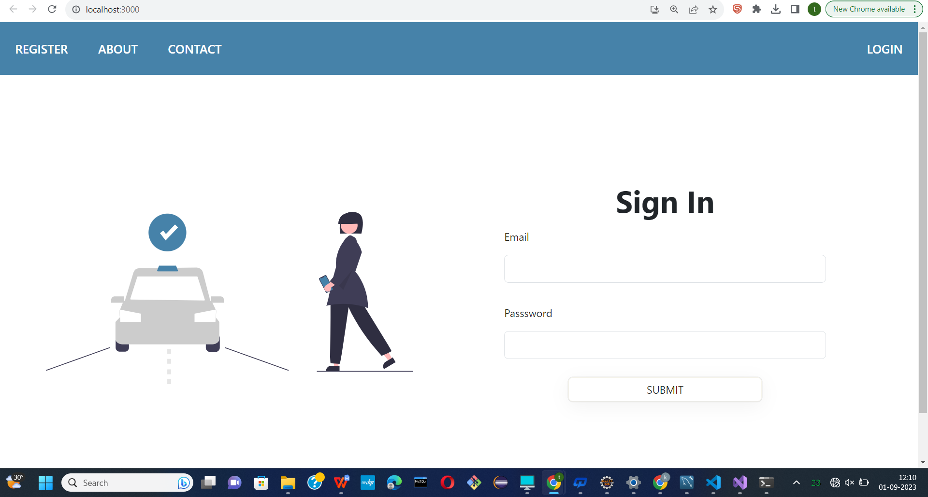

* Following snapshot shows the Home page of Inter-city Car Pooling System.

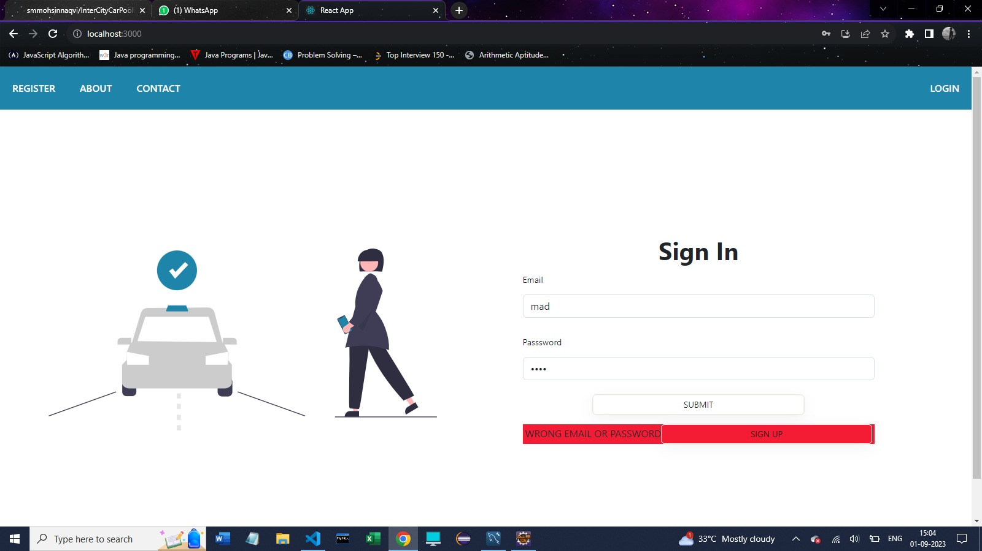

* **Registration**

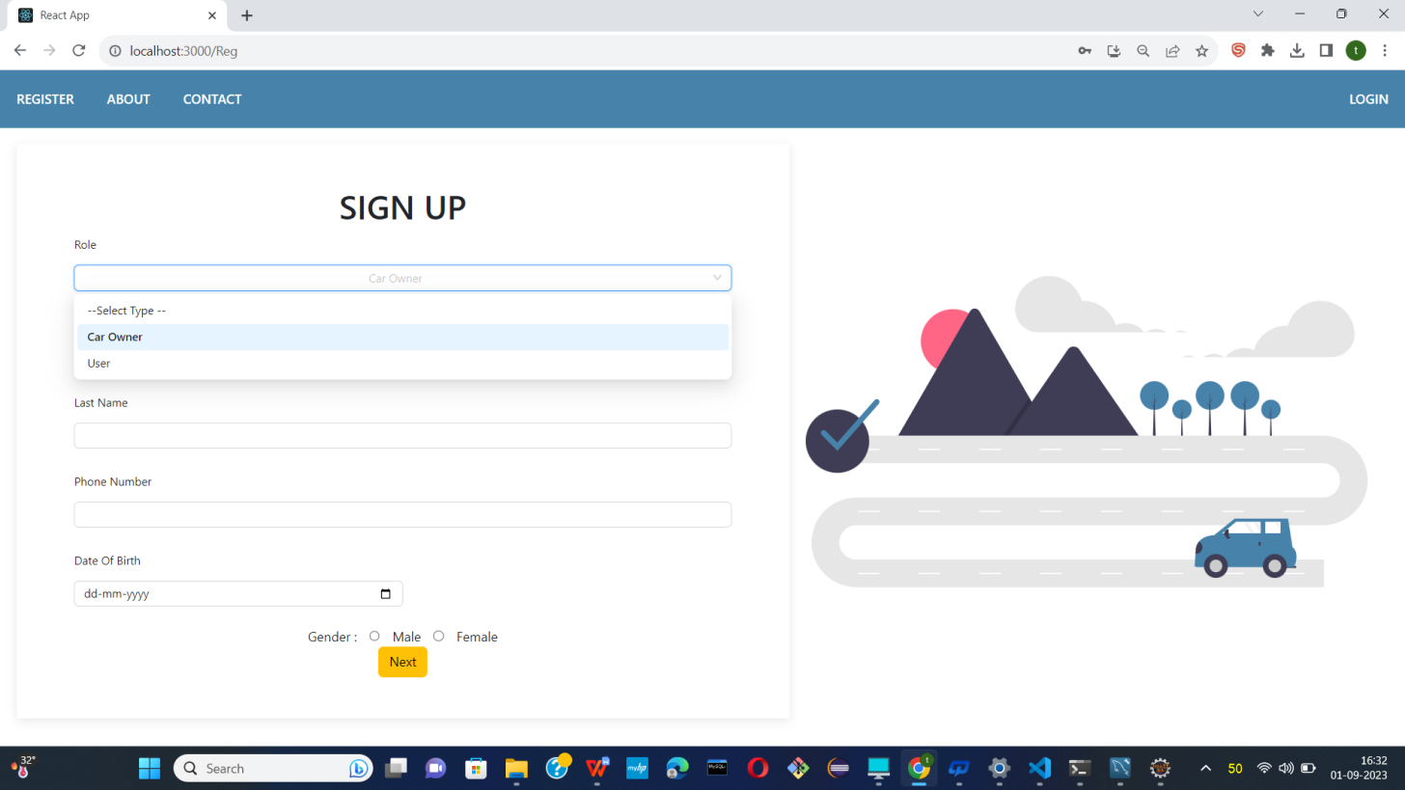

**Selecting type of User**

* 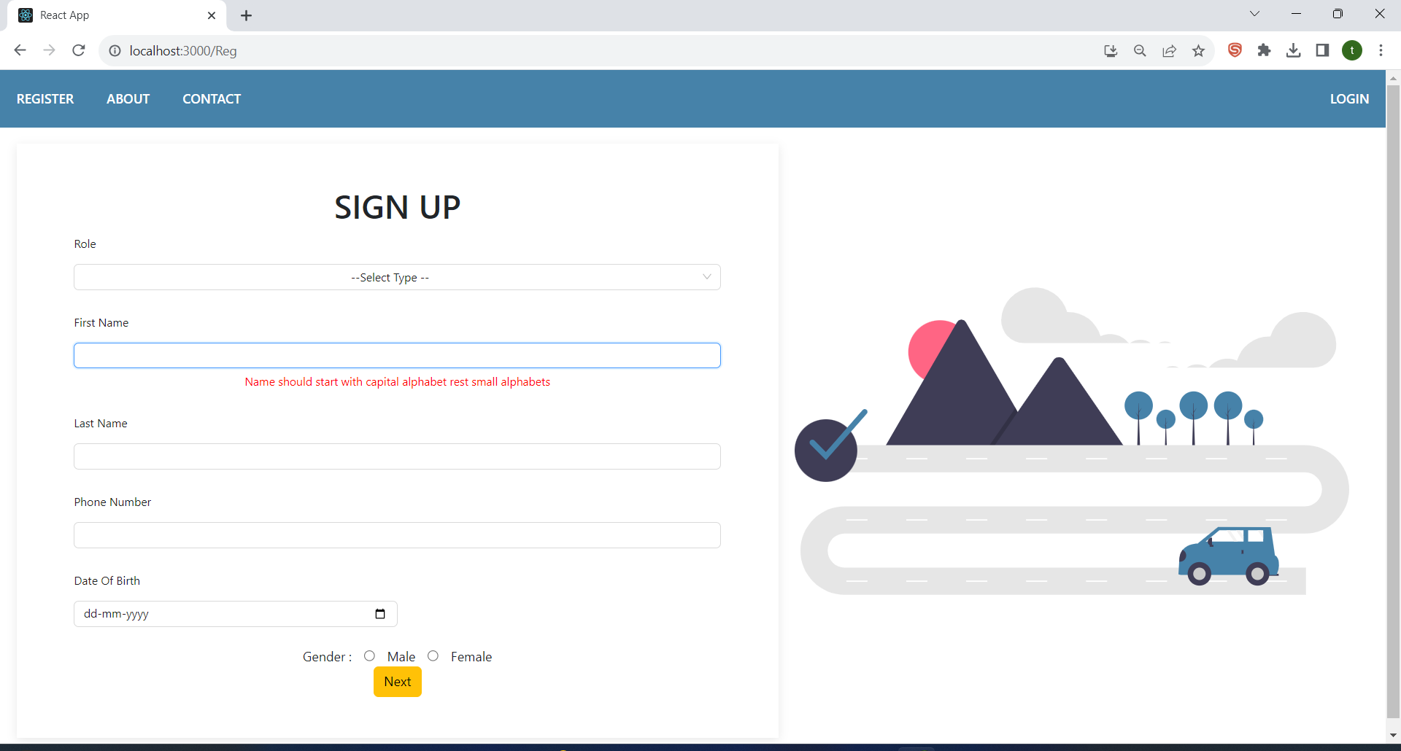

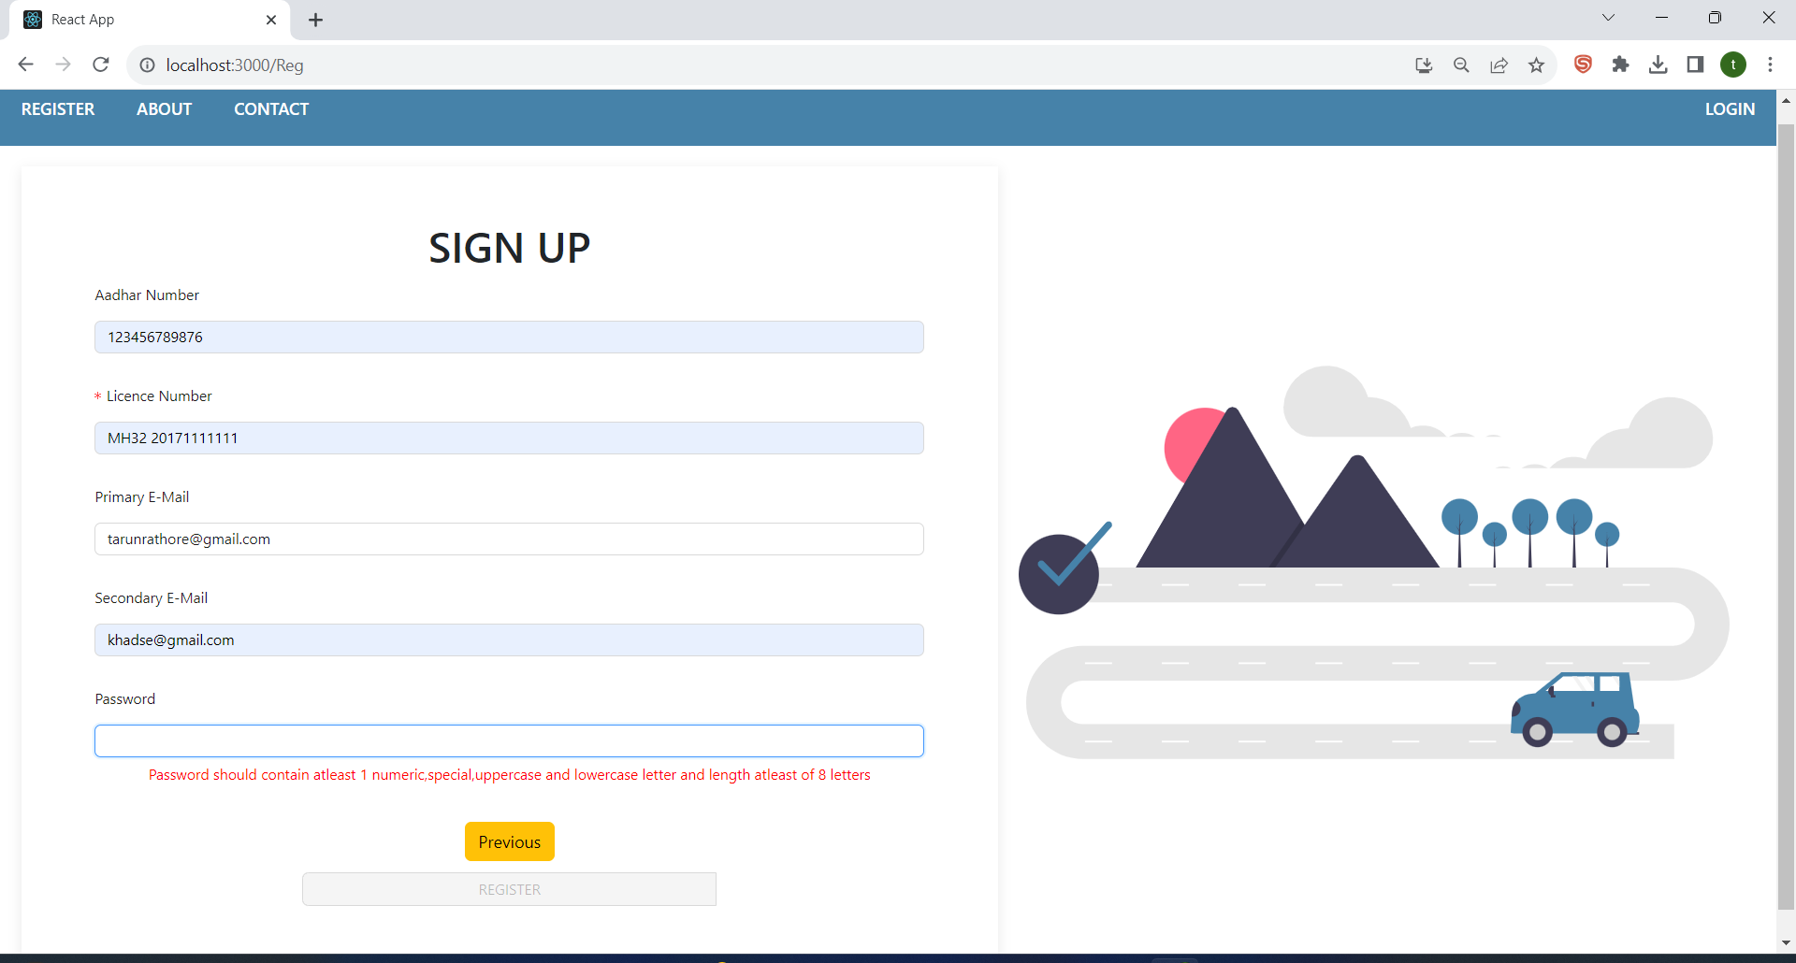

**Validation on all required fields**

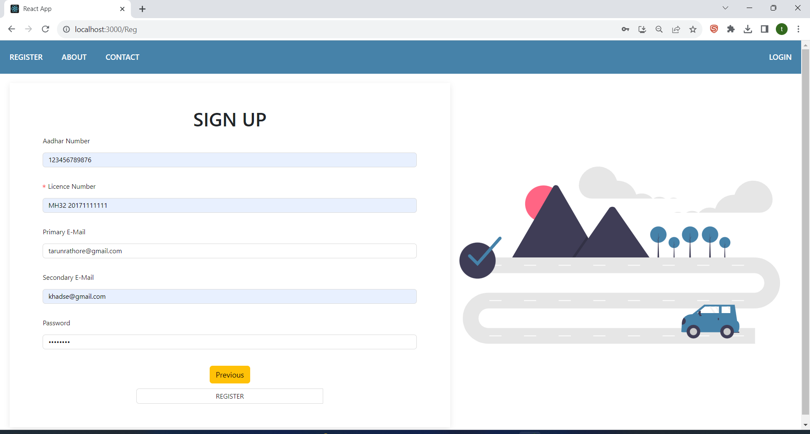

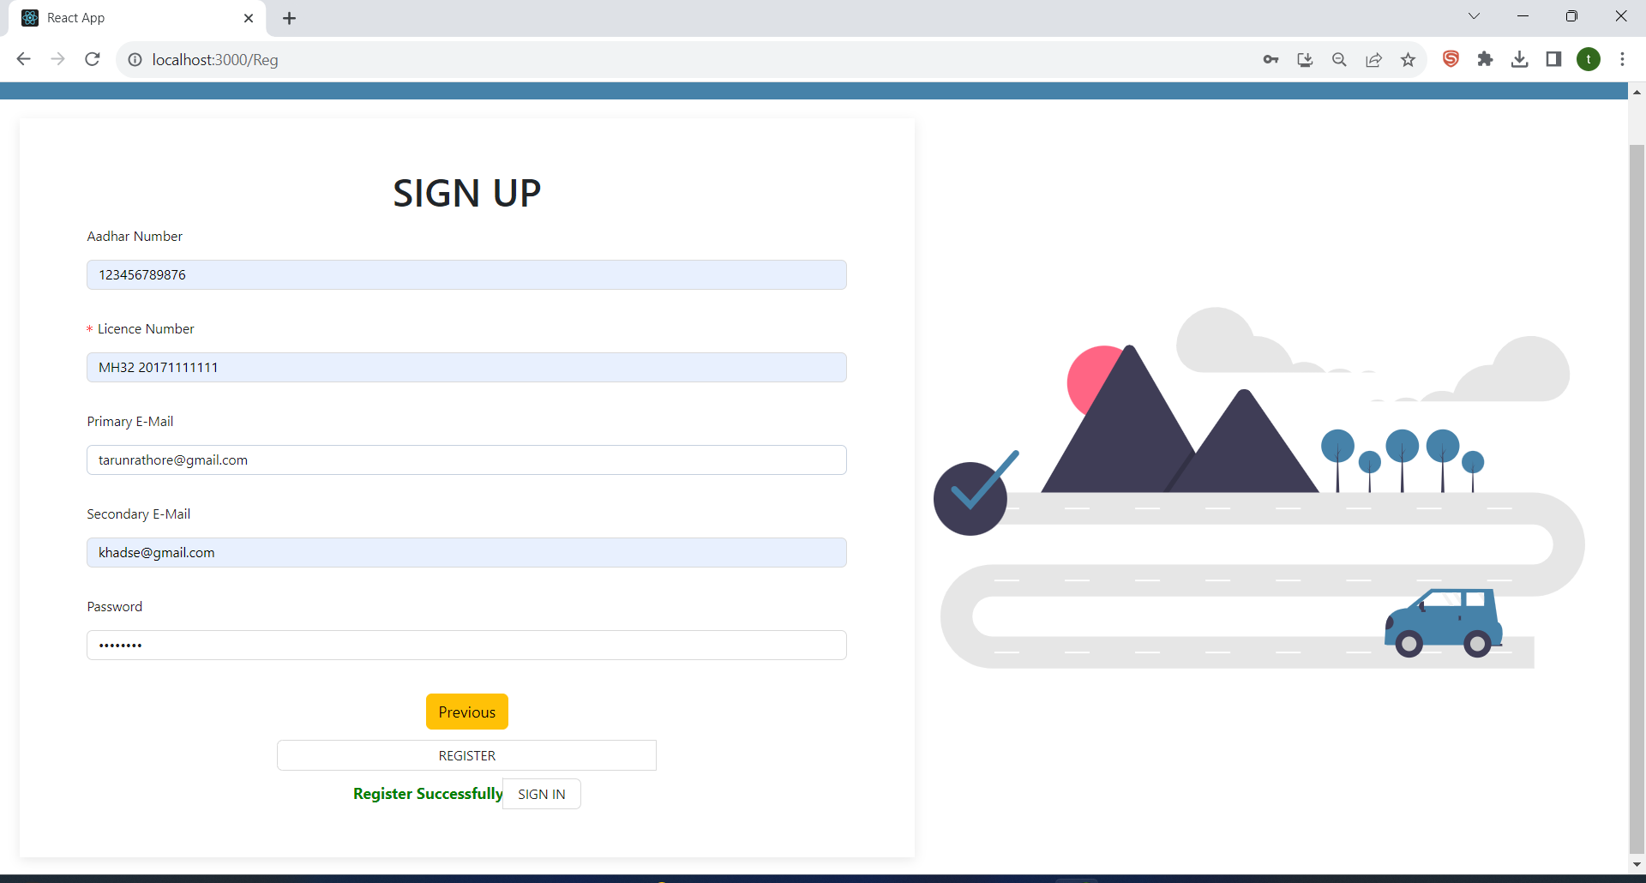

Registered Successfully.

* Need Approval by Admin

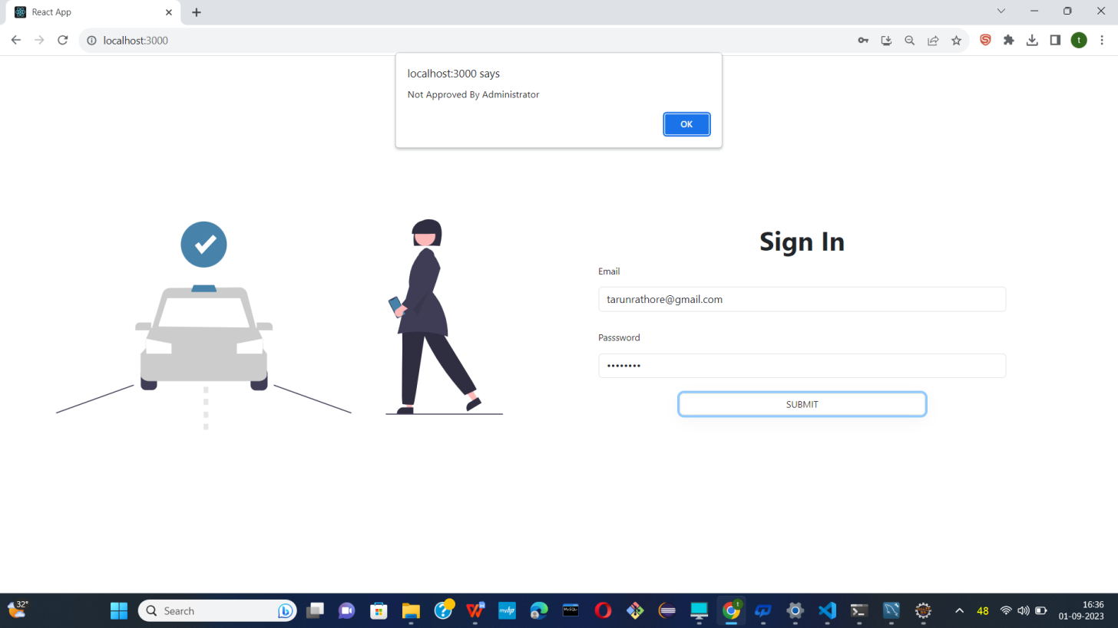

* Login as Admin

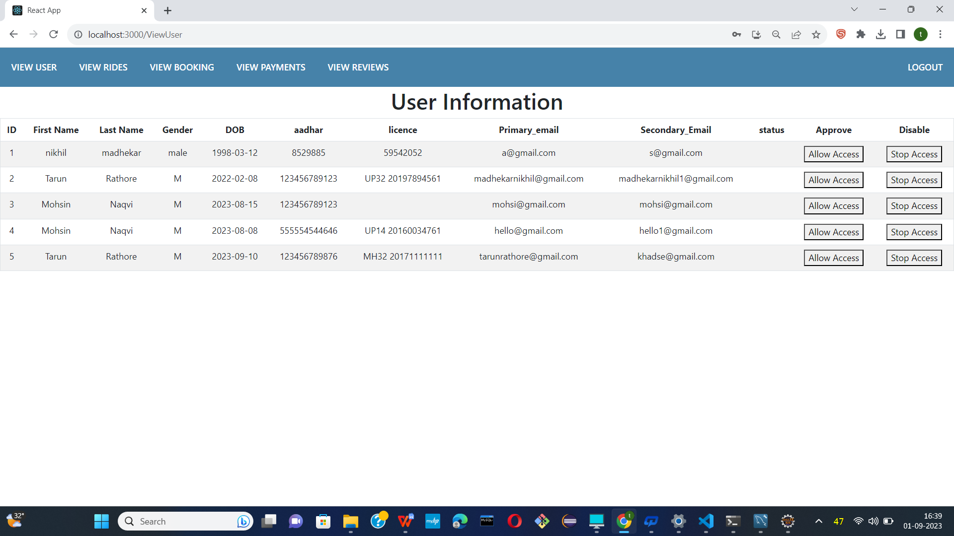

* Now Admin allow access New Car owner .

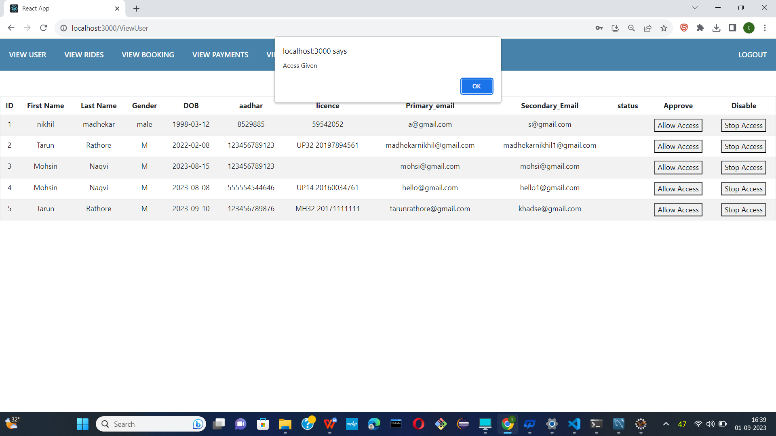

* Access allow.

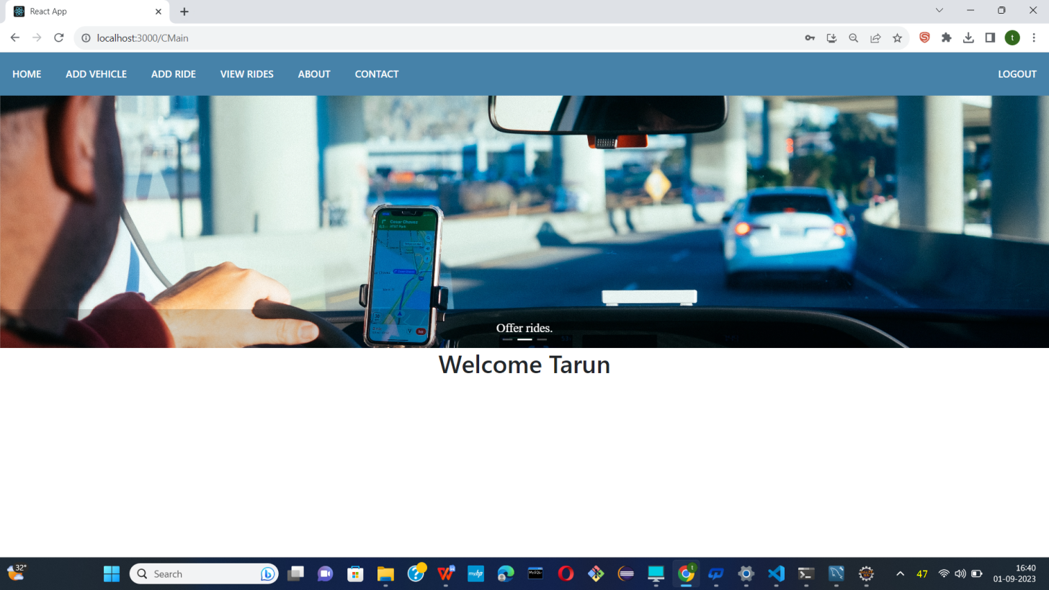

* Login as a Car owner

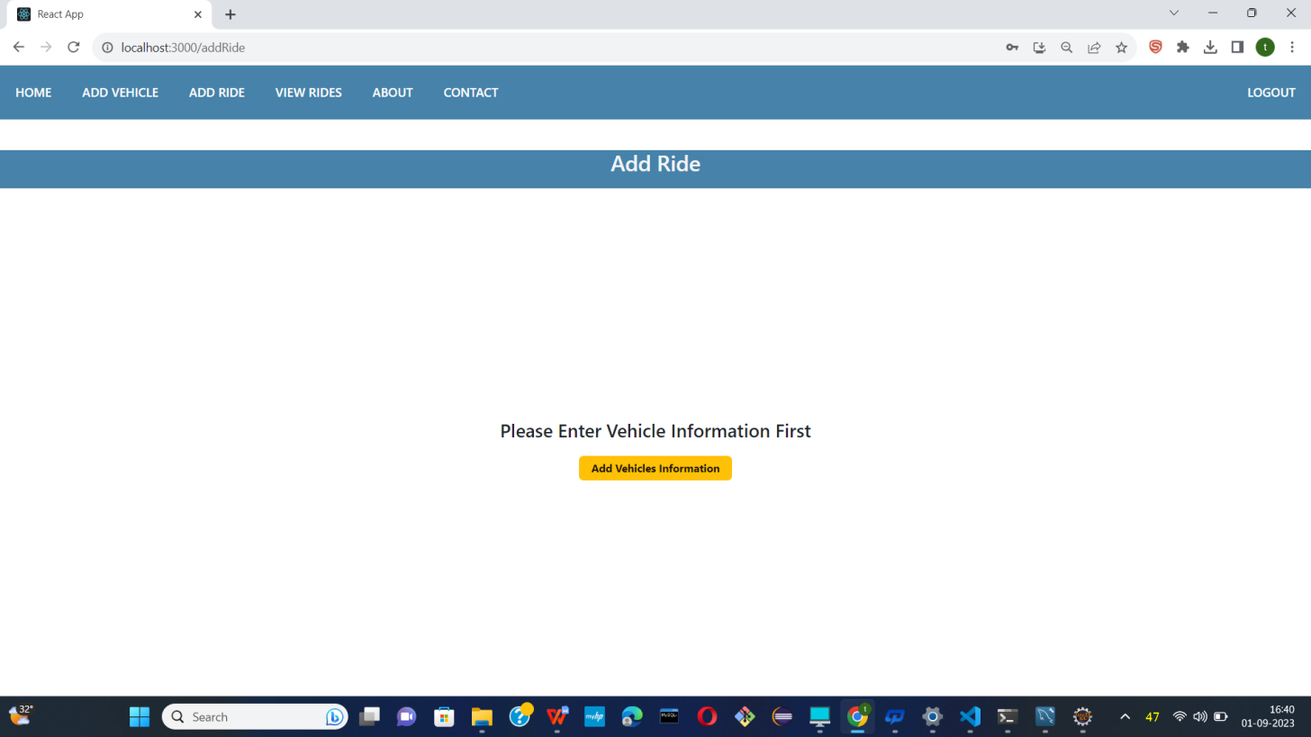

* Car-owner add vehicle information first.

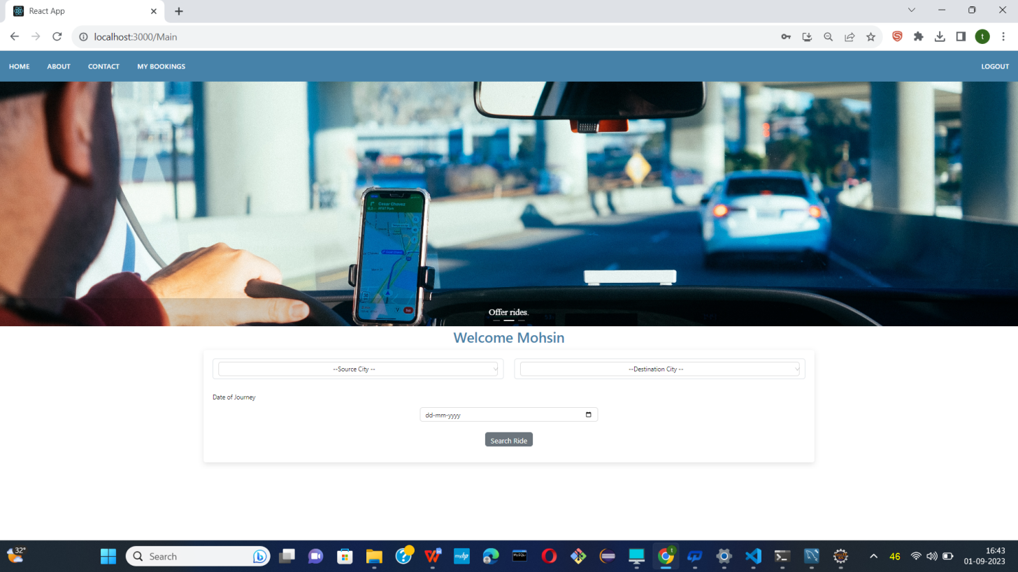

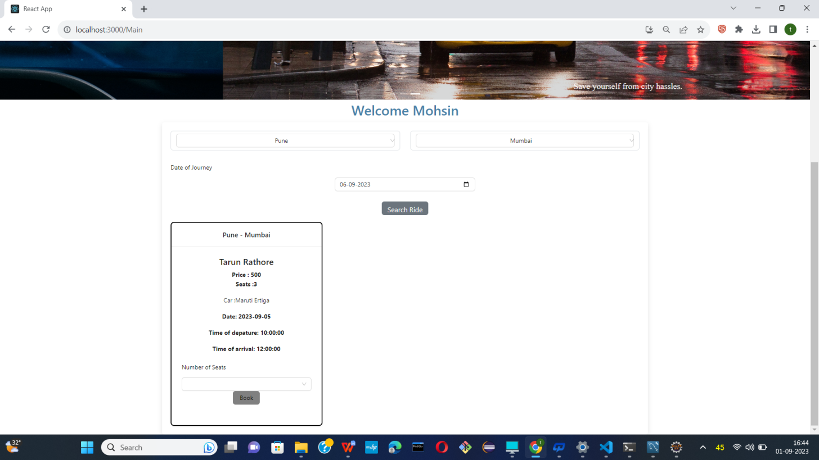

* User can search ride.
* 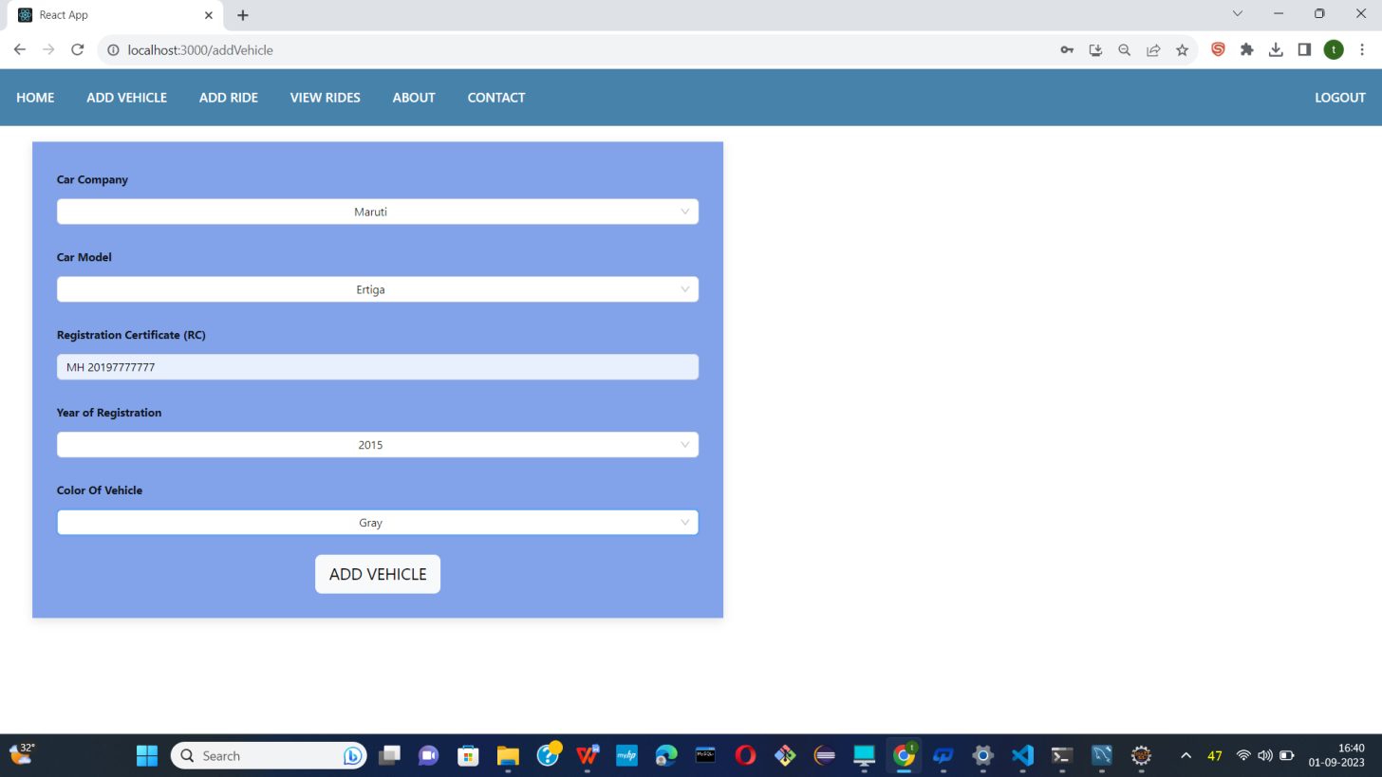
* Add vehicle information.

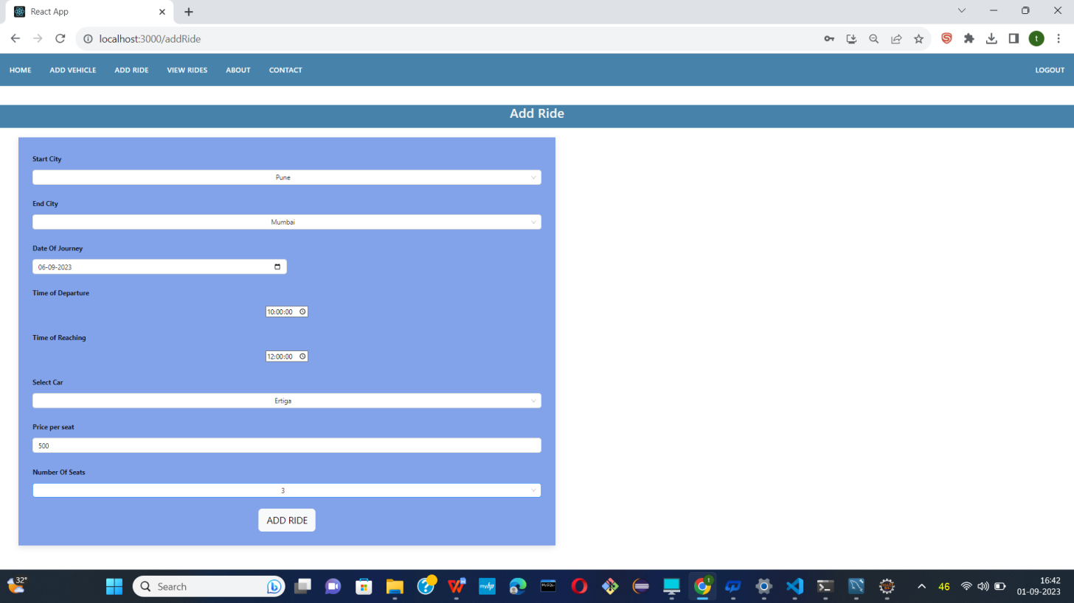

* Add ride information.

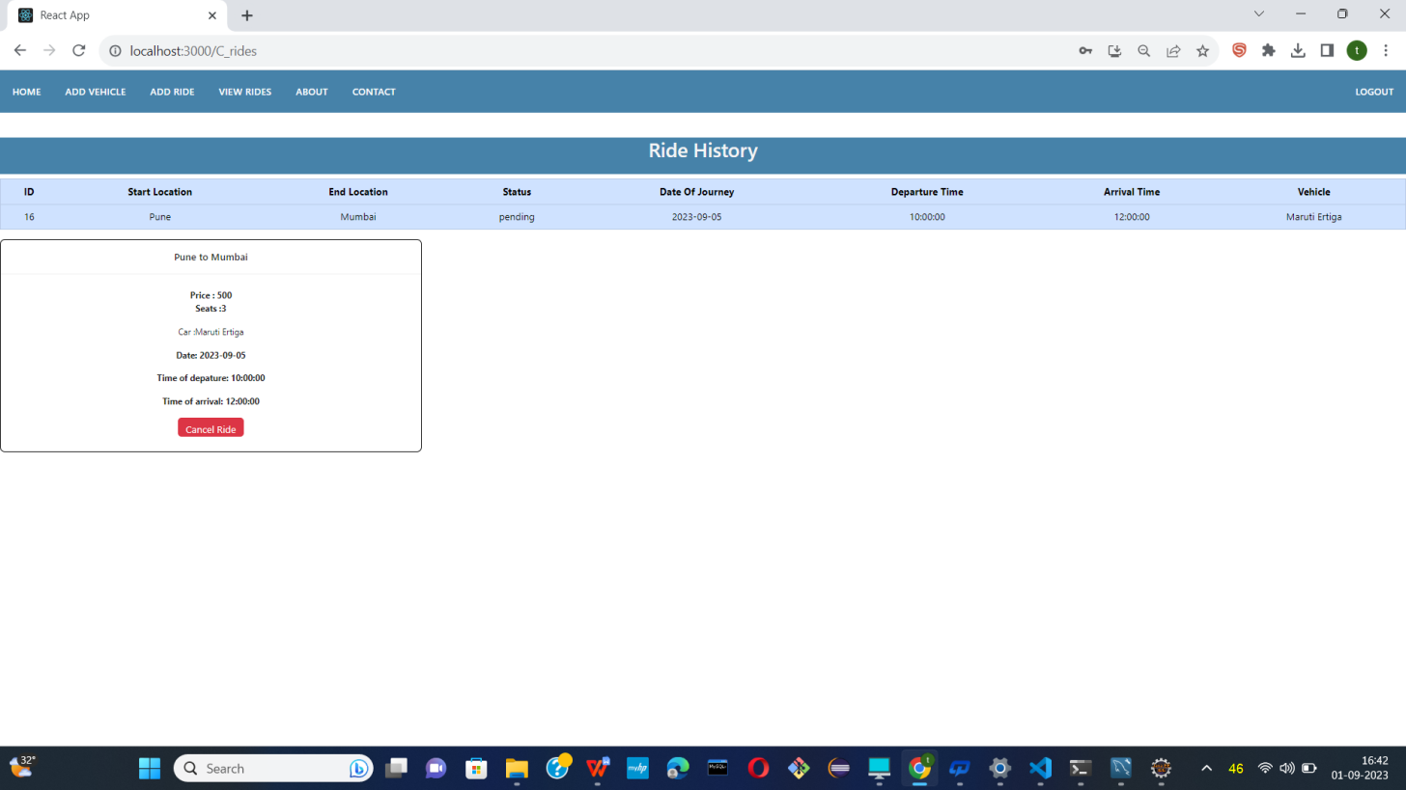

* Now ride shows users.

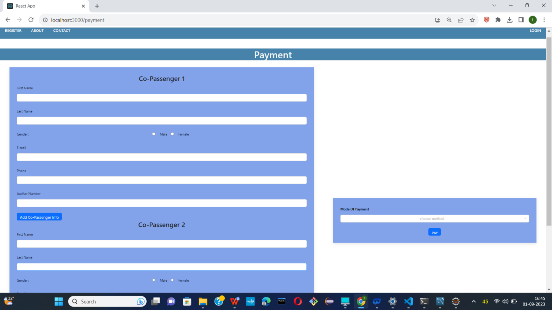

* Now users add co-passenger .

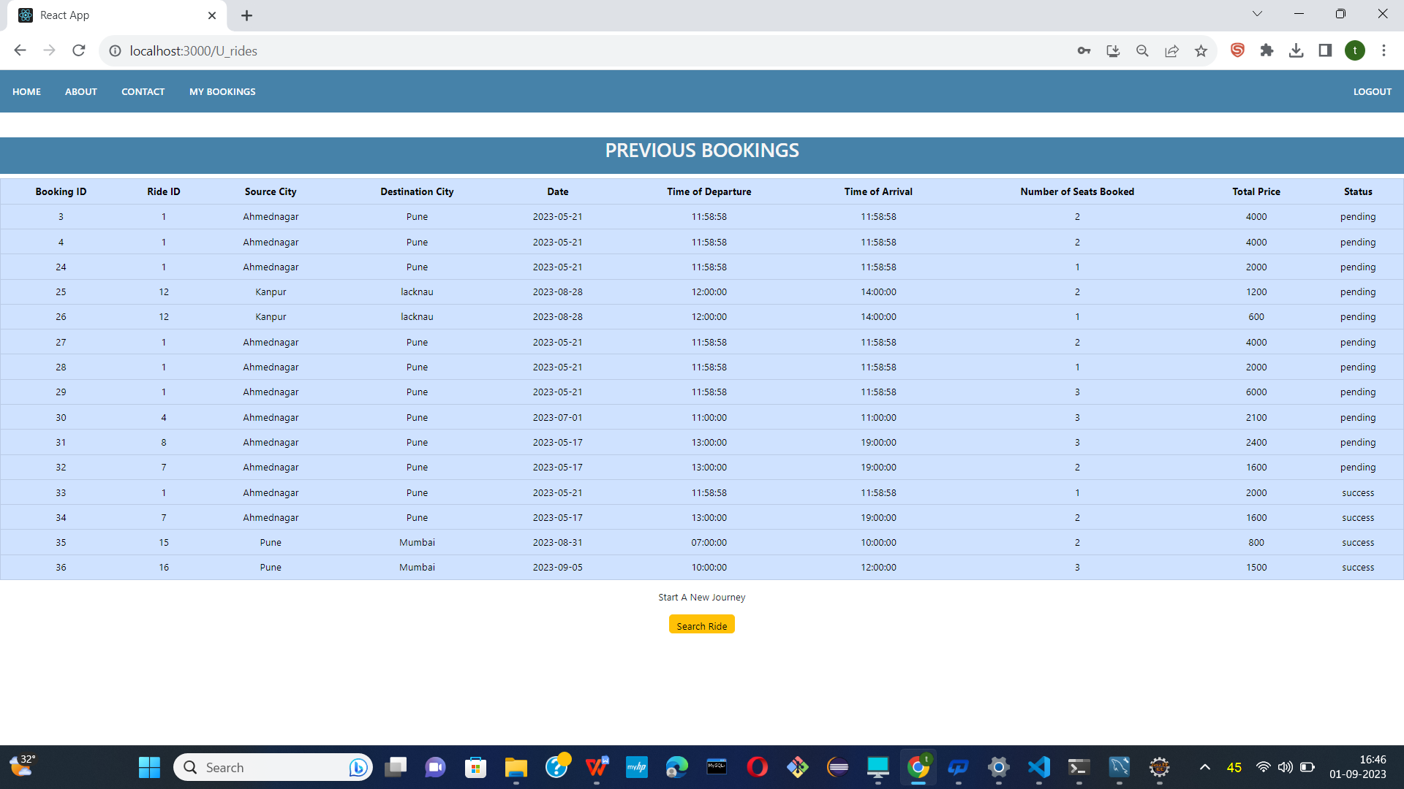

* Now users also shows their prevoius booking as well.

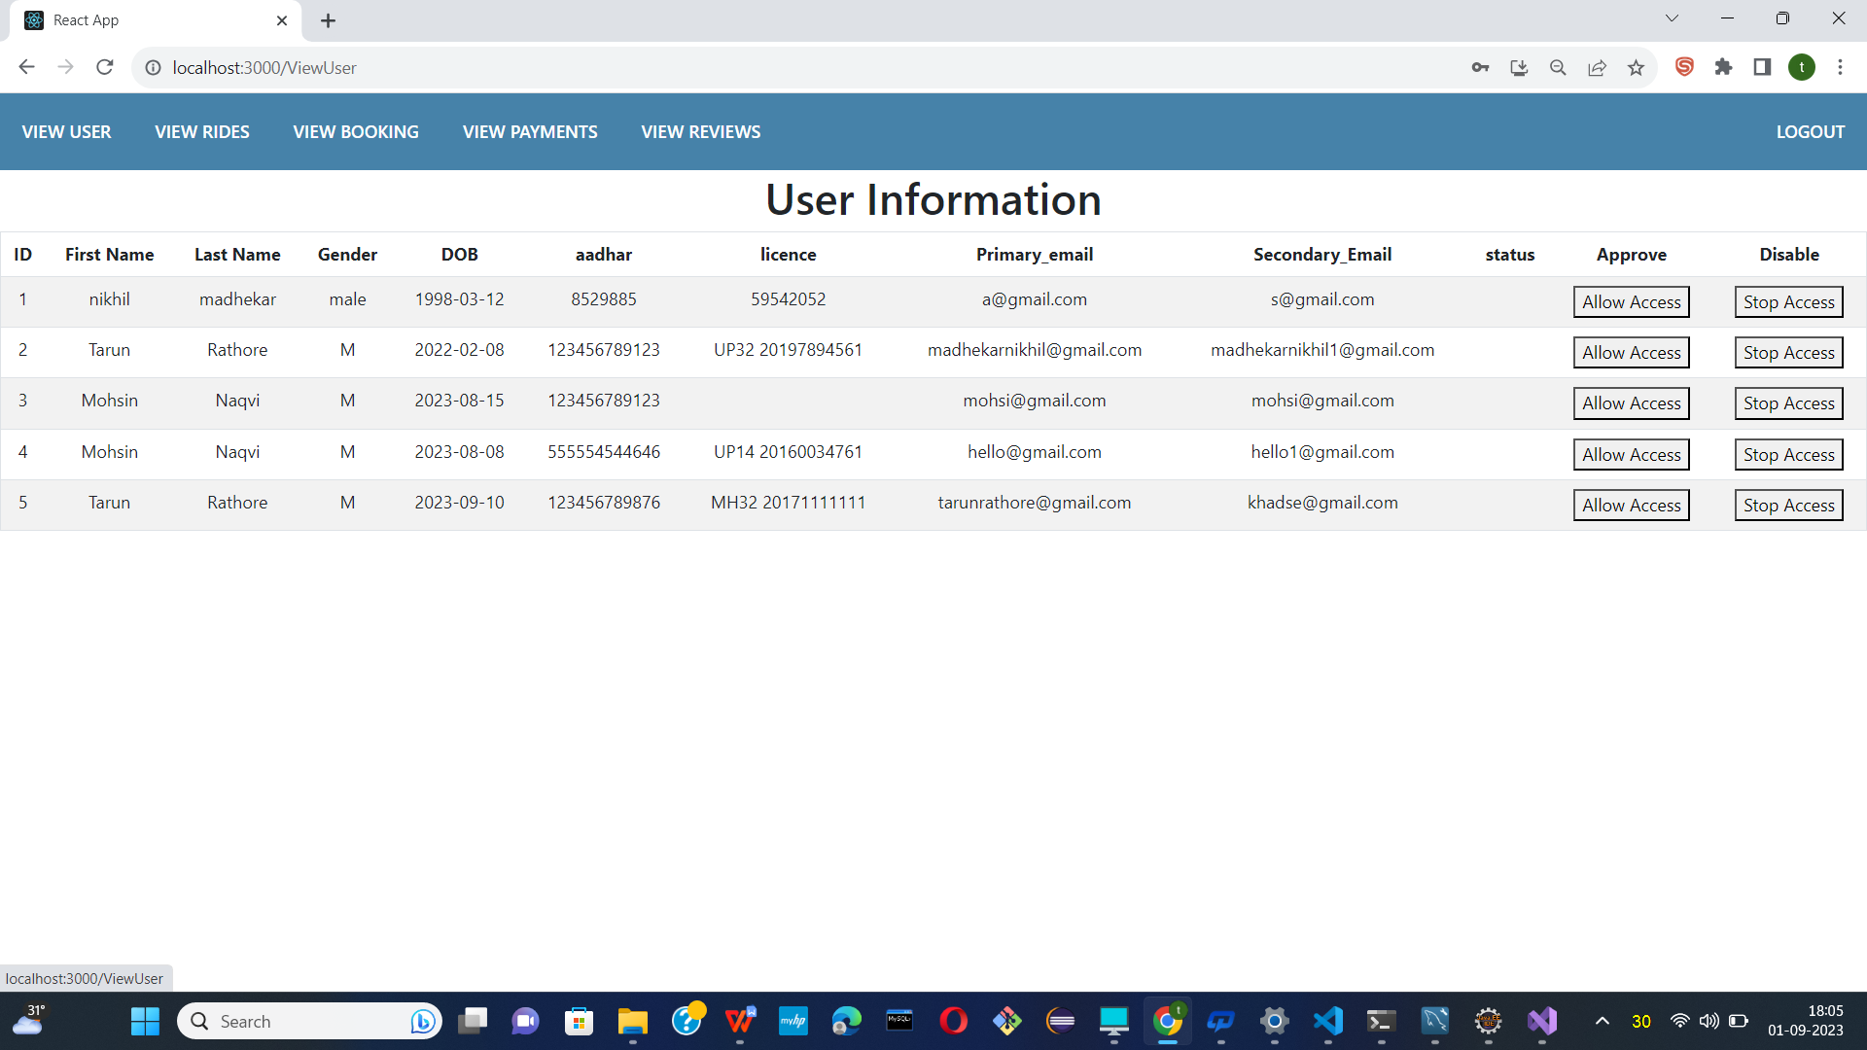

* Logged in as an Admin

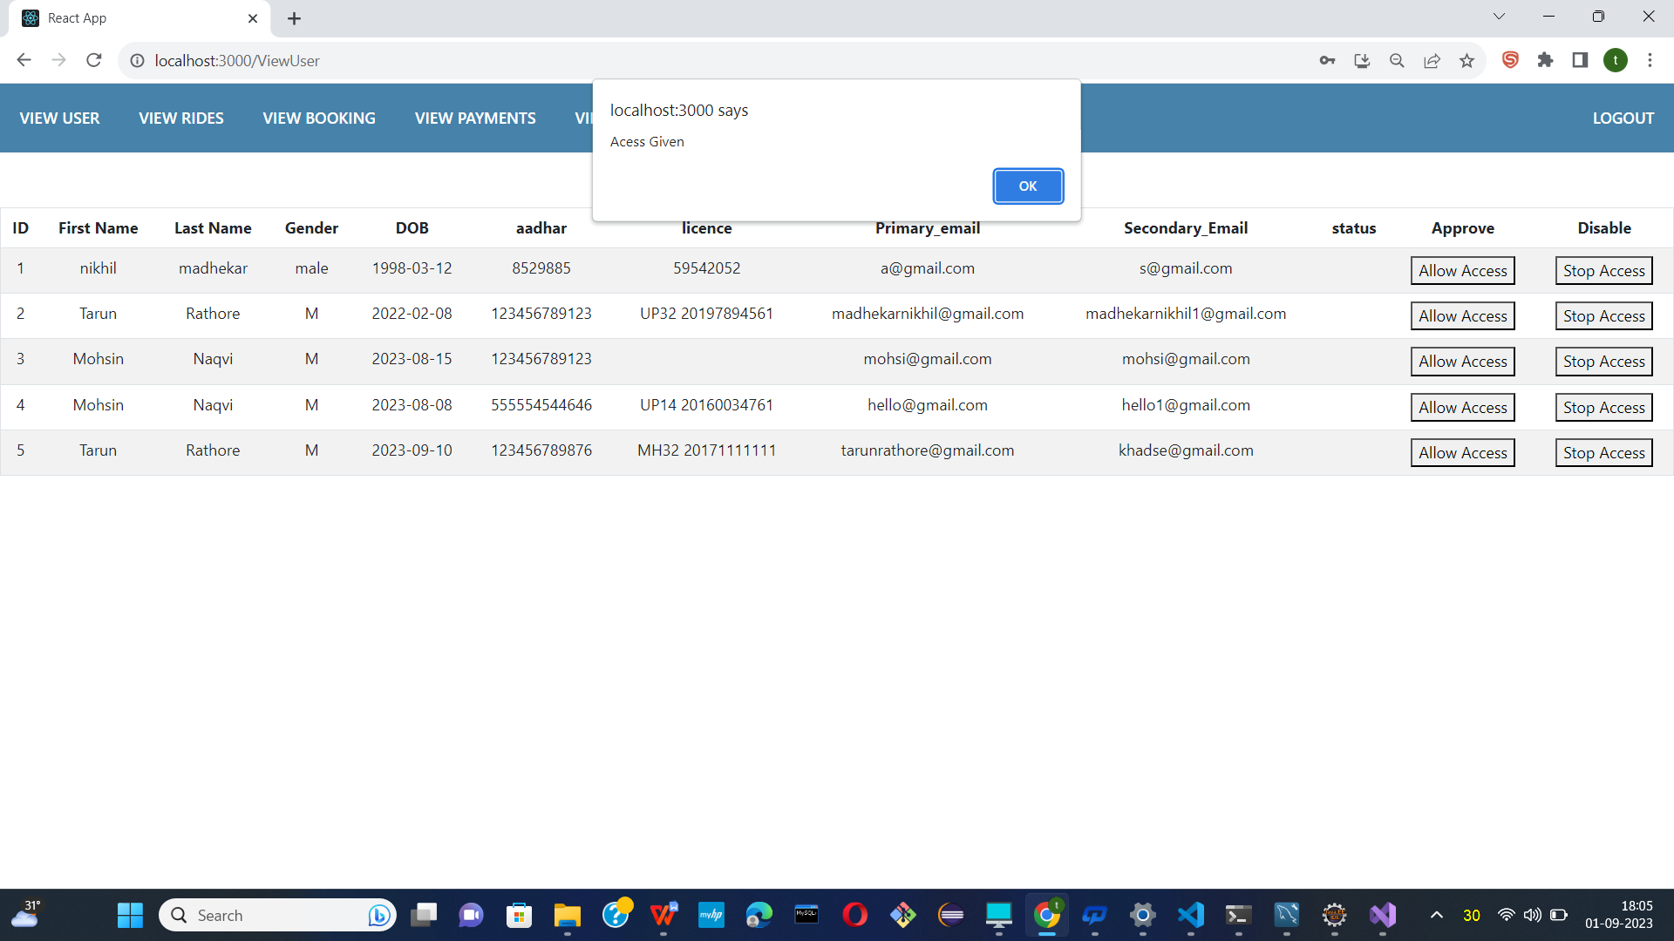

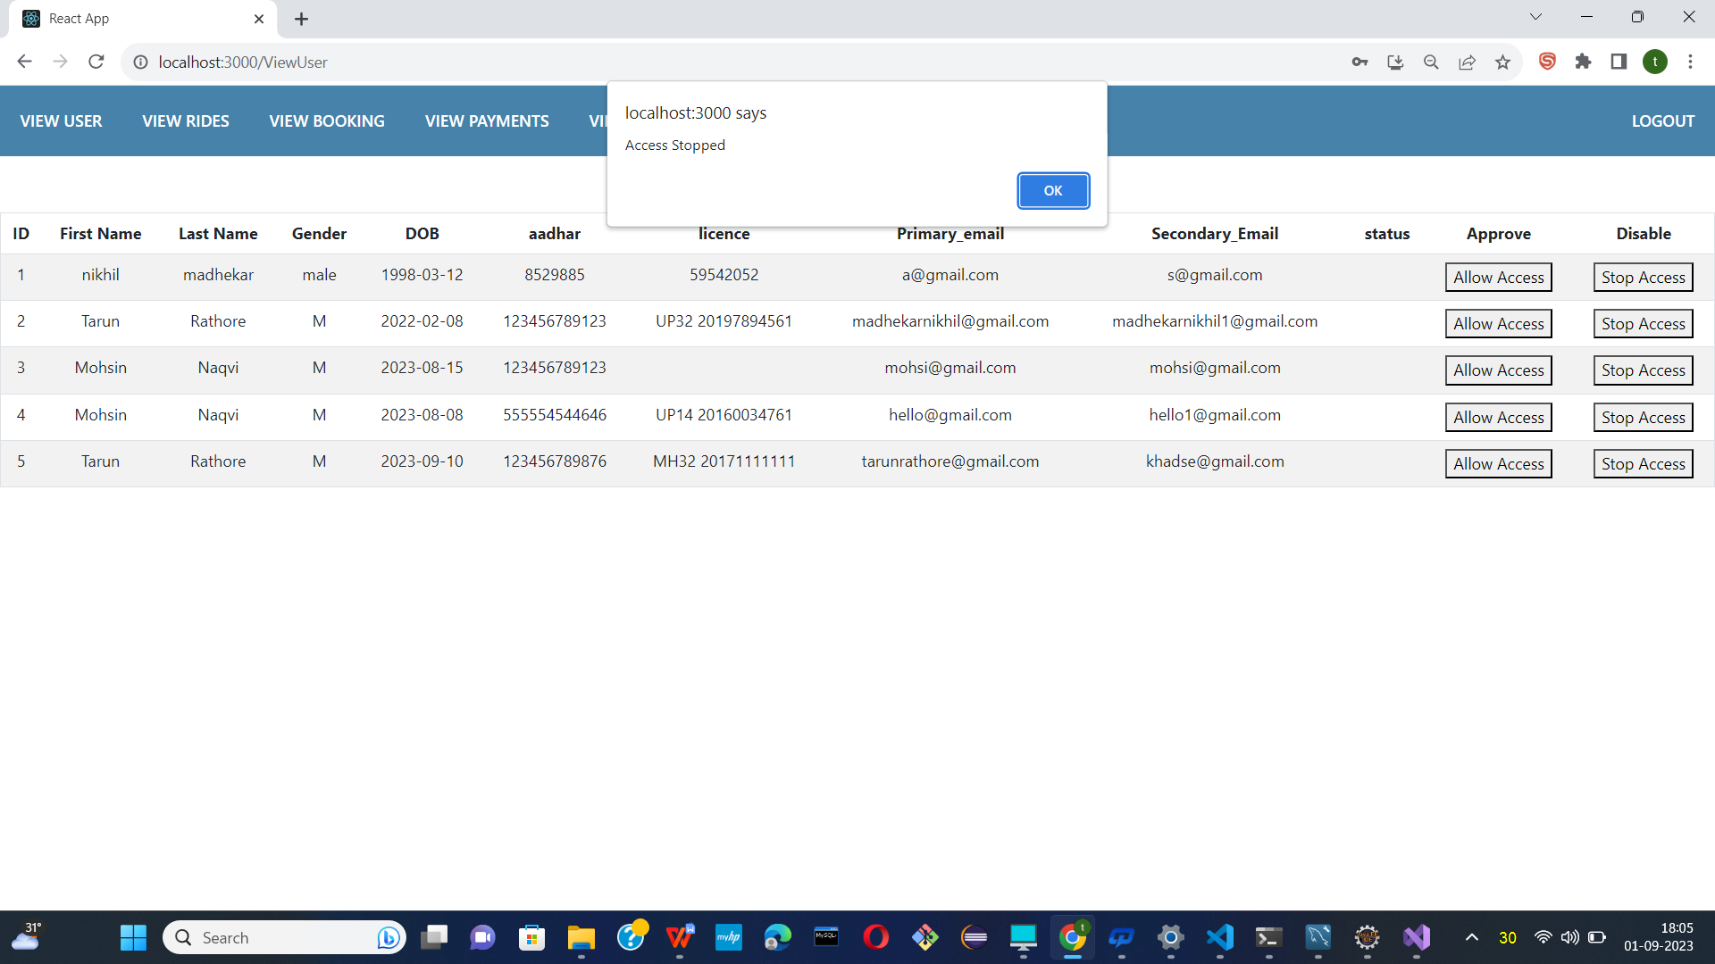

* Now admin had to Allow access and stop access to users.

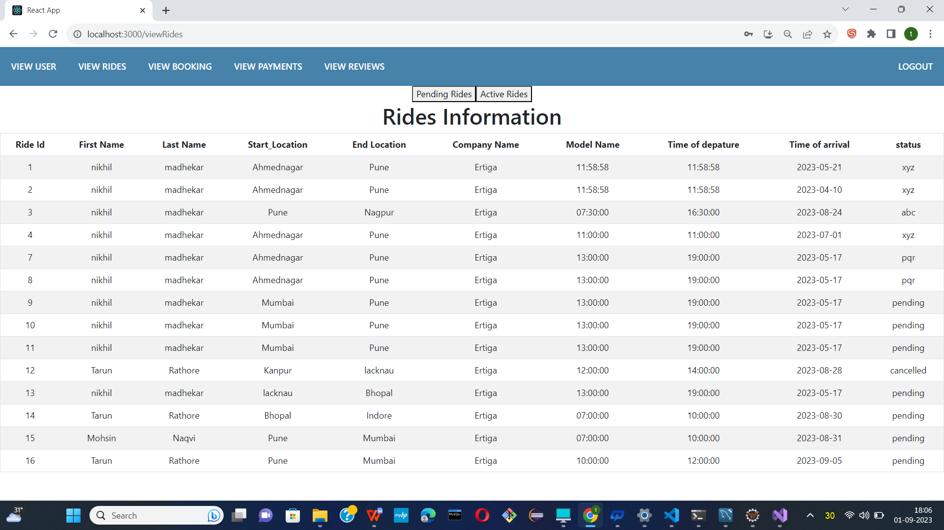

* Show all rides information.

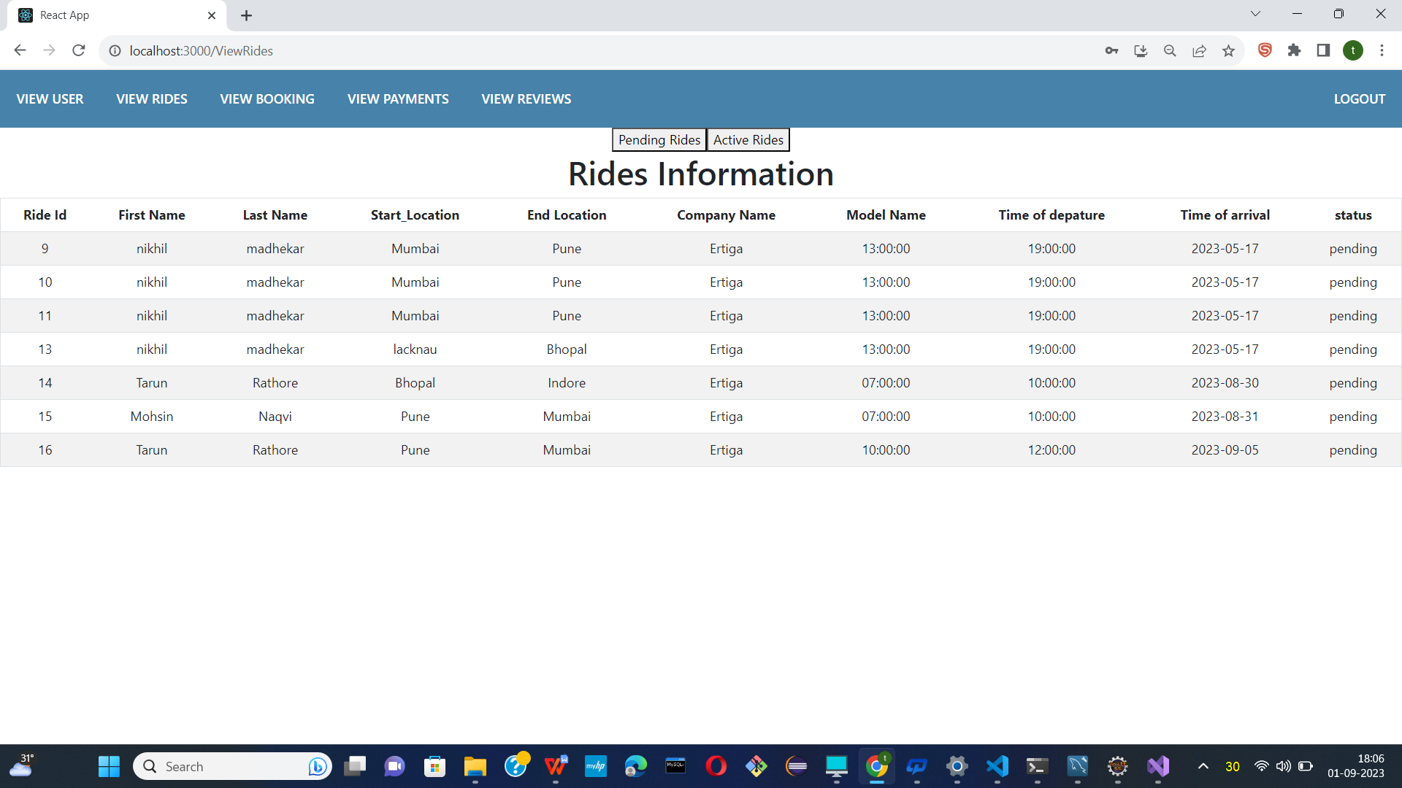

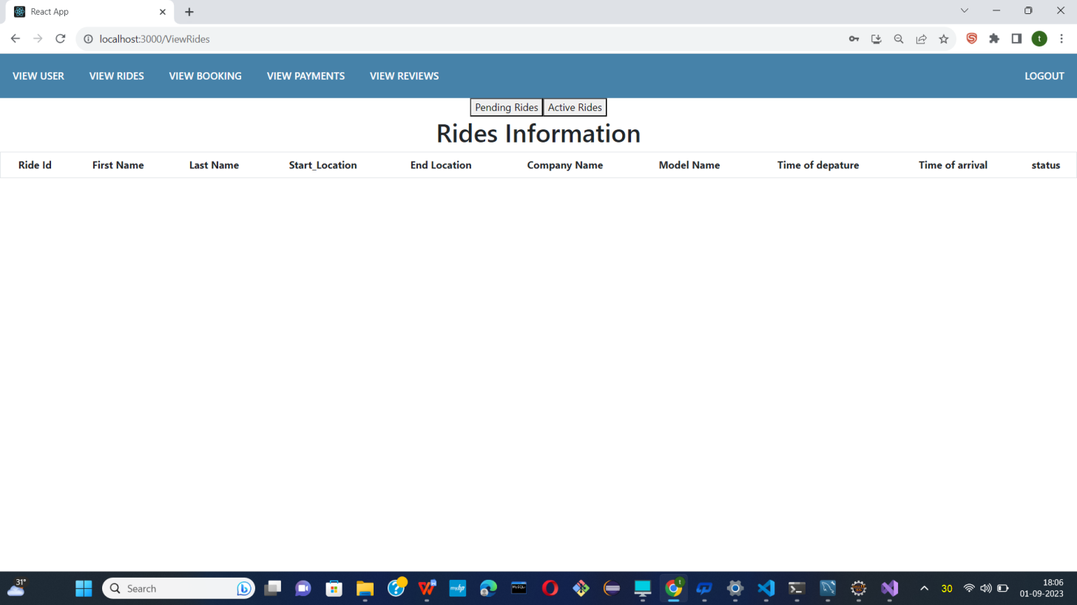

* Show all pending rides and active rides.

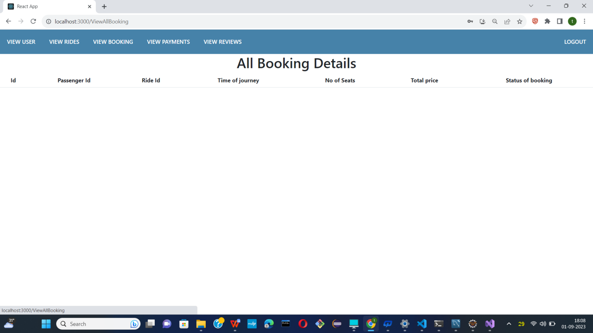

* Show all booking information.

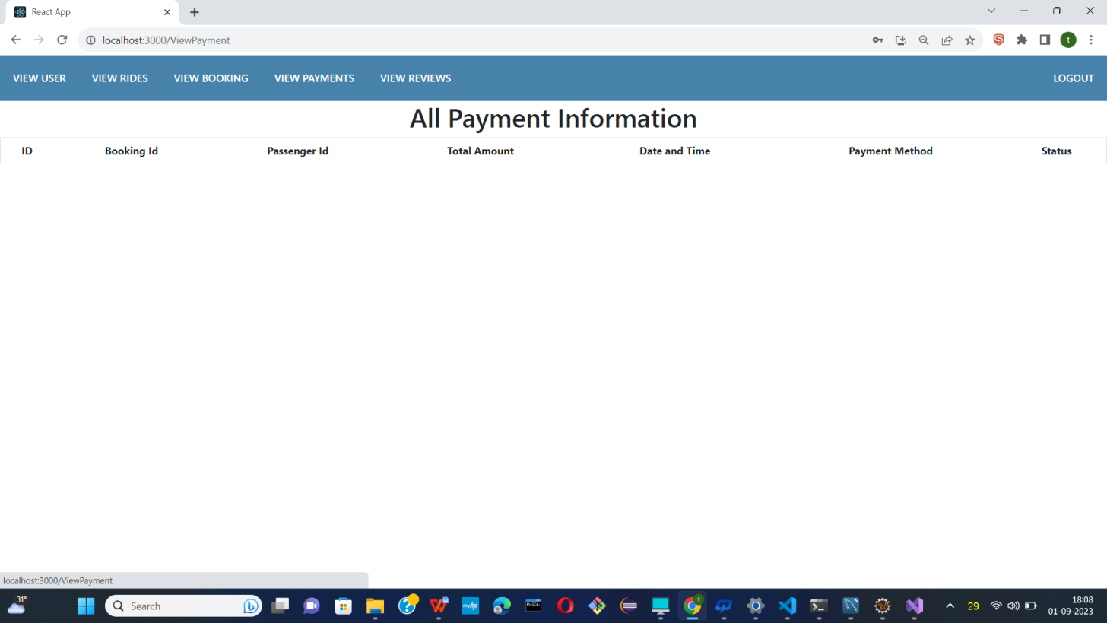

* Show all payment information.

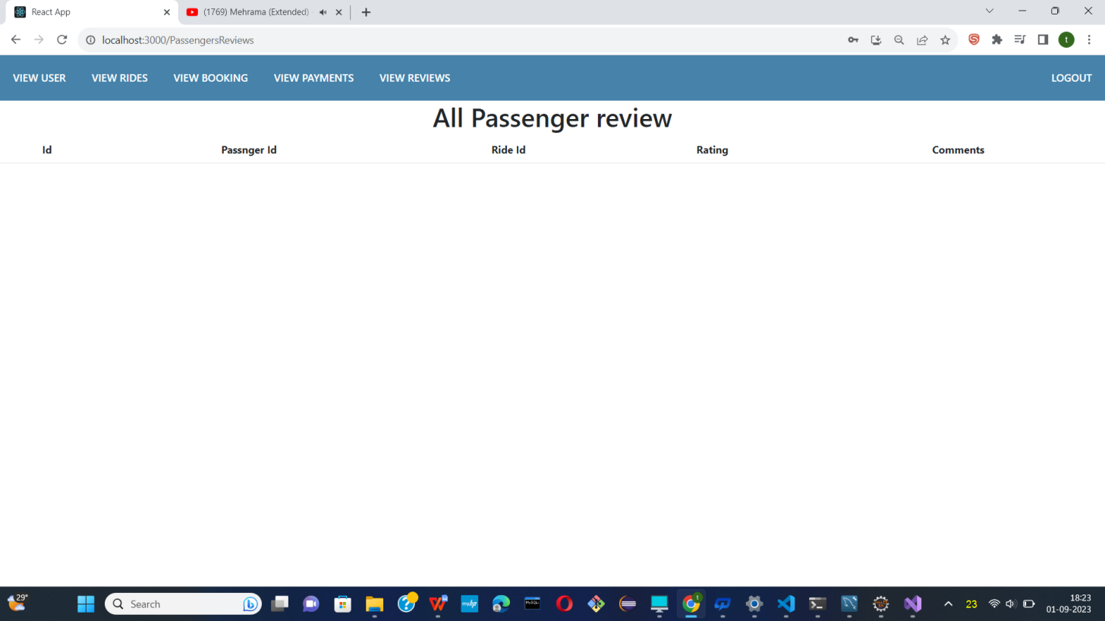

* Show all pasenger review.

**9.CONCLUSION AND FUTURE SCOPE**

Carpooling is the sharing of car journeys so that more than one person travels in a car, and prevents the need for others to have to drive to a location themselves with own car.

Reduce traffic congestion – The benefits of carpooling on a large scale are huge.

The software is flexible enough to be modified and implemented as per future requirements.

We have tried our best to present this free and user–friendly website to Society.